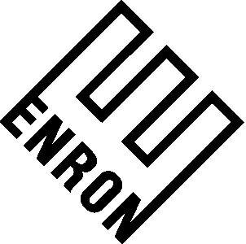

May 17, 2001

Mr. __________________
Cinergy
______________________

Re: Assignment of Kern River Gas Transmission Company’s Transportation Capacity

Dear _____________:

This letter agreement (this “Agreement”) sets forth the agreement of Enron North America Corp., a Delaware corporation (“ENA”) and Cinergy ___________, a _____________ corporation (“Cinergy”), (each referred to as a “Party” or collectively as the “Parties”), addressing certain details regarding Cinergy’s permanent assignment to ENA of transportation capacity that Cinergy currently holds on Kern River Gas Transmission Company (“Kern River”) under that certain Firm Transportation Agreement for 3,000 Mcf per day, Contract No. ________ dated March ___, 2001 between Cinergy and Kern River (the “Transport Contract”) in consideration for a one time payment of $1,500,000 (the “Payment”) from ENA.

Cinergy agrees to immediately permanently assign the Transport Contract to ENA utilizing a form of assignment acceptable to Kern River. Upon completion and execution of the permanent assignment, ENA agrees to immediately pay the Payment to Cinergy via wire transfer at an account as directed by Cinergy in writing.

THIS AGREEMENT SHALL BE GOVERNED BY AND CONSTRUED IN ACCORDANCE WITH THE LAWS OF THE STATE OF TEXAS, EXCLUDING ANY CONFLICTS-OF-LAW RULE OR PRINCIPLE WHICH MIGHT REFER TO THE LAWS OF ANOTHER STATE.

This Agreement may be executed in separate counterparts and delivered by facsimile.

Sincerely,

ENRON NORTH AMERICA CORP.

By: _____________________________
Title: ____________________________

AGREED TO this __ day of May, 2001.

Cinergy _____________________

By: ________________________________
Title: _______________________________

