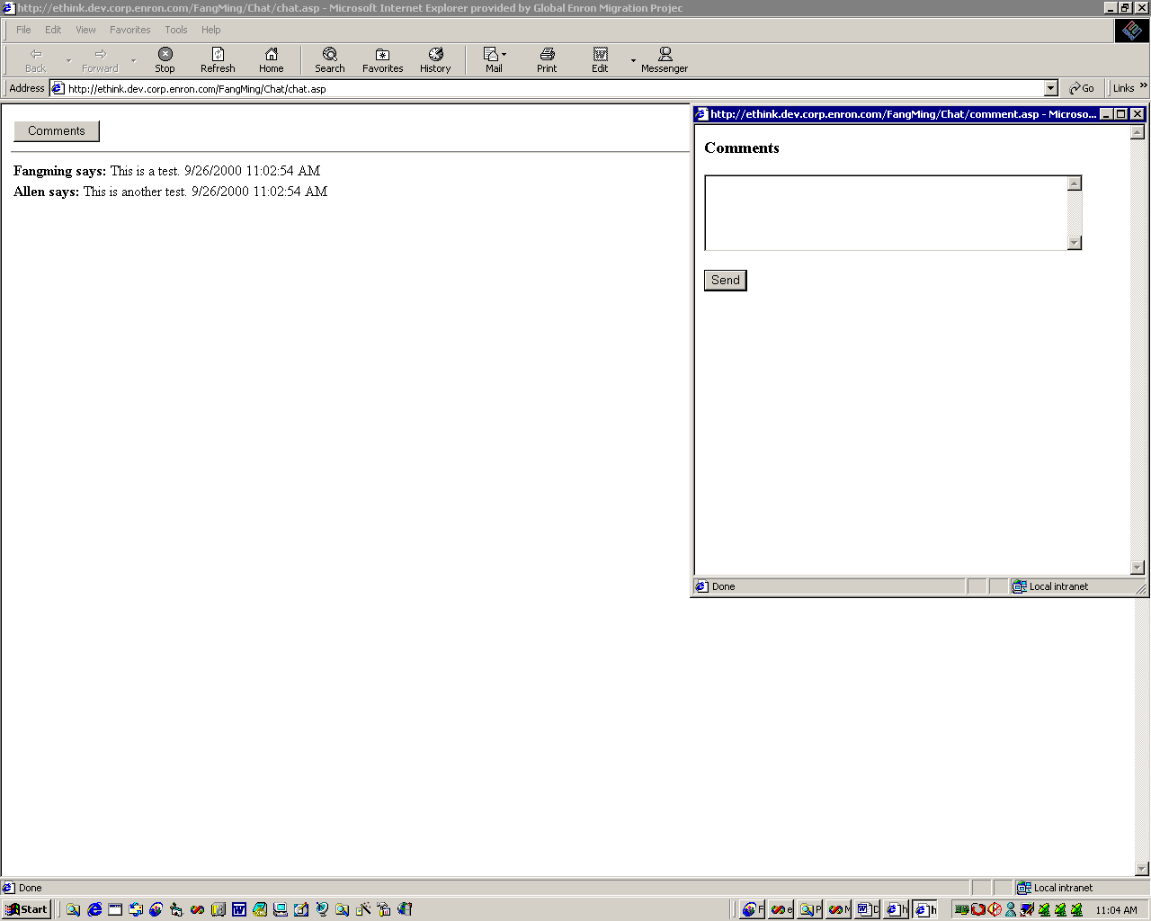

Goal of this application:

This web application is for users to be able to post their messages and to see other’s messages as well. All the messages should be available any time during a day. All the messages will be deleted by the end of the day.

This application is a message board tool rather than online chat. If users want an online chat, they should be looking for other solutions, such as, free download Microsoft Instant Message Tool from Microsoft website.

Compare to online chat, the advantage of our application is to be able to get previous messages at anytime during the day. On the online chat, if you close the session of a message, you will loose all messages. Since our information will be stored in the database, all messages should be retrieved manually by clicking on the refresh button on the menu bar.

Screen Names and their usages:

Screen Name: 1) Message Display
Usage: When valid users get on this site, they should be able to see the messages that are posted by the other valid users. Any valid users can add message by clicking on the comments button. The comments button should navigate the user to the comment popup screen.

Screen Name: 2) Comment Popup Screen
Usage: On this popup screen, users can type their messages, then click on send button to submit their messages. Once the messages are submitted, user can click on the refresh button on the menu bar to review the posted message on the Message display screen. Users also can continue to submit their messages by clicking on the back to the comments.

Security:

A valid user will be set up as authenticated method with window NT authentication on IIS server. The valid users of this website must be in corp. window NT group.

File Storage:

The file will be stored into Oracle database and it should last for one day only. All messages should be deleted by the end of the day. During the day, if users go to the site any time, they should be able to see the previous messages that are posted by other users.

Size of the user community:

The size of the user community will be up to 10 users. However, the design of the system can handle more than 10 concurrent users.

