To: All Enron Houston Associates
From: Barry S. Sternlicht, Chairman & CEO
Date: October 23, 2000
Re: Grand Marshal Thank You!!…..Starwood Shatters JDF Walk Records
On Sunday, September 24th, a crowd of approximately 7,000 walkers entered Battery Park, Manhattan, in support of the Juvenile Diabetes Foundation’s Eleventh Annual “Walk to Cure Diabetes”. Walkers enjoyed a fun and festive day with their colleagues, friends, and family, filled with food and live entertainment. Children enjoyed clowns, face painters, stilt-walkers, animated cartoon characters and much more.
Special thanks to everyone at Enron who volunteered their weekend time to walk with my family and I on that morning to cure juvenile diabetes. Also, many thanks to our walkers for their impressive fund-raising efforts. Thanks also goes out to those employees who were unable to participate on “Walk Day”, but so generously supported this event by donating funds or sponsoring a walker. As Presenting Sponsor of the Walk, Starwood assumed a tremendous leadership role. Enron’s employee presence that day and donated $10,000 sponsorship funds sent a strong signal that you, as a company, care about the health and welfare of the community.
It was terrific to be with all of you and to feel the enthusiasm and energy of everyone assembled that morning. I hope you enjoyed the Walk and had as much fun as my family and I did. My son, William, and the million other kids like him with diabetes, especially thank you for supporting and funding the “Walk to Cure Diabetes”. Your steps keep our dream alive that a cure will be found in these children’s lifetime. Raising awareness and dollars brings JDFI one step closer to their singular mission--finding a cure through research.
Despite uncertain weather conditions, over 900 walkers from corporate, Enron Energy Services-Houston, Starwood Capital, Starwood Ceruzzi, Rinaldi, Finklestein & Franklin and 22 hotel properties crossed the Brooklyn Bridge and back in an effort to “knock out” diabetes. I proudly announce that Starwood Hotels & Resorts had the strongest representation in Battery Park and for three consecutive years has defended its #1 Walk Team title. Joining forces with us that day were Caesars Pocono Resorts (Caesars Cove Haven, Caesars Paradise Stream, Caesars Pocono Palace, Caesars Brookdale), Sheraton New York Hotel & Towers, Sheraton Manhattan, Sheraton Russell, Sheraton JFK Airport, Essex House-Westin, The St. Regis Hotel, W New York Hotels, Sheraton Stamford, Westin Stamford, Danbury Hilton Hotel, Sheraton Meadowlands, Sheraton Edison, Sheraton Parsippany, Sheraton Atlantic City, Four Points Barcelo Hotel Newark Airport, and Four Points Barcelo Hotel Piscataway.

Page 1 of 2

What an amazing experience to have been on stage as Grand Marshal of this event. Also, it was a great honor to have been introduced by Mary Tyler Moore, Juvenile Diabetes Foundation International Chairman, who traditionally cuts the ribbon at the start line and sets the pace for the Walk. Mary has been a vocal and active participant in the Walk efforts year after year and courageously battles against this dreaded disease herself. Mary testifies before congressional committees to urge for increased funding for diabetes research. It was an awesome sight seeing nearly a thousand walkers out there wearing our colorful T-shirts and sports caps with feelings of pride, hope and reward--there was a great sense of team spirit and camaraderie amongst our employees and corporate business associates. When Mary Tyler Moore announced to the crowd that Starwood Hotels & Resorts was the #1 fund-raiser and the largest walk team, there was an incredible cheer.
The Juvenile Diabetes Foundation excitedly reported that over $815,000 was collected in cash and pledges on “Walk Day”. To date, JDF has collected $2 million in cash and pledges well on their way to achieving their goal of $2.5 million. The “Walk to Cure Diabetes” is the fastest growing Walk-A-Thon Program in the country. Starwood Hotels & Resorts has fund-raised for the 2000 Walk-A-Thon nearly $1 million dollars in corporate and walker sponsorship dollars, and in our three-year participation $2.4 million.
Thanks again from me and my entire family. Mary Tyler Moore also extends her thanks to the Starwood Walk Team for their spirit and valiant efforts. Your continued support has made the “Walk to Cure Diabetes” a tremendous success and has led the New York Chapter to a milestone year. Together, the “Starwood Family” made a difference!! Your participation in the JDF “Walk to Cure Diabetes” helped raise the much needed funds to continue the battle against diabetes. Children and young adults with diabetes need up to six shots of insulin every day just to stay alive. Even if a child with diabetes strictly keeps his/her insulin regimen, insulin is not a cure-only life support until a cure is found. Our children are our precious future and with much hope and support, we strive to eradicate diabetes so not another child will need 13,485 shots just to make it to age 17!!
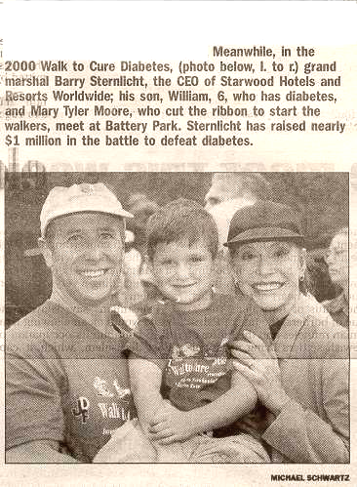
Daily News Monday, September 25, 2000

