DRAFT VI 10/18/00 (For discussion purposes only)

CAPACITY TRADING FUNCTIONAL SPECIFICATIONS

- OBJECTIVE
To create a multiparty Internet based trading system that will allow 3rd party pipelines to offer primary capacity to their customers.

- OVERVIEW
The following document describes the functional specifications of the new “Capacity Trading Tool”. The Internet based application will consist of three modules or interfaces:
- Customer Interface
This will be the main application. The customers will use this application to buy capacity from the Pipelines.
- Capacity Owner Interface
This is the application that the Capacity Owners (traders) will use to mange their products. It will be accessed through a unique url.
- Product Control Interface
This application will be used by the traders (owners) and by EnronOnline Product Control personnel. The application will be the interface to build and approve products. Also, this application will be used to update each pipeline customer list including contract and credit checks. Furthermore, the application will have a module to build the elements needed for the Product Long Descriptions.
- Profiles Manager
This application will be used by the Product Control Group to manage the Capacity Owners’ profiles (i.e. contract, credit, and Products levels of access).

Please note that the use of Screen Mock-ups, throughout this document, is intended for descriptive purposes only.

- FUNCTIONAL CHARACTERISTICS

  - General System Characteristics
- Multiparty System (i.e. Enron is not principal)
- Internet based Interfaces:
- Customer Interface
- Capacity “Owner” Interface
- Product Control Interface (need to define if it is going to be internet based)
- Handle up to 3000 products (Products are defined below)
- Display up to 150 different products on the screen or via filters.
- Automated counterparty credit checking. The credit checks will be done using Gross Transaction Value against Pipeline Headroom Limits
- Automated counterparty contract checking. The contract checking will be done against pipeline approved lists.
- EnronOnline “Look and Feel”
- Automatic Refreshing. The actual rates need to be determined (For ClickPaper: messages every 15 seconds; Markets every 3 minutes)

  - Products Characteristics
Each Capacity Product will be defined by the following attributes:
- Pipeline. Name of the Pipeline offering the Service
- Service. Approximately 12 different services (e.g. Interruptible Transportation, Firm Transportation).
- Transport Path. Defined by a Receipt and a Delivery point (e.g. Katy – HSC).
- Reference Periods (Start Date and End Date). No tokenized references will be used.
- Volume (MMBtu/d) or Maximum Daily Withdrawal Quantity (MDWQ). The volume will be further defined in the “Long Description” describing the relationship to the following terms:
- Maximum Daily Injection Quantity (MDIQ)
- Maximum Storage Quantity (MSQ)
- Rate ($ US). The Rate will be further defined by the following components which will appear as part of the Long Description:
- Reservation charge
- Commodity charge
- Surcharges
- GRI
- Fuel charge
- Fuel. It can be inclusive or non-inclusive in the rate.
- Product Long Description. A detailed description of the Product (Similar to EnronOnline product long descriptions). The Product Long description will be put together by the system. In other words, the system will grab the information for each of the product attributes and will then combine them in sentences or paragraphs.

The following tables show an example of the attributes for each product.
Table A.

The Volume (MDWQ) is further defined by its relationship to:

- Maximum Daily Injection Quantity (MDIQ)
- Maximum Storage Quantity (MSQ)

Again, both MDIQ and MSQ will be defined in the Long Description as relationships to the volume (MDWQ). (Need to expand and check with Stephanie Miller on details)

The Rate is composed by:

*Need to verify with Stephanie Miller if fuel is dependent of volume or rate

- CUSTOMER INTERFACE

This will be the main application. Here, the customers will log on to buy capacity from the Pipelines. It will be an Internet based application that will be accessed through the current EnronOnline Quotes Page.

  - Customer Log On
- Users will login through EnronOnline using their existing ID and Password. If the user is not an existing customer then he or she will need to register (i.e. send a PA and a Registration form to the Product Control Group PCG) (subject to legal discussions). Customer will have the alternative of registering to EnronOnline and “Pipelines” or only to “Pipelines”.
- Once customer logs into EnronOnline, he will need to click on the “Pipelines” button on the Quotes Screen.
- We will need to have a new product type “Pipeline Capacity” added to EnronOnline. The new product type will allow EnronOnline to set profiles for the Capacity Trading users.

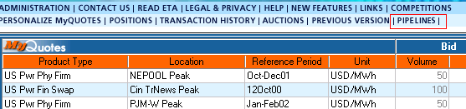

  - Legal Disclaimer Screen
- After clicking on the “Pipeline” button (see above), a new window will appear. This window will have a legal disclaimer informing the customers:
- That they are entering the Pipelines Area.
- That Enron may not be the principal behind some or all the transactions.
- That prices are not controlled by Enron personnel
- Customer needs to click on “Accept” button to continue (Only first time a user logs in). After the first log in, the disclaimer can be read again on the Homepage of the application.

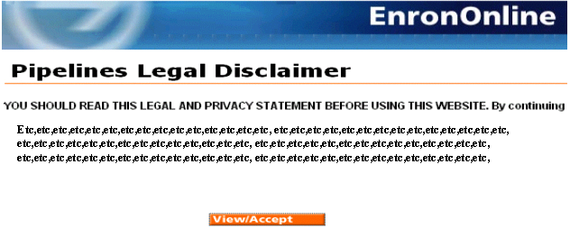

  - Contract Acceptance Screen
- Customers will then arrive at the Pipeline Trading Agreement Screen and they will need to click on “Accept” before continuing (Only first time users).
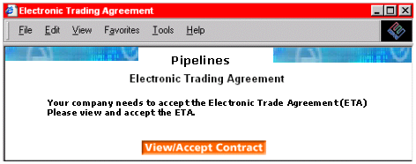

  - Pipelines Homepage
- The Pipelines Homepage will have a list of all the Pipelines available on the system (i.e. HPL, NNG, NGPL, TW, and others).
- Customers will be able to customize (Filter) by:
- Pipelines
- Pipelines Regions: East, Central, and West
- Contract Type (approx. 12)
- Receipt / Delivery Points
- Service Type (IT, FT, etc.)
- Tenors (one day, one week, >than a week, one month)
- Customers will also have the ability to click on a Pipeline Logo to go to the Pipeline’s Internet site (hyperlink). Each Pipeline will have its Logo by its side.
- Homepage will also have Ticker Items to display short news and info messages of common interest.
- Homepage will include brief explanatory text and possibly a standardized disclaimer.
- After filtering, clients will click on any pipeline or region they choose and they will be sent to the “Pipelines Quotes Screen”.

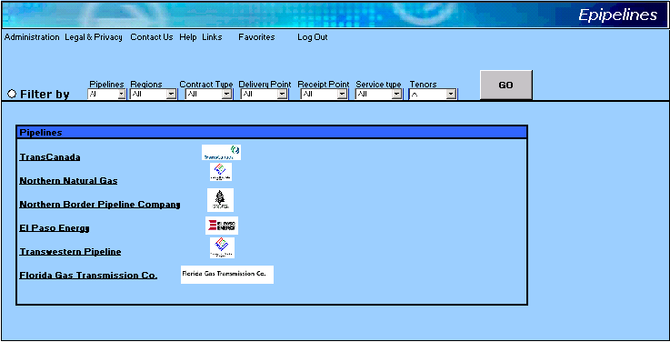

  - Pipelines Quote Screen
- The Quote Screen will have a main screen with a list of all the active products being offered by the pipelines that the customer chooses to see (according to the filters set on the Homepage).
- Products will be listed in the format shown on the screen mock-up below.
- If possible, the users should have the ability to sort the product list in descending or ascending order. To sort they will need to click on the attribute’s heading they want to sort by (i.e. Pipeline, Product, Delivery Point)
- By “Left-clicking” anywhere on a product (except on the offer price), a window with the Product Long Description, Contact Details, Volume Breakouts (see 3.2), GTC, and Rate Breakout (see 3.2) will appear.
- Below the main screen there will be a “Transaction” screen that will list all the transactions of the day.
- The Application will also allow customers to see Historicals (i.e. Transaction History). The Transaction History can be downloaded to excel. Transaction History would be accessed through the “Transaction History” link on the menu bar.
- The application will have a screen to monitor “Price Limit Orders”. The customer will be able to cancel such orders at any moment.
- To buy, a customer will click on the Offer (Rate). A “Submission” window will appear.
- The users should also be able to download the Request for Service forms from the menu bar (i.e. Download Forms). (need to confirm if this is necessary)
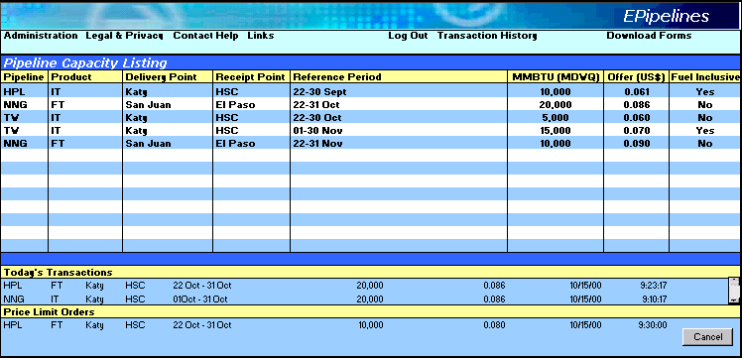

  - Submission Screen
- The submission screen will show the details of the product including Pipeline, Service, Transportation Path, Reference Period, Volume, and Rate.
- Then the customer will have the ability to either:
- Submit
- Change the Volume and/or Rate and then Submit. (Counter-offer)
- If a), the customer is done.
- If b), the customer will only be done if the “Pipeline” accepts the changes.
- Counter-offers will be active for one trading day. Then they will be automatically canceled by the system.

- The user will also have the ability to accept Partial Volumes.
- After a) or b) submission window closes and if transaction took place it will appear on the Transaction window below the main quotes screen.

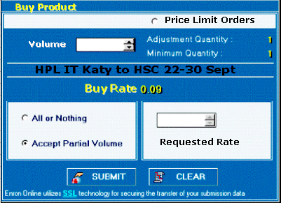

- CAPACITY “OWNER” INTERFACE

This is the application that the Capacity Owners (traders) will use to manage their products. It will be an Internet application accessed through a unique url.

  - Trader Log On
The trader will log on to the application through a new url. If it is the first time, he/she will need to register. (Need to define if registration is online or offline). Capacity Owners will require a unique Id and Password for this application.

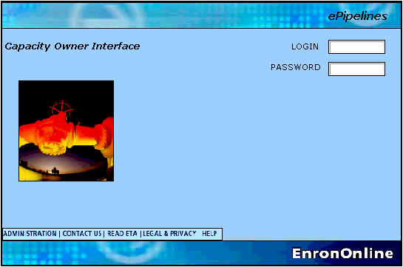

  - Homepage
- At the Capacity Owner Homepage the owners will have a list of all their capacity products (Valid or Persisted). The system should remember the last managed products for each user ID.
- Expired Products will not show on the screen.
- By selecting a product and clicking on “delete” the user will be able to delete products from the list.
- The Homepage will also have a button to go to the Product Control Interface (For more detail go to 6.0).
- The users will be able to select which products they want to manage. This will be done by selecting each or all the products.
- After selecting the products, the user will click on the “Manage Products” button to go to the “Capacity Transaction Screen”.
- The Homepage should be customized for each pipeline (i.e. have the pipeline Logo)

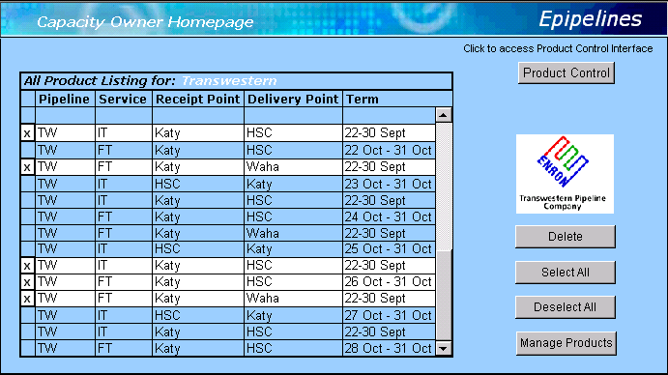

  - Capacity Transaction Screen
- The trader (owner) will manage his/her products by:
- Selecting the Product he/she wants to manage (left clicking on the product).
- Then, the users will input the volume and the rate components of their choice.
- For the rate, the trader will need to fill in the individual components that make up the rate: Reservation, Commodity, Surcharges, GRI, and Fuel percentage. The system will then sum the parts and come up with the rate.
- For the volume, the trader will need to fill a box that specifies the Maximum Daily Withdrawal Quantity details (MDWQ). The MDIQ and the MSQ will only show as relationships to the MDWQ on the Product Long Description.
- The Owner will be able to create stacks for each market (i.e. the trader will be able to mange his market depth)
- The trader will be able to update or to change the rate components and/or the volume at any given moment.
- The Application should update based on completed transactions (i.e. if an offer is lifted for less than the total volume specified, then the next offer will reflect the remaining volume).
- The application should allow for “Price Limit Orders” (PLO) management. PLOs will only be active for one trading-day. To accept a PLO the owner will only need to highlight the appropriate PLO and the click on the “Accept Price Limit Order” button.
- There is no need for cross-product-relationships or for functionality such as, linking, and advance price controls.
- The Application should have a window to keep track of all the transactions done during the day.
- The trader (owner) should be able to run historical transaction reports. The users should be able to search by date. If possible, the traders should be able to download them into excel.
- The application should have a “suspend all products” button.
- If possible there should be a Price breakdown interface in case of communication errors. In other words, if there is a loss of communication the user should be notified by a message on the screen (i.e. communication error). Also, if the system goes down all the user’s products should be automatically inactivated.

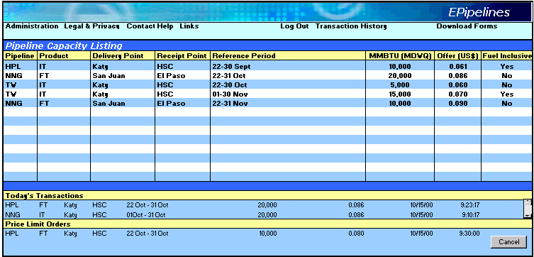

- PRODUCT CONTROL INTERFACE

This application will be used by the Pipeline’s Owners and by EnronOnline Product Control personnel. The application will have three modules.
- Product Creation Module: the interface to build and approve new products.
- Contracts and Credit Module: this application will be used to update each pipeline’s customer list for contract and credit limits.
- Product Long Description Manager: this module will be used to build the Long Descriptions for each Product Type.
The modules will be shown as three different tabs on the same window (similar to excel spreadsheets).

  - Product Controller Log On
- The log on will be through the same url as the one used for the Capacity Owner Interface.
- On the Homepage the users will need to click on the Product Control button. This button will only be visible if the user ID is set up with the appropriate access right.Instead off login to the Stack Manager they will login to the Product Control Interface.
- Unique user ID’s and passwords will be required. This is required because the user of this application may or may not be the actual Capacity Trader (Owner). If the user is not the trader then, the “All Product Listing” on the Capacity Owner Homepage will be empty.

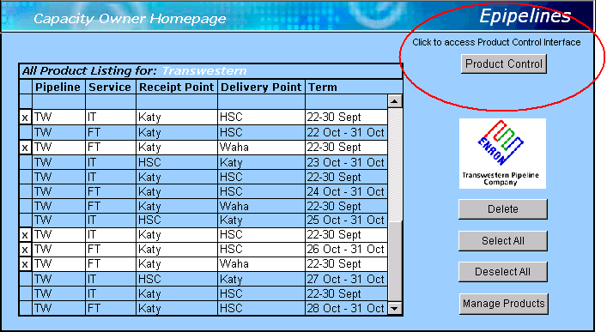

  - Product Control Module
- This Product Control Module will be located on the first Tab of the Window.
- This tool will allow for the creation of products with the correct attributes (for more on attributes see 3.2).
- The process will start with the trader (owner) creating the product by selecting the attributes (Pipeline, Service, Transport Path, Reference period, and Volume Relationships). The attributes will be displayed in drop down boxes.
- Only the attributes appropriate for the pipeline associated with the user ID will be displayed.
- The user will then have the choice to create, edit, or cancel his selections by right clicking on the product description on the Created Products screen.
- If the user chooses to create then he will have the opportunity to review the product in the lower half of the screen. He will also have the ability to see the long description of the product.
- The Long Description will be built in a standard format by the different attributes chosen (see 6.4).
- Once the product is created it will be displayed on the lower half of the screen. Here, the user (needs to be determined if its going to be the pipeline or PCG of EnronOnline) will have the ability to approve, reject, or delete the product.
- If product is approved it will be added to the database and therefore, will be active on the Capacity Owner Interface.
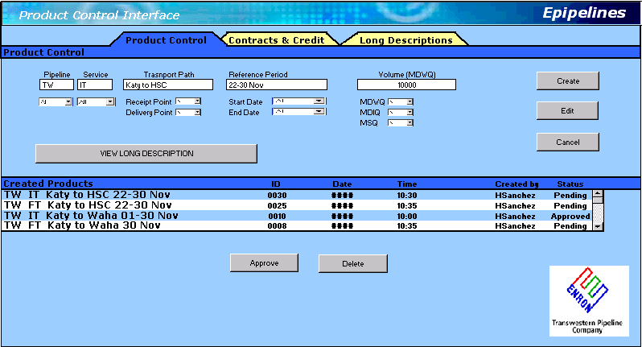

  - Contracts and Credit Module
- The Contracts (Contract Monitor) and Credit Module (Credit Monitor) will be located on the second tab of the Product Control Interface main window.
- The users will use this module to create and/or update the contract status of each of their clients and to check and update credit limits with each client.
- The screens should be customized (show the logo) for each pipeline.
- Contract Monitor:
- To update existing contracts status, the user will check the appropriate box in the Counterparty/Contract matrix and then click “on update”.
- To create or enter a new counterparty the user will input the counterparty name (Global Counterparty Database Approved Name and/or Duns number)information and then hit “Add”. The additions will then be added to the matrix.
- The users will also have the ability to upload html forms (i.e. requests for service). To do this the user will need to paste the text into the uploading box and then click “save”. The system will generate a number. This number can be used to search and edit the document.
- The system will be able to map the contracts against the products, and the pipelines and will not allow clients to trade on those products that they do not have a contract for.
- Credit Monitor:
- This module will be used to update or to monitor credit information for the pipeline’s clients.
- The user will only need to add the name of the counterparty and then assign a credit Headroom.
- To update a credit line, the user needs to 1) select the counterparty by right clicking on the name (or by running a search), 2) input the new headroom amount, and 3) click on “update”.
- The system will monitor the credit limits using Gross Transaction value against pipeline headroom limits. The credit matrix will use volume, tenor, and rate to determine limits.
- Input on the Contract Module (i.e. counterparties) will be available on this module.
- Headroom input will not be allowed if Duns number is not available.
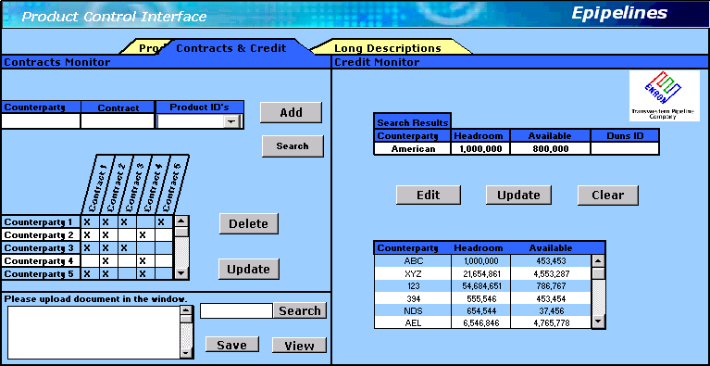

  - Product Long Description Manager
- The user will use this application to build and approve the product types long descriptions.
- Long description elements will be associated with each attribute. For example, for the Reference period we would have: “The term of the Transaction shall be from the Effective Date of <Start Date> to the Termination date of <Termination Date>.”
- After selecting each attribute, the user may choose to add, edit or cancel.
- If the user chooses to “add “, the system will save the long description segment.
- As each product is built by assembling the attributes, the long description will be automatically generated.
- To approve the long description segments, the user will need to select an attribute, review the description, and then click on “Approve”.
- The Product long description can be reviewed at the “Product Control” tab on the Product Control Interface (see 6.2).

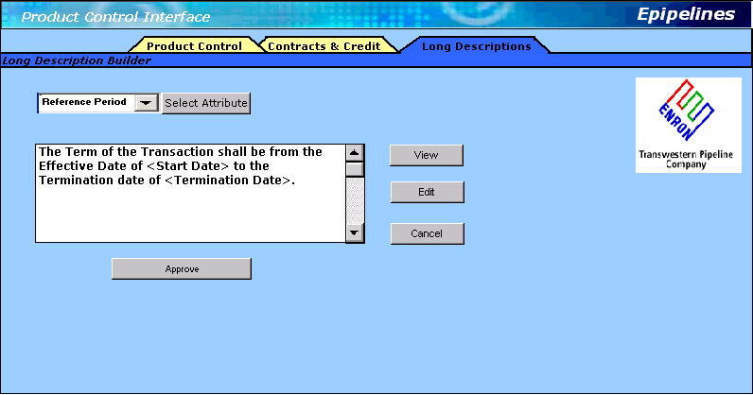

- PROFILES MANAGER

This application will be used by the Product Control Group to manage the Capacity Owners’ profiles (i.e. contract, credit, and products levels of access). This application is similar to EnronOnline’s Static Data Manager.

  - Profiles Manager Log On
- The log on to this application will be done through a unique url. The use of a separate application makes sense because only Product Control Group personnel will use it.
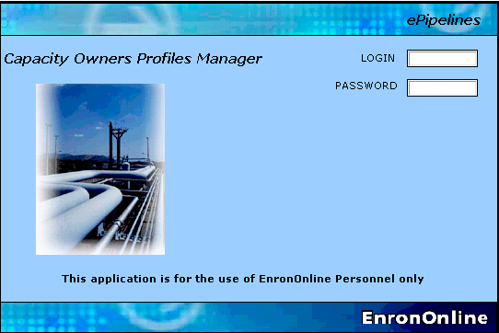

  - Profiles Manger Homepage
- Product Control (PCG) personnel will use this application to manage the Capacity Owners Profiles.
- The process will be as follows:
- Select Pipeline and click on “View Users”
- Select the User’s Login form the list and click on “View Profiles”. If user is new then input user’s login and click on “Add User”.
- Go to “User Profiles” control screen and update as necessary :
- Contract Access: None vs. Read vs. Manage
- Credit Access: None vs. Read vs. Manage
- Products Access: None vs. Read vs. Mange
- Select the period by which the access is granted (i.e. number of months)
- Select “Save” or “Cancel” to update the new settings.
- Repeat process for other users.
- The system will the automatically set the new profiles to the Capacity Owner and Product Control Interfaces.

