DRAFT III 10/13/00 (For discussion purposes only)

CAPACITY TRADING FUNCTIONAL SPECIFICATIONS

- OBJECTIVE
To create a multiparty Internet based trading system that will allow 3rd party pipelines to offer primary capacity to their customers.

- OVERVIEW
The following document describes the functional specifications of the new “Capacity Trading Tool”. The Internet based application will consist of three modules or interfaces:
- Customer Interface
This will be the main application. The customers will use this application to buy capacity from the Pipelines.
- Capacity Owner Interface
This is the application that the Capacity Owners (traders) will use to mange their products. It will be accessed through a unique url.
- Product Control Interface
This application will be used by the traders (owners) and by EnronOnline Product Control personnel. The application will be the interface to build and approve products. Also, this application will be used to update each pipeline customer list including contract and credit checks.

- FUNCTIONAL CHARACTERISTICS

  - General System Characteristics
- Multiparty System (i.e. Enron is not principal)
- Internet based Interfaces:
- Customer Interface
- Trader or Owner Interface
- Product Control Interface (need to define if it is going to be internet based)
- Handle up to 3000 products (Products are defined below)
- Display up to 150 different products on the screen or via filters.
- Automated counterparty credit checking. The credit checks will be done using Gross Transaction Value against Pipeline Headroom Limits
- Automated counterparty contract checking. The contract checking will be done against pipeline approved lists.
- EnronOnline “Look and Feel”
- “Heartbeat” monitoring for users. Interface by which customers get error messages when communication fails.
- Automatic Refreshing. The actual rates need to be determined (For ClickPaper: messages every 15 seconds; Markets every 3 minutes)

  - Products Characteristics
Each Capacity Product will be defined by the following attributes:
- Pipeline. Name of the Pipeline offering the Service
- Service. Approximately 12 different services (e.g. Interruptible Transportation, Firm Transportation).
- Transport Path. Defined by a Receipt and a Delivery point (e.g. Katy – HSC).
- Reference Periods (Start Date and End Date)
- Volume (MMBtu/d) or Maximum Daily Withdrawal Quantity (MDWQ). The volume will be further defined in the “Long Description” describing the relationship to the following terms:
- Maximum Daily Injection Quantity (MDIQ)
- Maximum Storage Quantity (MSQ)
- Rate ($ US). The Rate will be further defined by the following components (in the form of a “pop-up” box, or on the submission screen):
- Reservation charge
- Commodity charge
- Surcharges
- GRI
- Fuel charge
- Fuel. It can be inclusive or non-inclusive on the rate.
- Product Long Description. A detailed description of the Product (Similar to EnronOnline product long descriptions). The Product Long description will be put together by the system. In other words, the system will grab the information for each of the product attributes and will then combine them in a long description standard format. If an attribute is not defined then the description part for that attribute will not be displayed.

The following tables show an example of the attributes for each product.
Table A.

The Volume (MDWQ) is further defined by its relationship to:

The Rate is composed by:

- CUSTOMER INTERFACE

This will be the main application. Here, the customers will log on to buy capacity from the Pipelines. It will be an Internet based application that will be accessed through the current EnronOnline Quotes Page.

  - Customer Log On
- Users will login through EnronOnline using their existing ID and Password. If the user is not an existing customer then he or she will need to register (i.e. send a PA and a Registration form to the Product Control Group PCG) (subject to legal discussions). Customer will have the alternative of registering to EnronOnline and “Pipelines” or only to “Pipelines”.
- Once customer logs into EnronOnline, he will need to click on the “Pipelines” button on the Quotes Screen.
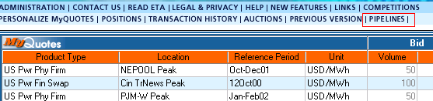

  - Legal Disclaimer Screen
- After clicking on the “Pipeline” button (see above), a new window will appear. This window will have a legal disclaimer informing the customers:
- That they are entering the Pipelines Area.
- That Enron may not be the principal behind some are all the transactions.
- That prices are not monitored by Enron personnel
- Customer needs to click on “Accept” button to continue (Only first time users).
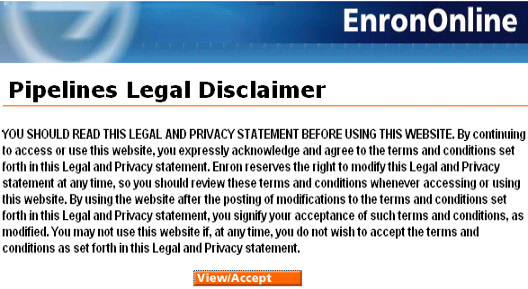

  - Contract Acceptance Screen
- Customers arrive at Electronic Trading Agreement Screen and need to click on “Accept” before continuing (Only first time users).
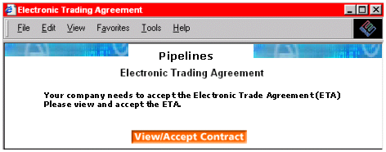

  - Pipelines Homepage
- The Pipelines Homepage will have a list of all the Pipelines available on the system (i.e. HPL, NNG, NGPL, TW, and others).
- Customers will be able to customize (Filter) by:
- Pipelines
- Pipelines Regions: East, Central, and West
- Contract Type (approx. 12)
- Receipt / Delivery Points
- Service Type (IT, FT, etc.)
- Tenors (one day, one week, >than a week, one month)
- Customers will also have the ability to click on a Pipeline Logo to go to the Pipeline’s Internet site (hyperlink). Each Pipeline will have its Logo by its side.
- Homepage will also have Ticker Items to display short news and info messages of common interest.
- Homepage will include brief explanatory text and possibly a standardized disclaimer.
- After filtering, clients will click on any pipeline or region they choose and they will be sent to the “Pipelines Quotes Screen”.
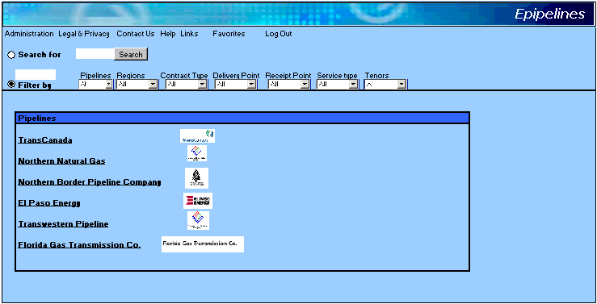

  - Pipelines Quote Screen
- The Quote Screen will have a main screen with a list of all the active products being offered by the pipelines that the customer chooses to see (according to the filters set on the Homepage).
- Products will be listed in the format shown on the screen mock-up below.
- If possible, the users should have the ability to sort the product list in descending or ascending order.
- By “Left-clicking” anywhere on a product (except on the offer), a window with the Product Long Description, Contact Details, Volume Breakouts (see 3.2), GTC, and Rate Breakout (see 3.2) will appear.
- Below the main screen there will be a “Transaction” screen that will list all the transactions of the day.
- The Screen will also have a series of buttons that allow customers to see Historicals (i.e. Transaction History). The Transaction History can be downloaded to excel.
- To buy, a customer will click on the Offer (Rate). A “Submission” window will appear.

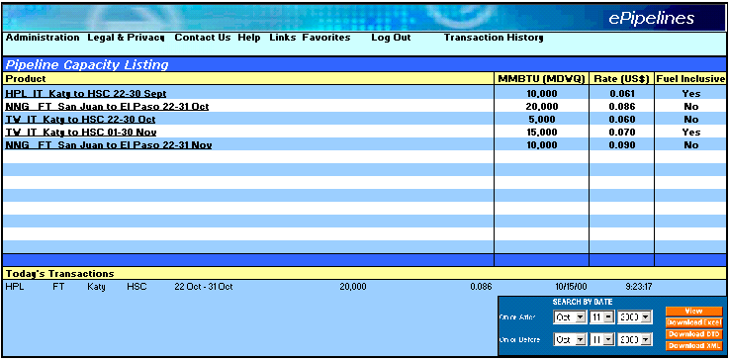

  - Submission Screen
- The submission screen will show the details of the product including Pipeline, Service, Transportation Path, Reference Period, Volume, and Rate.
- Then the customer will have the ability to either:
- Submit
- Change the Volume and/or Rate and then Submit. (Counter-offer)
- If a), the customer is done.
- If b), the customer will only be done if the “Pipeline” accepts the changes.
- Counter-offers will be active for one trading day. Then they will be automatically canceled by the system.
- The user will also have the ability to accept Partial Volumes.
- After a) or b) submission window closes and if transaction took place it will appear on the Transaction window below the main quotes screen.

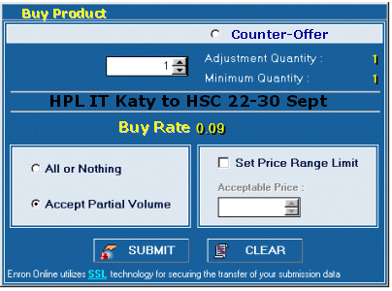

- CAPACITY “OWNER” INTERFACE

This is the application that the Capacity Owners (traders) will use to mange their products. It will be an Internet application accessed through a unique url.

  - Trader Log On
The trader will logon to the application through a new url. If it is his first time, he/she will need to register. (Need to define if registration is online or offline). Capacity Owners will require a unique Id and Password.

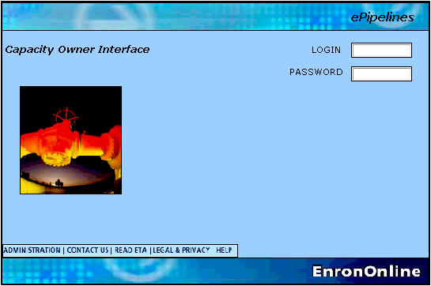

  - Homepage
- At the Capacity Owner Homepage the owner will have a list of all his/hers capacity products (Valid or Persisted).
- The Homepage will also have a button to go to the Product Control Interface (For more detail go to 6.0)
- The users will be able to select which products they want to manage. This will be done by filtering or by checking each product.
- After selecting the products, the user will click on the “Manage Products” button to go to the “Capacity Transaction Screen”.
- The Homepage should be customized for each pipeline (i.e. have the pipeline Logo)

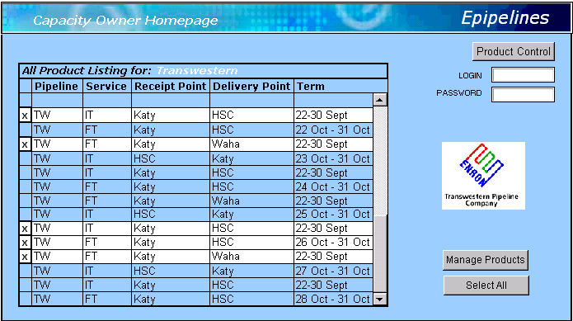

  - Capacity Transaction Screen
- The trader (owner) will manage his/her products by:
- Selecting the Product he/she wants to manage
- Then, selecting the volume and the rate components of his choice.
- For the rate, the trader will need to fill in the individual components that make up the rate: Reservation, Commodity, Surcharges, GRI, and Fuel percentage. The system will then sum the parts and come up with the rate.
- For the volume, the trader will need to fill a box that specifies the Maximum Daily Withdrawal Quantity details (MDWQ). The MDIQ and the MSQ will only show as relationships to the MDWQ on the Product Long Description.
- The Owner will be able to create stacks for each market (i.e. the trader will be able to mange his market depth)
- The trader will be able to update or to change the rate components and/or the volume at any given moment.
- The Application should update based on completed transactions. (i.e. if an offer is lifted for less than the total volume specified, then the next offer’s volume will reflect that change).
- The application should have an interface for Counter-offers management. Counter-offers will only be active for the one trading-day.
- There is no need for cross-product-relationships or for functionality such as, linking, and advance price controls.
- The Application should have a window to keep track of all the transactions done during the day.
- The trader (owner) should be able to run historical transaction reports. If possible download them into excel.
- The application should have a “suspend all products” button.
- If possible there should be a Price breakdown interface in case of communication errors.

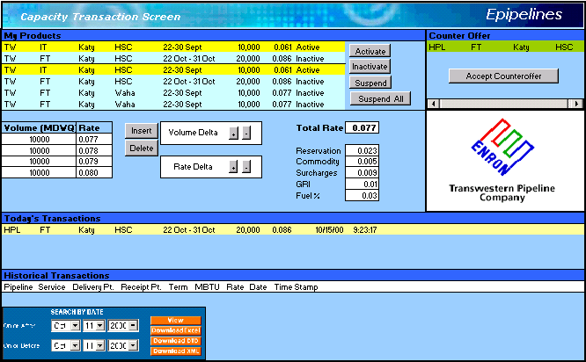

- PRODUCT CONTROL INTERFACE

This application will be used by the traders (owners) and by EnronOnline Product Control personnel. The application will have to modules.
- Product Creation Module: the interface to build and approve new products.
- Contracts and Credit Module: this application will be used to update each pipeline’s customer list for contract and credit checks.
The modules will be shown as two different tabs on the same window (similar to excel spreadsheets).

  - Trader (Owner) and Product Controller Log On
- The log on will be through the same url as the one used for the Capacity Owner Interface. Instead off login to the Stack Manager they will login to the Product Control Interface.
- Unique user ID’s and passwords will be required. This is required because the user of this application may or may not be the actual Capacity Trader (Owner). If the user is not the trader then, the “All Product Listing” on the Capacity Owner Homepage will be grayed-out.

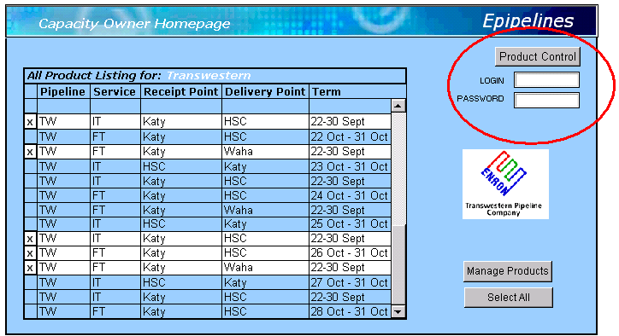

  - Product Creation Module
- This Product Creation Module will be located on the first Tab of the Window.
- This tool will allow for the creation of products with the correct attributes (for more on attributes see 3.2).
- The process will start with the trader (owner) creating the product by selecting the attributes (Pipeline, Service, Transport Path, Reference period, and Volume Relationships). The attributes will be displayed in drop down boxes.
- The user will then have the choice of create, edit, or cancel his selections.
- If the user chooses to create then he will have the opportunity to review the product in the lower half of the screen. He will also have the ability to see the long description of the product.
- The Long Description will be built in a standard format by the different attributes chosen.
- Once the product is created it will be displayed on the lower half of the screen. Here, the user (needs to be determined if its going to be the pipeline or PCG of EnronOnline) will have the ability to approve, reject, or delete the product.
- If product is approved it will be added to the database and therefore, will be active on the Capacity Owner Interface.

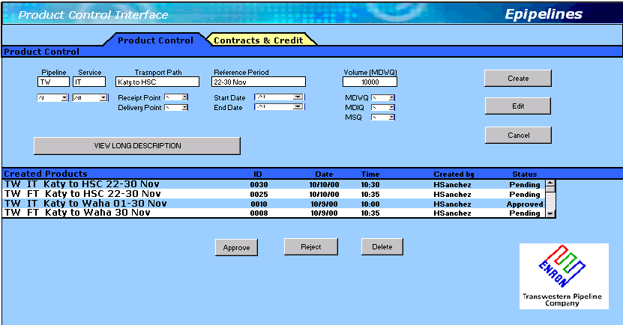

  - Contracts and Credit Module
- The Contracts (Contract Monitor) and Credit Module (Credit Monitor) will be located on the second tab of the Product Control Interface main window.
- The users will use this module to create and/or update the contract status of each of their clients and to check and update credit limits with each client.
- The screens should be customized (show the logo) for each pipeline.
- Contract Monitor: to update existing contracts, the user will check the appropriate box in the Counterparty/Contract matrix and then click on update. To create or enter a new counterparty or contract type the user will input the information and then hit update. The system will be able to map the contracts against the products and the pipelines thus, not allowing clients to trade on those products that they do not have a contract for.
- Credit Monitor: this module will be used to update or to monitor credit information for each pipeline’s clients. The user will only need to select the name of the counterparty and then monitor or assign a new credit Headroom. The system will monitor the credit limits using Gross Transaction value against pipeline headroom limits. The credit matrix will use volume, tenor, and rate to determine limits.
