CSC 2, second set of CSCs

Maximum allowable clusters=4, neglect less than 5 buses per cluster, result = 3 clusters

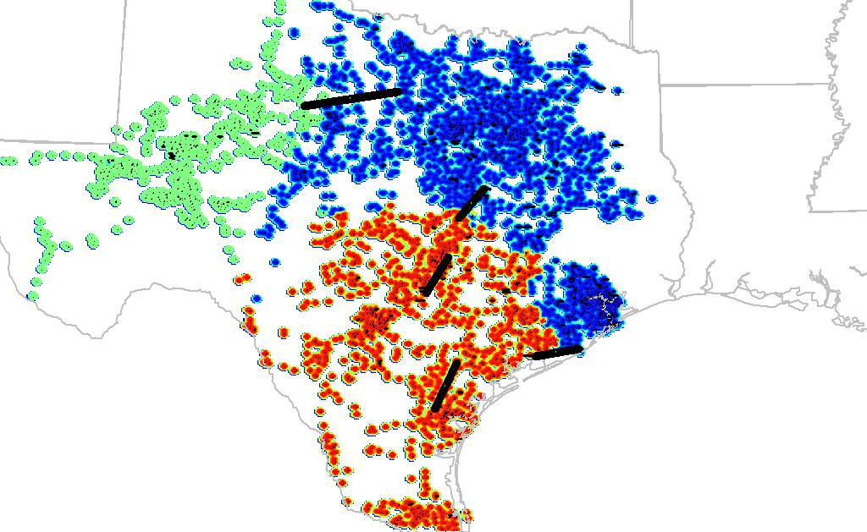

Maximum allowable clusters=5, neglect less than 5 buses per cluster, result = 4 clusters

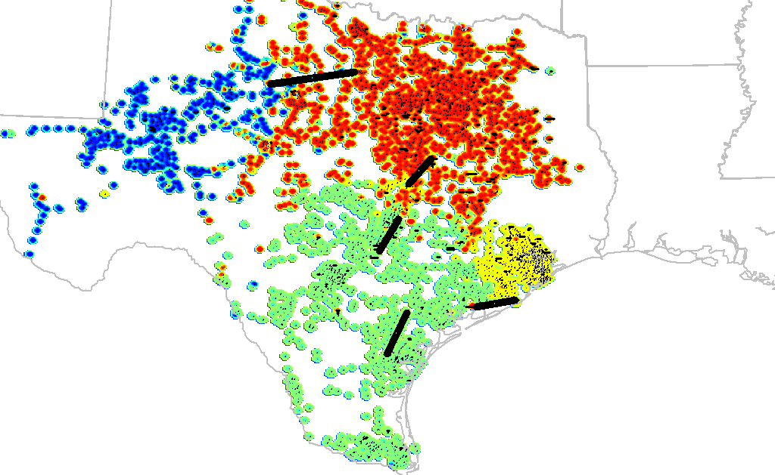

Maximum allowable clusters=6, neglect less than 5 buses per cluster, result = 5 clusters

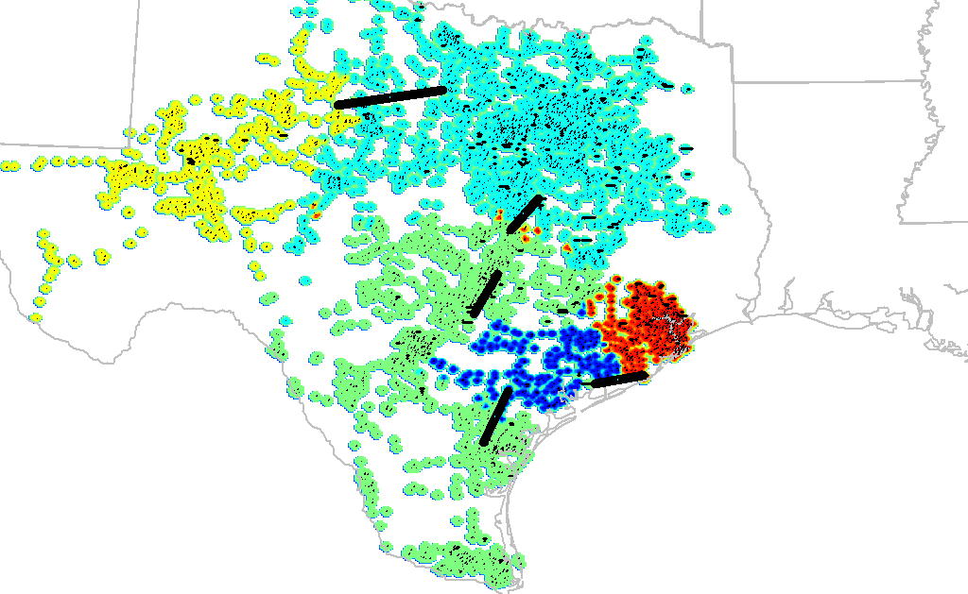

Maximum allowable clusters=7, neglect less than 5 buses per cluster, result = 6 clusters

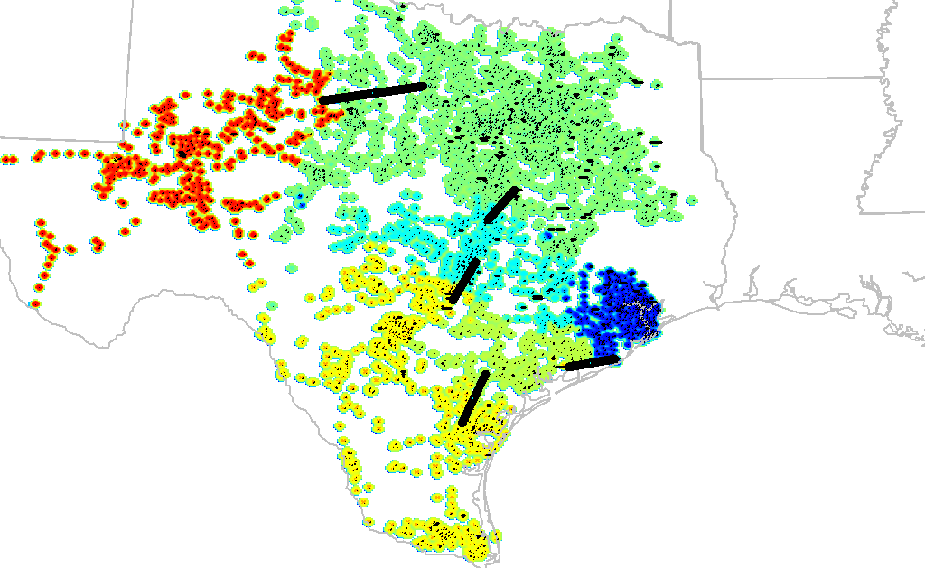

Maximum allowable clusters=8, neglect less than 5 buses per cluster, result = 6 clusters

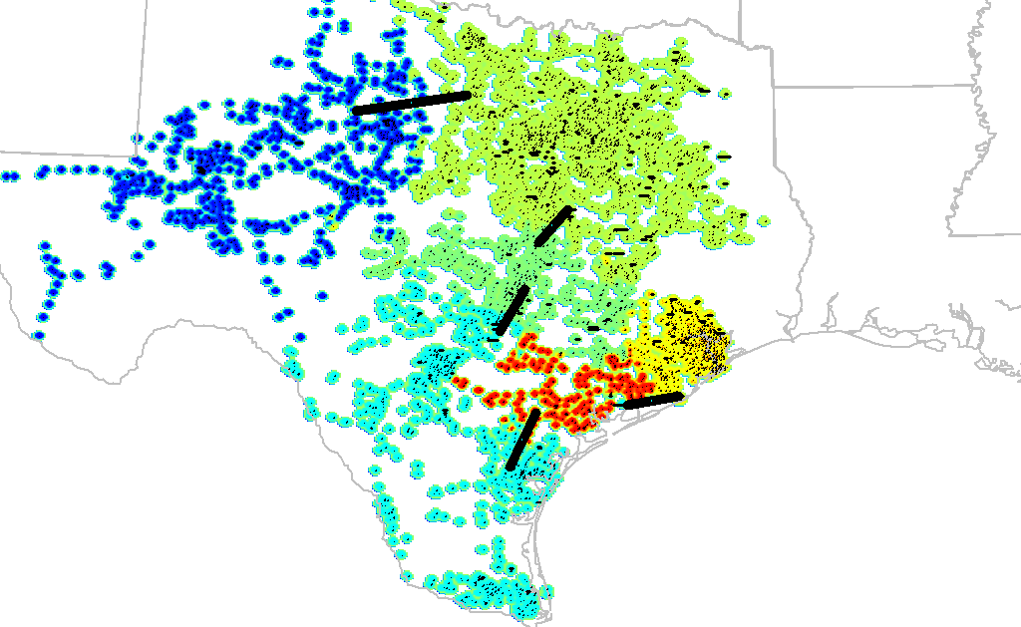

Maximum allowable clusters=9, neglect less than 5 buses per cluster, result = 7 clusters

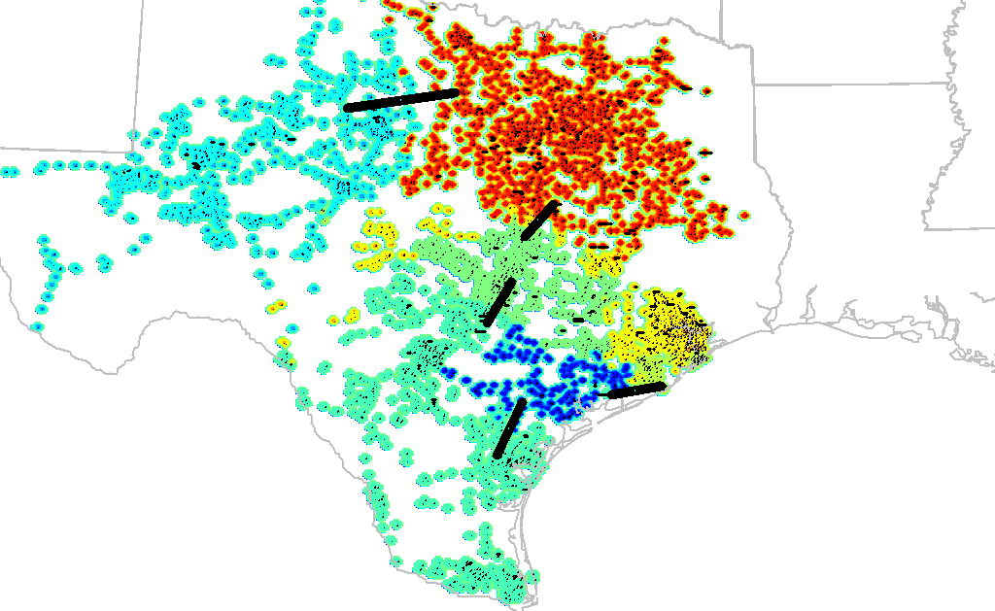

Maximum allowable clusters=10, neglect less than 5 buses per cluster, result = 8 clusters

