CSC 1

Maximum allowable clusters=3, neglect less than 5 buses per cluster, result = 3 clusters

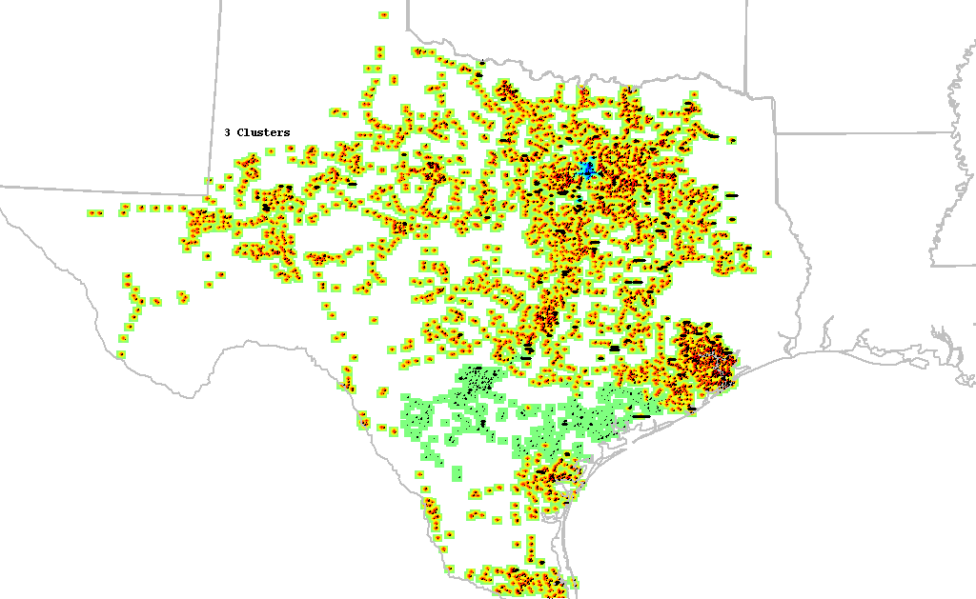

Maximum allowable clusters=5, neglect less than 5 buses per cluster, result = 3 clusters

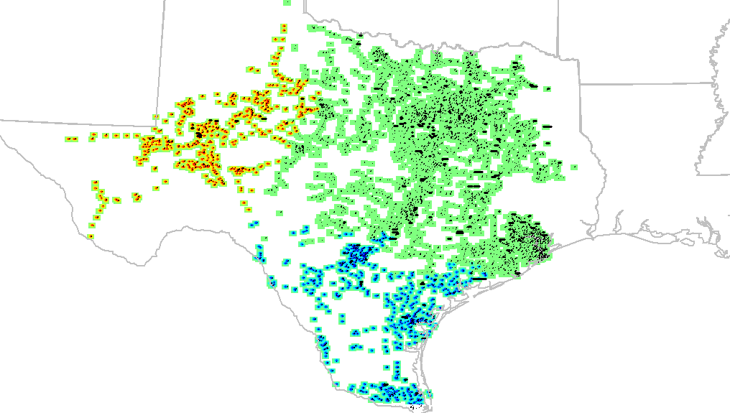

Maximum allowable clusters=6, neglect less than 5 buses per cluster, result = 4 clusters
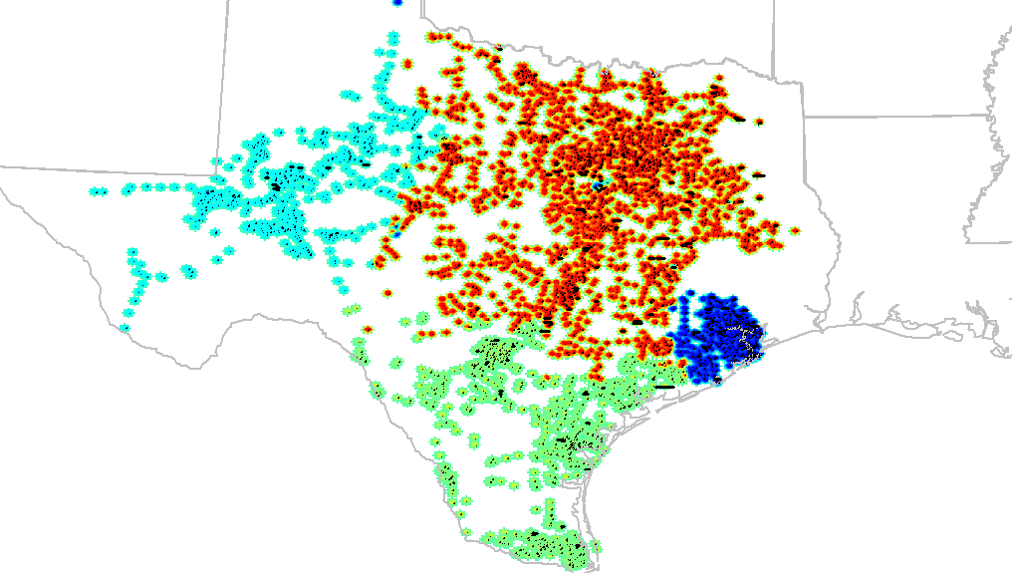

Maximum allowable clusters=7, neglect less than 5 buses per cluster, result = 6 clusters

