SOFTWARE CONFIGURATION INFORMATION FOR THE ISO's

SCHEDULING INFRASTRUCTURE (SI) Development System

Software
The ISO recommends using Netscape Communicator version 4.6.1 (not 4.6) or greater for a Web browser and Windows NT 4.0 with service pack 5 or greater for an operating system.

Basic Connectivity Check
To check connectivity to the SI Development server please attempt to either ping or telnet to the IP address as follows:

Open a Command Prompt window (Press the Start button, choose run, type cmd in the box, press the enter key) at the command prompt please enter
C:\> PING 166.49.51.33

OR

Open a telnet session (Press the Start button, choose run, type telnet and the ip address in the box, press the enter key)
telnet 166.49.51.33

If you are connected to the ISO's private network (ECN) and reaching the SI server you should receive a reply with the ping test or a login prompt with the telnet test.

If there is no response with both the ping and the telnet tests, please try entering the following URL in the Netscape location box https://166.49.51.33 and see if you reach an enterprise server screen.

You only need one of these three tests to succeed to verify that you are able to reach the server. However, if all three tests fail, first check with your local network personnel to ensure they are allowing the workstation access to this server through your firewall and please make sure they are allowing packets though on port 443 which is utilized in the https (secure socket layer) protocol.

If all of the above attempts fail, please call the MCI help desk at (800) 979-7211.

Create or Modify your Local Hosts file
- Close all other applications.
- Perform a file search on your local hard drive (press the Start button, select Find, select Files or Folders) for all Host files (enter host*.* in the Name & Location box.)
- There may be more than one host file on your system and you most likely will be required to posses administrator rights to modify this file.
- The most likely name will be C:\ WINNT\SYSTEM32\DRIVERS\ETC\hosts (hint: look for your most recently modified host file to determine which your system is using)
- Open this file with a text editor such as Wordpad or Notepad
- A pound sign (#) denotes a remark or comment, please put a pound sign in front of any address beginning with 166.49 (to avoid accidentally sending data to production) and then page down past the last pound sign and the file should look somewhat like this:
127.0.0.1 localhost (a special address that is used by your workstation to find itself without having to go out onto the network)

After the 127.0.0.1 line insert the following lines:
166.49.51.33 alhidev33.wepex.net alhidev33 devsi
- Save this file, overwriting the existing hosts file, and exit the text editor.

To verify that you have updated your host file correctly you may try to PING the alias as follows:
C:\> From the command prompt type in the following: PING devsi and press <Enter>

If your ping is successful, you will see the IP address (166.49.51.33) as the reply.
However, if you were unable to successfully PING during the basic connectivity check, this function may be disabled on your firewall and you will only be able to verify that the host file is correct by going directly to Netscape and following the instructions below. If your were able to PING during the basic connectivity test and your ping is not successful - please verify the changes made to your host file for errors or typos.

ISO SI MACHINE INFORMATION
MACHINE NAME= alhidev33.wepex.net
ALIAS = devsi

ENABLING YOUR BROWSER FOR FILE UPLOAD AND DOWNLOAD
EDIT NETSCAPE PROXIES

Open Netscape and select the Edit menu located at the top of the browser.
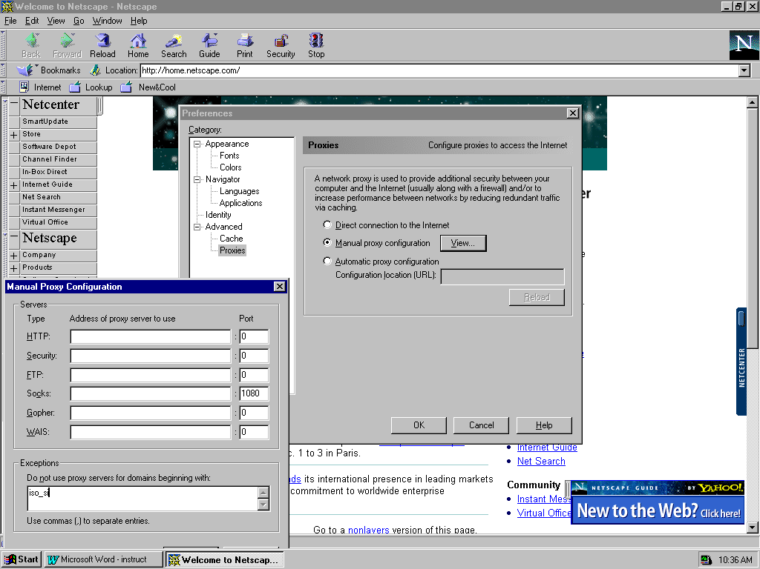
Choose Preferences. Choose Advanced. Choose Proxies as detailed below.

Select the Manual proxy configuration option and then press the view button.
The Manual Proxy Configuration screen will appear as shown above.
In the Exceptions area enter devsi. (you may already have iso_si in the exceptions box. If so, place a comma after it and add devsi as follows (iso_si, devsi)
Press OK to exit the Exceptions area.
Press OK to exit the Proxies area.

MODIFY CACHE OPTIONS

Open Netscape and select the Edit menu located at the top of the browser.
Choose Preferences. Choose Advanced. Choose Cache.

Clear Memory and disk caches by pressing the appropriate buttons entitled clear memory and clear disk.
Check the radial button indicating to look to the drive every time (default is once per session.)
Restart Netscape to ensure all changes are activated.

Accessing the SI Machine Through the Web Browser
Please enter https://devsi/iso in the Location box to enter the SI home page.
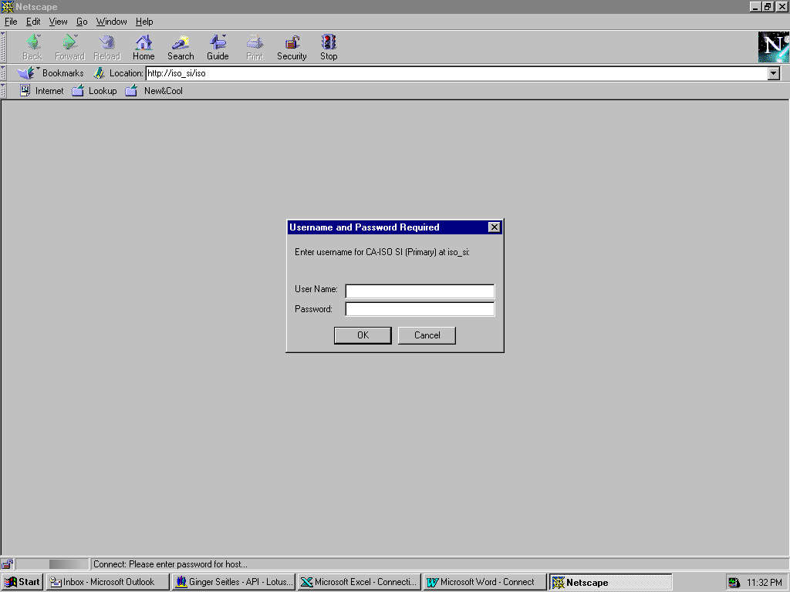
Please Enter your assigned user ID and password for access to the SI machine when prompted.
Choose Grant for the Object signing security prompt.
Welcome to the ISO!

