Well, the time has arrived
and
here is the information you've been waiting for!

We hope you are looking forward to this event – it's a great chance for us to catch our breath, see where we've been and where we're going and learn about what's been going on around us while we've had our heads down working! As always, we have great speakers lined up for this year's Conference. There are a few details that we want to pass on to you about this year's Conference:

Confirming that You Will Be There

First, please contact Linda Noske at (713) 853-6082 or Linda.J.Noske@enron.com by noon on Monday, October 2, 2000 if your plans to attend the Conference or your plans to participate in any of the activities have changed.

Getting There

The Conference will start at 1:00 p.m. on Thursday, October 5 (yes, that's 2000). Directions to the hotel are included at the end of this e-mail. Lunch will be served in The Woodlands Dining Room before the Conference begins, so bring your appetite! Check-in time to the hotel is after 3:00 p.m. on Thursday.

Being There

We are meeting in the Houston Room. Dress is casual. You may want to bring along a sweater or jacket just in case the conference room gets too cool.

Working There

We will circulate the phone numbers and fax numbers where we can be reached during the Conference. Pat Radford (713-853-9282) will be our contact person in the Houston office while we are at the Woodlands, in case you need to be reached. We will take a couple of breaks on each day for the obligatory voicemail and e-mail check. In addition to the faxes, phones and modems in our breakout room, there are modems in each room.

Hanging Out There

On Thursday evening, the Conference will conclude at approximately 5:00 p.m. Then, please join us for

BEER, BARBEQUE AND BOWLING!

After chowing down at the Woodlands, we'll hook it down to the AMF Diamond Lanes on FM1960 and let our true competitive spirits show. Of course, appropriate prizes will be awarded for inappropriate behavior. Mr. Lyons has, not surprisingly, agreed to act as emcee for the awards ceremony.

Feel free to bring your own bowling ball and shoes (Don’t forget your socks!!!).

Wishing You Had Gone Home Earlier the Night Before
There

The Conference will begin at 8:30 a.m. on Friday morning. You can have breakfast in the Woodlands Dining Room or grab a Danish just outside the Conference. Aspirin and Alka-Seltzer will be provided at a small markup. The Conference ends at approximately 12:00 p.m. with lunch and afternoon activities to follow.

- Golfers -- Tee times on The Pines Course are from 1:48 p.m. to 2:36 p.m. – box lunches will be provided to the golfers.

- Bikers -- should report to the The Bell Stand to request a bike.

- Exercise Nuts -- The use of the swimming pool and the Athletic Club are at your leisure.

- Tennis Players -- A tennis court has been reserved from 2:00 p.m. to 5:00 p.m. It is an indoor court, but if you wish to have an outdoor court, you can request it per our conference coordinator.

- Spa-sters -- For those of you that have already made your reservations for the spa, please note that once you have made your reservation, there will be a charge for "no shows".

Check-out time is at 12:00 noon on Friday.

Should you have any questions, please contact me at (713) 853-6082, Sheri Cromwell at (713) 853-3543 or Carolyn George (713) 853-3439.

DIRECTIONS:

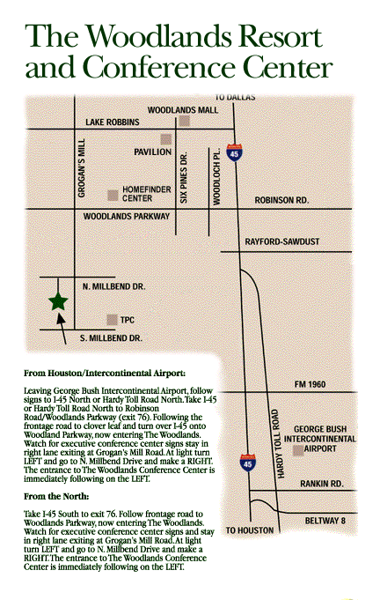

2301 N. Millbend Drive
The Woodlands, Texas 77380

281-367-1100

