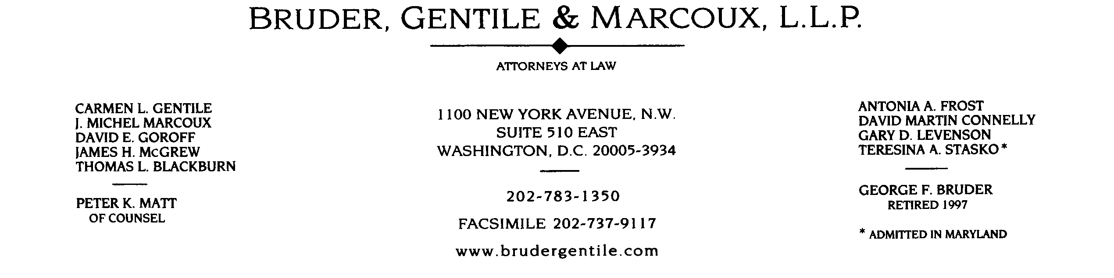

clgentile@brudergentile.com

August 14, 2001

Edward A. Berlin, Esquire
Swidler Berlin Shereff Friedman, LLP
3000 K Street, NW
Suite 300
Washington, DC 20007-5116

Jo Ann Scott, Esquire
Office of Administrative Litigation
Route AL-1, Room 51-05
Federal Energy Regulatory Commission
888 First Street, NE
Washington, DC 20426

RE: Diego Gas & Electric Company
Docket Nos. ER00-95-000, et al.

Dear Ed and Jo Ann:

This is a request to the California System Operator (“CAISO”) and the Commission Staff for their views on whether the Protective Order entered in this proceeding allows CalPX to distribute the CAISO’s Protected Materials to other Participants, and a request to either the CAISO or the Commission Staff, as appropriate, for the list of parties who have executed the non-disclosure agreement.

We ask the Staff and CAISO for their views as to whether the Protective Order enables CalPX to disseminate to other Participants who have executed non-disclosure agreements CAISO Protected Materials or information derived from CAISO Protected Materials. We have examined Section 4 and related provisions of the Protective Order which could arguably be construed as limiting CalPX’s authority to disseminate Protected Materials only to is own Reviewing Representatives and not to other Participants. If CalPX is so restricted, it would not be able to distribute its own data for the Day-Ahead and Day-of Markets nor the SC data to its market participants to the extent those data were derived from CAISO provided data. Such an interpretation would require modification of the Protective Order which has been entered in this proceeding.

CalPX needs to obtain from the CAISO or the Staff the list of parties by name and by company who have executed the Protective Agreement. We will then check that list to identify those CaLPX market participants who have not executed the non-disclosure agreement. CalPX cannot release any data to any party until this list is made available to it.

I suggest that the three of us get together by telephone tomorrow morning at 11:00 AM. I will place the call. If another time is more convenient, please let me know by e-mail with a copy to the other. I am circulating this letter to the electronic service list in the event any party has a comment regarding the distribution of the Protected Materials.

Very truly yours,

Carmen L. Gentile

Carmen L. Gentile
Counsel for California Power
Exchange Corporation

Cc: Attached List

/mnt/main-storage/datasets/enron-docs/doc/CLG0114.DOC

