Crude Oil Technical Commentary
Monday, 30 July 2001

Energy Desk

Tel. 1 212 859 1350

Near Term (Basis September): Neutral

Monday’s inside range bar on the daily chart keeps the board trapped between the 18-day and 40-day moving averages and in a neutral near-term stance from our perspective. We feel the ‘specs will look at today’s trading as being a small salvation considering they have a sizable net-short position and up against the 40-day MA resistance that could easily open the flood gates of technical buying on a strong close. This makes the $26.25 level basis September as a very important short-term level on the chart. Some chart watchers will see a small double top pattern (best seen on the intra-day chart) being confirmed with a trade below $26.25. In addition, this would put futures down through the 18-day MA support and into a more bearish near-term bias. In our view, today’s session was a very good save for the ‘fund-types’ shorts that have a very sizable bearish position on. We like the idea of trading the chart as a breakout trader…buying a move above $27.15 and selling a fall through $26.25. Leave the middle ground alone.

Long Term: Bearish
Our long-term technical model remains bearish. Major resistance is at $30.20 and $32.70, while support is $24.60 and $23.70.
Daily Numbers
Last Trade: | 26.60
Change: | -.42
9-Day Stoch: | K= 79.22 D= 68.54
18-Day MA: | 26.37
40-Day MA: | 27.02
Resistance 2nd: | 27.15
Resistance 1st: | 26.85
Support 1st: | 26.25
Support 2nd: | 25.87

Commitments of Traders Data (futures only) as of July 24, 2001
Trader Group | Long | Short | Net
Large Spec | 13,861 | 63,619 | -49,758
Commercial | 346,772 | 276,690 | 70,082
Small Trader | 32,034 | 52,358 | -20,324

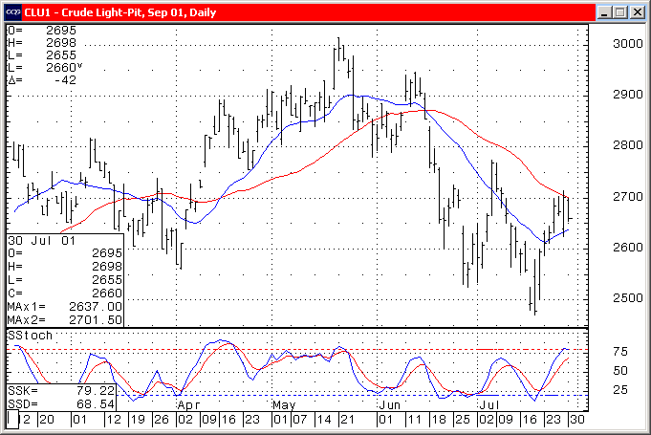

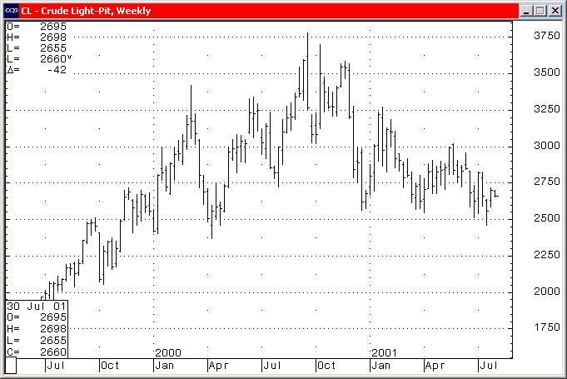
Charts courtesy of CQG, Inc.

