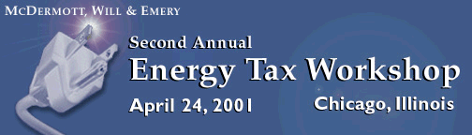
Tuesday, April 24, 2001
8:00 a.m. Introduction
8:15 a.m. Domestic Acquisitions
9:00 a.m. Restructuring Issues
10:15 a.m. Break
10:30 a.m. Stranded Asset Securitizations
11:15 a.m. Nuclear Decommissioning Issues
12:00 p.m. Luncheon
1:00 p.m. California Issues
1:30 p.m. Energy Trading and Hedging Activities
2:30 p.m. Break
2:45 p.m. Generation/Transmission Disposition Techniques
3:30 p.m. Synthetic Generation
4:00 p.m. Cross Border Acquisition
4:30 p.m. Close
Faculty
Thomas C. Borders | Special Guest Speakers:
David R. Hardy | John Gamino, TXU Corp.
Daniel J. Hartnett | Charles Mannix, Exelon Generation
Andrea S. Kramer
Richard M. Lipton
Laurie S. Marsh
William R. Pomierski
Martha Groves Pugh
Stephen E. Wells
Daniel N. Zucker
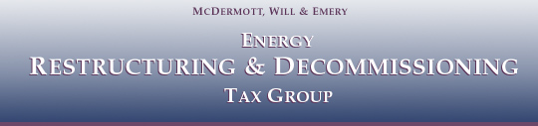
Wednesday, April 25, 2001
8:00 a.m. - 12:00 p.m.
- Introduction
- Discussion of Legislative Issues
Patricia Healy
Martha Groves Pugh, McDermott, Will & Emery
- Code Section 355(e)
David R. Hardy, McDermott, Will & Emery
Laurie S. Marsh, McDermott, Will & Emery
- Hedging Programs and Compliance Matters
Andrea S. Kramer, McDermott, Will & Emery
- Recent Developments on Nuclear Regulatory Commission Decommissioning Funding Assurance Policies Discussion
Robert S. Wood, Nuclear Regulatory Commission
- Consideration of Issues of Importance and Common Interest to Participants
- Closing Comments

