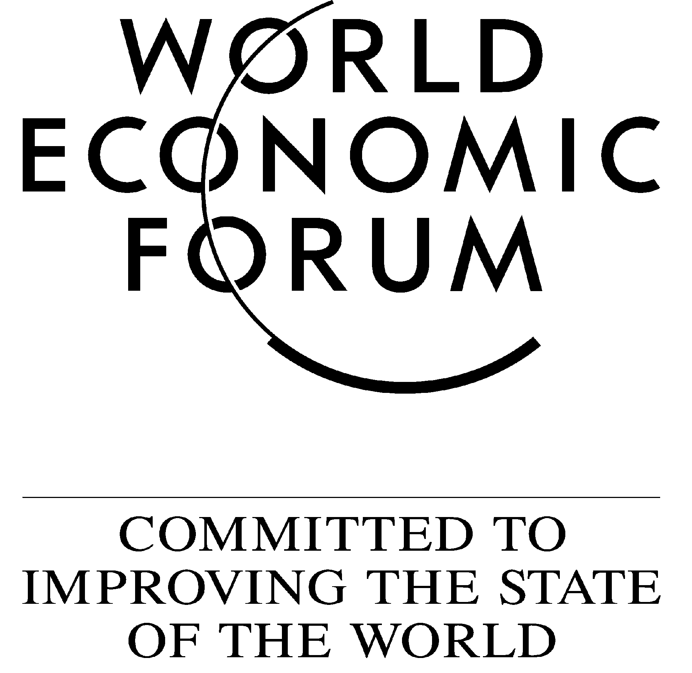

Mexico: Managing New Expectations and Old Challenges

MEXICO MEETING 2001 AT A GLANCE

Monday 26 February |  | Tuesday 27 February
07.30-08.30 |  | 07.45-08.50
Registration with Light Breakfast |  | Working Breakfast with Experts
08.30-09.00  Welcoming Remarks by Central Bank Governor Guillermo Ortiz |  | - Demography  - Environment  - Japan-Mexico Relations  - Social Corporate Responsibility
09.00-10.00 |  | 09.00-11.00
Financial Outlook Tequila Sunrise? |  | Workshops in Parallel
10.00-10.45  New Administration, New NAFTA? |  | - Entrepreneurship  Forum Initiatives (Digital Divide, Corporate Governance)
10.45-11.00 Contact Break |  | Technology (Biotechnology, Education & Technology)
11.00-11.45  Mexico and the EU: A Different Kind of  Transatlantic Alliance? |  | 11.00-11.15 Contact Break
11.15-12.15
The Social Agenda
11.45-12.30  Mexico: The Bridge of the Americas |  | 11.15-12.15  The Social Agenda
 |  | 12.15-12.30 Contact Break
12.30-12.45 Contact Break |  | 12.30-13.30
12.45-13.30 |  | E-Impact
Towards Good Governance and Efficient Institutions |  | 13.30-13.40
13.45-15.00 |  | Next Steps for Mexico
Industry Lunches in Parallel |  | Closing Remarks by the Rapporteur
- Automotive | - Infrastructure | 14.00-16.00
- Banking & Financial | - IT & Multimedia | Closing Lunch
Services  - Energy | - Tourism | Special Address by  President Vicente Fox

15.15-16.30

Competitiveness Brainstorming
Building/Debating Action Proposals

Industrial Policies

New Federal / State Relations?

Tax Reform
16.30-17.00 Contact Break

17.00-18.15

Towards a Competitive Mexico?

18.15-19.00

Cultural Identity & Globalization
20.30-23.00

Networking Dinner
Meet the Secretaries of the Fox Administration
27/11/2000

