PROJECT PROPOSAL
SECTION 1
Work Initiation Number: | 2139 | Purchase Order Number: | N/A
Request Title: | California ISO Audit #2
EESO Requestor: | Ken Lewchuck | Work Request Submission Date: | 7/23/2001
CSC Contact: | Marsha Campbell | Project Proposal Issue Date: | 8/2/01

Work Request Information

Description / Objectives of Work Request:

To comply with annual California Independent Services Operator (ISO) and Enron Corporate audit schedules and requirements, Enron Energy Services Operations, Inc. (EESO) has requested Computer Sciences Corporation’s (CSC) assistance. The following Work Request (WR) description and objectives have been updated from the initial WR per WR review meetings with the EESO Requestor, Ken Lewchuk.
EESO is requesting that CSC deliver the following for all EESO metered accounts for the days of 2/15/00, 6/11/00, 7/15/00, 8/7/00 and 12/27/00 from the MDMA application. The data reported will be from the “master tables” within MDMA, meaning the data is validated and settlement ready quality.

- Microsoft Excel data file for all interval accounts, column output format:
Report Day | Total Accounts | Estimated | Actual | % Estimated
2/15/00
6/11/00
7/15/00
8/7/00
12/27/00

Field Definitions

Total Accounts – Number of active accounts (meters) for the report day
Estimated – Number of active meters for which no usage was received for the report day

Actual – Total Accounts minus Estimated
% Estimated – Estimated divided by Total Accounts (rounded to nearest whole number)

- Microsoft Excel data file for all interval accounts, column output format:

Report Day | Total Accounts | Total Intervals | Estimated Intervals | Actual  Intervals | % Estimated  Intervals
2/15/00
6/11/00
7/15/00
8/7/00
12/27/00

Field Definitions

Total Accounts – Number of active accounts (meters) for the report day
Total Intervals – Extended total of Total Accounts multiplied by 96, which is the total number of expected daily interval KWh meter interval reads per account
Estimated Intervals – Number of expected Total Intervals for which no usage was received
Actual Intervals – Total Intervals minus Estimated Intervals
% Estimated Intervals – Estimated Intervals divided by Total Intervals
(rounded to nearest whole number)
Lastly, EESO is requesting that CSC deliver a complete audit trail for all meters (interval and monthly) from meter reads to the ISO report for all EESO metered accounts for the day of 12/27/00 from the MDMA application. The data reported will be from the “master tables” within MDMA, meaning the data is validated and settlement ready quality. CSC is to provide a Microsoft Excel spreadsheet with the daily meter read detail for the report day, and the corresponding settlement (SQMD) and ISO (ASCII) files.

The Microsoft Excel spreadsheet with the daily meter read detail column format:

Report Day | Account  Number | Read  Start | Read  End | Estimated  Or Actual | Usage  Amount | Load  Profile | Distribution Co  ID Number
12/27/00

Field Definitions

- Report Day – 12/27/2000 only
- Account Number – Meter identification number
- Read Start – Interval read start time in PST
- Read End – Interval read end time in PST
- Estimated / Actual – Estimated read or actual read indicator (column populated with E or A)
- Usage Amount – Meter read KWh quantity
- Load Profile – Load Zone ID alphanumeric indicator
- Distribution Co ID Number – UDC Duns Number

Since CSC does not have the SQMD file archived, it does not have to be provided. However, CSC is requested to re-create a SQMD file for the report day. This is to be done using the same Microsoft Excel spreadsheet column format as specified above for the daily meter read detail - excluding the Read Start and End time columns and including a Customer Name column. The SQMD report will be summarized at an account level. EESO may want to accept this proposal without the SQMD report; therefore CSC is to show the costs and hours for this portion of the project separately.
The ISO file is to be the actual MDEF file created for the requested report day converted to a text (ASCII) file format.

This is a one-time request. EESO is requesting that the information be returned by 8/7/2001.

CSC Response:
CSC submits this proposal as the final proposal and functional requirement acceptance document for the CA ISO Audit # 2 CES 2139 project. CSC will expedite delivery of the requested reports upon EESO’s acceptance of this proposal.
Requirements and report formats were developed and reviewed by CSC and EESO and are included in the “Description / Objectives of the Work Request” Section of this document. In summary, CSC will deliver the following reports as defined per those specifications:
Interval account % of estimated daily reads by report day
Interval account % of estimated intervals by report day
Daily meter read detail by report day
SQMD File (re-created) for 12/27/2000
ISO Text File for 12/27/2000
Following is a list of the major assumptions used to establish this project’s approach and cost estimate.
- Requirements have been defined and are sufficiently represented within this proposal.
- CSC will be able to e-mail, FTP, or place on a shared network location the requested reports.
- CSC will not report to EESO specific results of unit and reasonability tests.
- Development products and code will be valid for this request only. They do not have to be able to be leveraged in future requests.
- Delivery of the reports within seven business days of EESO proposal approval is acceptable to EESO.
- EESO will assist CSC with work prioritization to meet project plan and schedule objectives.

Invoicing:
Actual labor hours expended to provide this service shall be invoiced to EESO at the contract rate in effect at the time the service is provided and in accordance with the terms of Exhibit 15 (“Unit Prices and Minimum Volumes”) and Section 17 (“Invoicing and Payment”) of the Services Agreement. Estimated labor hours required to provide the service are provided at the current rates for budgetary purposes. All rates are subject to the annual inflation adjustment.
Any changes to the scope of either the applicable setup or ongoing services set forth in Section 3 of this Work Request are subject to the Work Initiation Process outlined under section 7 of the Services Agreement, and detailed in the Interface Procedures Manual.

Cancellation:
This service may be cancelled upon thirty (30) days prior written notice to the CSC Work Initiation Team. The service will remain in effect until the sooner of receipt of such cancellation notice or twelve months from the Purchase Order Authorization Date.

This data, furnished in connection with this Project Proposal, shall not be disclosed outside EESO and shall not be duplicated, used, or disclosed in whole or in part for any purpose other than to evaluate the Project Proposal. If EESO issues a Purchase Order to CSC as a result of or in connection with the submission of this data, EESO shall have the right to duplicate, use, or disclose the data to the extent permitted in the Purchase Order. This restriction does not limit EESO’s right to use information contained in this Project Proposal if it is obtained from another source without restriction.
SECTION 2

PRICE ESTIMATE
This Project Proposal Price Estimate is for additional services and is valid for ten (10) business days from the Issue Date.
SECTION 3

SCHEDULE
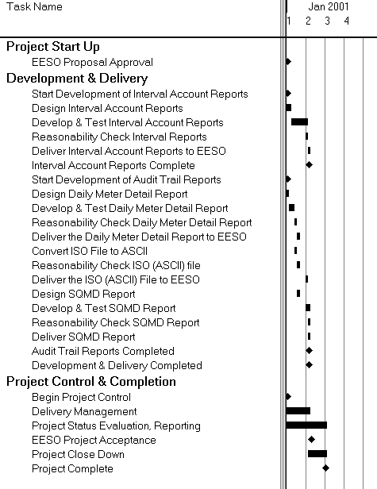
WEEKS

SECTION 4

PURCHASE ORDER
This Purchase Order is governed by and subject to the provisions of the Amended and Restated Services Agreement (“Services Agreement”) between the parties dated November 1, 2000. By this reference, the terms and conditions of the Services Agreement are incorporated into this Purchase Order. This Purchase Order additionally includes any specific terms and conditions contained in the Project Proposal.

The above Project Proposal is an offer for additional services and is valid for ten (10) business days from the Issue Date in Section 1 above. Execution of this Purchase Order is acceptance of the terms of the offer as set out in the Project Proposal.

EESO Authorization: | EESO Requester Name and Title | _____________________ | Date:
CSC Authorization: | CSC Request Owner Name and Title | _____________________ | Date:
 | Authorized Finance/Contract Contact Name and Title | ____________________ | Date:

Attachments:

