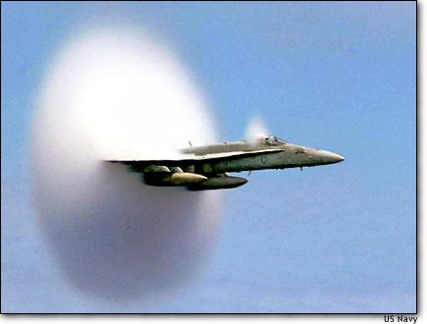
Pilot Ron Candiloro breaks through the sound barrier in an F/A-18 Homet fighter plane over the Pacific Ocean on July 7. The cloud ball effect is caused when forward sound waves squeeze moisture in the air.

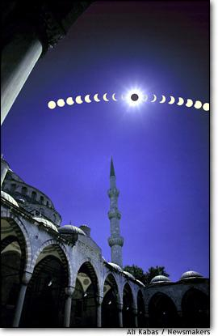
Black sun – the last solar eclipse of the millennium is seen in this multiple exposure photograph as it appeared from the famous Blue Mosque in Istanbul, Turkey, on Aug 11.

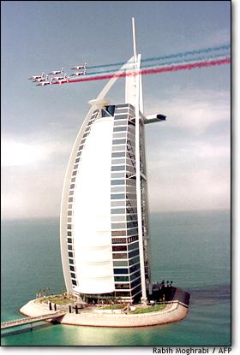
A room with a view – French jets fly over Dubai’s Burj Al-Arab, the world’s tallest sea-based hotel, on Nov 12 during preparations for the Dubai Air Show.

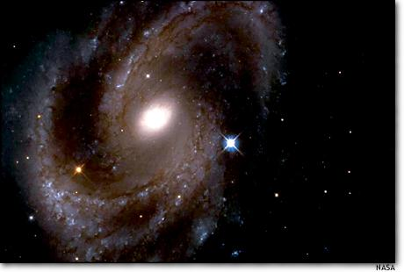
A NASA Hubble space telescope photo reveals the spiral galaxy NGC 4603, the most distant galaxy in which a special class of pulsating stars called Cepheid variables have been found.
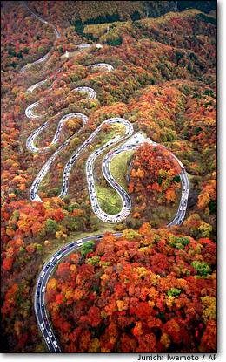
Falling for colour – hundreds of cars jam a road in Nikko, Japan on Nov 3, as drivers slow down to admire the colourfully tinted leaves of autumn.

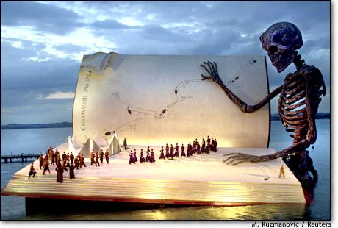
Singers perform on a giant stage on Lake Constance during a rehearsal of Giuseppe Verdi’s opera ‘Ein Maskenball’ on July 15. The design of the stage in the lake shows ‘Death’ reading the book of life.

