California’s Natural Gas Prices:
A Function of Supply and Demand

Natural gas prices in California, as throughout the country, have soared over the past year. Prices along the California border, however, have far exceeded prices elsewhere as illustrated below:

Basis Differentials Between Nymex and the California Border
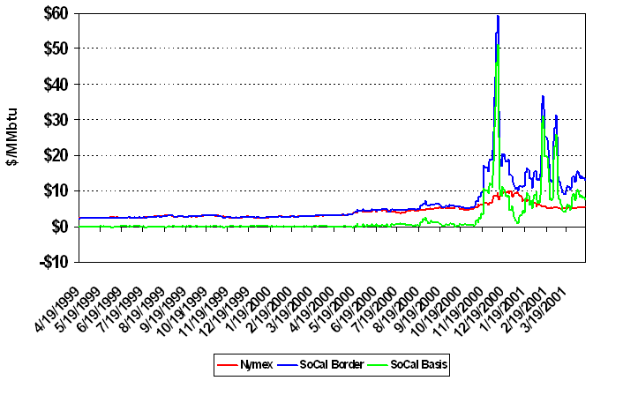
Natural gas prices are determined by a number of factors, both controllable and uncontrollable. Fundamentally, all of the major contributing factors impact demand, supply or both. Thus, prices in California’s gas markets, like its electricity markets, are a function of supply and demand. Each component of an effective response, therefore, must serve to either increase supply or decrease demand.

Factors Impacting Price

Factors That Have Increased Demand

The State’s demand for natural gas grew by approximately 4.2 percent per year since 1995 to 2,360 Bcf in 2000 (Energy and Environmental Analysis, Inc., Monthly Gas Update, April 2001). It is expected to continue to increase:

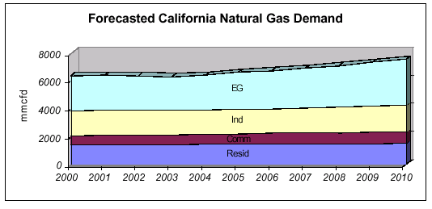
Source: CEC Staff Report, “California Natural Gas Analysis and Issues,” November 2000.

Increase in gas-fired generation
- The CAISO relies on natural gas and oil for more than 36 percent of its installed generation (NERC, 2001 Summer Special Assessment, 5/01).

- Demand has jumped as new gas-fired generators come on-line and existing generators work overtime. According to one analysis, gas demand last year for electricity generation sold to the grid was 700 Bcf, compared to a five-year average of 350 Bcf (Energy and Environmental Analysis, Inc., Monthly Gas Update, April 2001)*

- Environmental laws and an insufficient supply of emission credit allowances discourage non-gas fired generation.

- Low hydro supplies
  - Hydropower is used for approximately one-fourth of the state’s installed capacity.
  - Dryer than normal weather in the Pacific Northwest last year resulted in a decreased supply of hydroelectric capacity. As a result, electricity imports from the Pacific Northwest to California declined to 31 TWh from a five-year average of 46 TWh (Energy and Environmental Analysis, Inc., Monthly Gas Update, April 2001).
  - Hydroelectric generation in 2001 is expected to be at its lowest level since 1994 when it was at 75% of normal. (CERA Monthly Briefing, Western Energy, 3/26/01)
  - Water and stream levels are at their lowest in the Pacific Northwest in 50 years (NERC, 2001 Summer Special Assessment, 5/01).

Weather
- Cold weather last winter contributed to the depletion of natural gas storage levels, and forced generators to work overtime.

Factors Limiting Supply

Low Storage Levels
- Entering the 2000-2001 winter season, California had 152 Bcf of natural gas in storage, 34 Bcf below the 1995-1999 average (EIA, U.S. Gas Markets: Recent Trends and Prospects for the Future, 5/01). This mirrored the rest of the country where storage stocks were at the lowest level in 20 years. Only recently have injections considerably strengthened. Still, the EIA estimates that stocks in the West region at the beginning of May were approximately 19 percent less than the six-year average.

- The major withdrawals that followed a disruption in supply from the August 2000 rupture in the El Paso pipeline further contributed to the depletion of supply.

Slow Growth of Productive Capacity
- The growth in gas productive capacity in California relative to 1999 was only 0.01 Bcf/d in 2000 and is predicted to be 0.02 Bcf/d in 2001 and 0.05 Bcf/d in 2002 (CERA, Western Energy Roundtable presentation, 4/26/01, San Francisco).

Dependence on Imports
- California imports about 85 percent of the natural gas used in the state, according to the CEC.

Insufficient infrastructure (pipeline capacity)
- Until recently, construction of new pipelines into the state has been strongly opposed and California companies have failed to invest in pipeline capacity within the state.

- California has failed to provide the incentives to invest in in-state transportation infrastructure.
  - There is 1 Bcf/d of interstate pipeline capacity to SoCal Gas’ Wheeler Ridge Complex, but only 680 MMcf/d of firm, intrastate take-away capacity.
  - At SoCal Gas Topock facilities, El Paso and Transwestern can deliver approximately 850 MMcf/d, but there is only 540 MMcf/d of firm, intrastate take-away capacity.

- The last major interstate capacity additions were placed in service in 1993.

- In April, the California Energy Commission (CEC) predicted that if all proposed power plants are approved and constructed, 3 Bcf/d of new capacity, more than the system can handle would be needed. Even if only those plants already approved were constructed, “major expansions” would be required.

Proposed California Interstate Pipeline Expansions
Kern River | - 135 MMcfd by 7/1/01  - 2001; 900 MMcfd expansion for  operation in 2003.
PG&E – GTN Expansion | - 200 MMcfd partially available this winter,  the rest by summer 2002  - 1,000 MMcfd expansion expected within  the next 10 yrs.
Questar Southern Trails Pipeline | - By spring 2002 - 90 MMcfd to CA border  and 126 MMcfd to LA Basin
El Paso Natural Gas Company | - Plains All American Pipeline  - By late August, 230 MMcfd added  capacity from conversion of crude oil  pipeline; capacity could be increased to  500 MMcfd
Transwestern Pipeline Company | - Holding open season for 150 MMcfd.  Operational in 6/02.
North Baja Pipeline | - 500 MMcfd in capacity  - Operational by 9/02.  - Will require El Paso and possibly  Transwestern expansion.
Source: “Pipelines and Power Generation,” presentation by Scott Tomashefsky,
CEC at CPUC Natural Gas Infrastructure Workshop, 4/17/01.

Other

Flawed Regulation
- Surplus capacity and low gas prices in the early 1990s encouraged regulators to establish rate making schemes that gave the utilities financial incentives to rely upon the spot market instead of engaging in long-term contracts.

- Regulatory risk related to the California Public Utility Commission’ s (CPUC) reluctance to allow financial hedging and review of long-term contracts provided additional incentives for the utilities to stay short gas.

Solution

An effective solution to high natural gas prices in California will include components that address both supply and demand. Specifically, a comprehensive package of reforms should be implemented that:

- Gives all California consumers and businesses real Direct Access to gas suppliers;

- Moves to create a single, statewide, competitive market for intrastate transportation and storage services; and

- Provides incentives and streamlined approval for investment in intrastate gas infrastructure.

* Source: EIA for data through 1997, EEA estimates thereafter. Does not include gas demand from non-utility units constructed prior to 1998.

