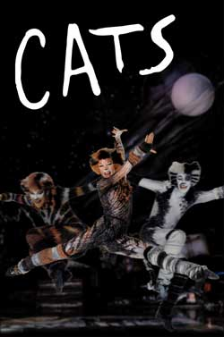
THE ENRON TRAVEL CLUB PRESENTS

“CATS”

THE MOST FAMOUS MUSICAL OF ALL IS BACK!!

The original production of CATS opened at the New London Theatre, in the West End in 1981. Eight years later, it celebrated both its birthday and another important milestone. It had become the longest running musical in the history of the British theatre. It is also one of the most successful musicals the world has ever seen and has played to packed houses around the world.

See it on its first national tour following its recent record-breaking Broadway run. All the wonder and spectacle of this legendary production, based on 14 poems of T.S. Eliot’s “Old Possum’s Book of Practical Cats”, is live on stage in this Andrew Lloyd Webber masterpiece.

There is no better way to introduce your family to the wonders of live theater than with the magic, the mystery, the memory of CATS.

Show time:
Date: Friday, December 28, 2001
Time: 7:30 PM
Place: Jones Hall
Price: $38.00 per ticket for ETC Members
$47.00 non-members
Seatings: Orchestra, Grand Tier, Boxes
Co-ordinator: Margaret Doucette
X5-7892 EB3855-A

