Enron Emissions Services

Business Plan

And

Market Guide

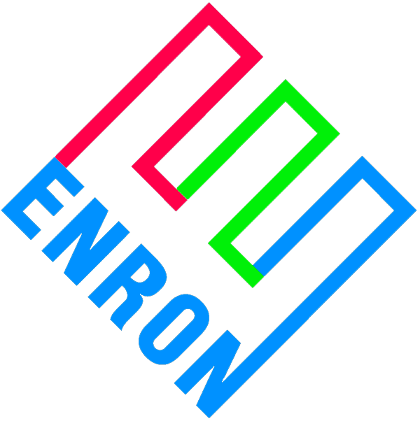
2002

Executive Summary

Business Analysis

The Enron Emissions desk came to fruition in 1994. The business traded SO2 allowances and dabbled in various ERC markets. It was not until recently that Enron began looking to expand this group from a book to a business. To this end we’ve developed a business plan for marketing the core skills developed by Enron the previous seven years. The first step in developing the business lies in developing a centralized risk management desk and emissions clearing house for Enron. Our next step is to liquidate a portion of our SO2 book to generate cash. The cash will be used to expand our expertise in market making to new markets such as regional ERC markets, the NOx SIP Call, and regional cap and trade programs. The EGM arrangement with Barclay’s bank may also be a viable option for holding credits and allowances. Enron assets and technologies such as NOx Tech should also help establish low cost positions in these markets. Next we will provide our services to third parties in outsourcing arrangements that maximize on our expertise.

Market Analysis

Title IV of the 1990 Clean Air Act and New Source Review created markets for emissions allowance trading on both a national and regional level. Enron was a key driver in the market development of the SO2 trading program and continues to be a leader in this as well as other emissions trading markets. Enron is now a major market participant in most US emission markets. The major markets are the SO2 acid rain program, NOx SIP Call, OTR NOx, HGA NOx Cap and Trade, and various ERC and DERC markets. Enron is also becoming increasingly active in a number of smaller markets such as the ZEV market and emerging global carbon markets. Markets such as carbon and mobile emissions will provide significant growth opportunities but they are at best a few years out from bearing significant earnings opportunities.

Need

Enron’s myriad businesses are virtually all touched by air quality issues. This includes coal trading, power trading, asset development, pulp and paper, EES and steel. An outline of the emissions synergies follows but it is important to realize there is no centralized emissions strategy among the different businesses. By operating without a central risk management desk and an emissions clearing house Enron is running the risk of competing against itself, exposing the company to excessive risk and legal liabilities, and missing out on opportunities. A key initiative for the emissions desk will be to develop as the emissions clearing house and risk management group for all Enron emissions related issues. The desk’s expertise will help enhance opportunities (as we have regular interaction with all of the major brokers as well as a significant number of political and industrial contacts) and mitigate risk throughout Enron.

Competition

The naturals are the largest customers in the emission markets, though a few players such as Mirant, APS, and PG&E do some speculative trading. These few could be viewed as competition in the national programs but they are also partners in a significant number of Enron’s transactions. In the ERC and DERC markets, naturals are the main participants. Some entities will speculate but there is almost always an asset to back the position.

Opportunity

The US emissions trading markets generate approximately $4 billion in annual revenues. The SO2 allowance market, of which Enron trades in approximately 12% of all transactions, makes up approximately 50% of the US emissions market. We have taken significant positions in the SO2 market and have developed a sizable book. The liquidation of this book can provide working capital for higher return projects such as the ERC and DERC markets. ERCs and DERCs make up the majority of the rest of the emissions markets and will be a major focus as the lack of price transparency can lead to high margin, high revenue deals. OTR NOx is the remaining large emissions’ market. In addition to the current markets, there are several new markets in either beginning or developmental stages. These markets include the NOx SIP Call, HGA Cap and Trade Program and various greenhouse programs. These markets, though varying in time frame until fruition, will provide Enron with future growth opportunities.

Summation

Enron is uniquely positioned to gain significant market share in the global emissions business. As one of the first players in the SO2 market we have developed extensive knowledge in emissions risk management, current and proposed regulatory rules, and market pressure points. The following sections will provide emissions market history, key statistics, major players and their positions (when available), transaction types and the strategy of Enron Emissions Services for each particular market.

SO2 National Program

The Market

The U.S. Environmental Protection Agency’s (EPA) Acid Rain Program is well established, with a defined and homogenous tradable instrument - the SO2 emission allowance. The Acid Rain Program falls under Title IV of the 1990 Clean Air Act Amendments and was established to achieve significant reductions in the emissions of sulfur dioxide (SO2) and nitrogen oxide (NOx), the primary causes of acid rain. The regulations state that emissions of SO2 in the U.S. must be reduced by 10 million tons below the 1980 emission levels to get to the permanent cap of 8.95 million allowances to the affected utilities. Essentially, every major fossil fuel-burning electric production facility in the United States is affected under Title IV. The program affects over 2000 utility units and has a predicted supply/demand scenario of:

Market Statistics

SO2 Overall System
 | Bank | Net for Year | Ending Position
2001 | 9,905,472 | (2,148,419) | 7,757,053
2002 | 7,757,053 | (2,123,678) | 5,633,375
2003 | 5,633,375 | (2,139,523) | 3,493,852
2004 | 3,493,852 | (2,167,976) | 1,325,876
2005 | 1,325,876 | (2,204,553) | (878,677)
2006 | - | (2,273,278) | (2,273,278)
2007 | - | (2,145,971) | (2,145,971)
2008 | - | (2,153,776) | (2,153,776)
2009 | - | (2,211,119) | (2,211,119)
2010 | - | (2,679,156) | (2,679,156)

Top 10 Short | Net Position
Southern Company | (2,830,396)
Cinergy Corp. | (2,429,429)
American Electric Power Co., Inc. | (2,387,203)
Tennessee Valley Authority | (2,078,722)
Progress Energy, Inc. | (1,439,098)
Dominion Resources, Inc. | (1,256,262)
Allegheny Energy, Inc. | (1,012,317)
Entergy Corp. | (790,290)
Constellation Energy Group, Inc. | (694,422)
NRG Energy, Inc. | (614,882)

Top 10 Long | Net Position
Xcel Energy, Inc. | 668,253
Ameren Corp. | 630,735
Oglethorpe Power Corp. | 596,719
Exelon Corp. | 545,413
Consolidated Edison, Inc. | 361,408
Dynegy, Inc. | 296,112
IDACORP, Inc. | 290,070
Public Service Enterprise Group, Inc. | 284,820
Associated Electric Coop, Inc. | 277,202
CMS Energy Corp. | 273,646

Trades

- Typical OTC daily volume from 25,000 – 50,000 tons
- 45 million tons transferred from 4/97 to 12/00 worth about $7 billion
- Enron is a partner in approximately 12% of all SO2 transactions
- Most actively traded emission allowance or credit

Transaction Types

- Immediate Settlement Transactions
- Forward Transactions
- Cross-commodity or Inter-pollutant Swaps
- Vintage Swaps
- Option Transactions
- Stream Transactions

Strategy

Enron has a large portfolio of SO2 allowances and forward sales. In the third quarter of 2002 Enron moved nearly 700,000 of these into an off balance sheet account with Barclay’s. This transaction generated positive cash flow and provided optimal carry rates. The desk is examining the feasibility of liquidating large portion of the SO2 book. This will generate cash, which will be applied to more profitable entities such as ERCs. John, expand

Historically Enron has relied on brokers and word of mouth to market emissions products. This is a strategy that will continue to be employed, albeit with an enhanced and slightly different approach. We will not change our use of brokers. The brokerage fees are extremely minimal, typically $.15/allowance. For a $500,000 revenue deal, $200 on 2,500 allowances, which works out to be $375 or .075% brokerage fee. Enron has successfully instituted a middle marketing effort in 2001. The effort has been directed at establishing Enron as the first Call for utilities looking to trade emissions. The key change in our middle marketing will be an increased reliance on our coal middle marketing staff.

Beginning in August, emissions marketing has been attending and presenting at one coal-marketing meeting per month. The initial presentation included a market assessment and background on both NOx SIP Call and SO2, potential deal structures, top five utility allowance positions per marketer, and current emissions status per utility. The lengthy presentation was then broken down into a marketers index with information on rules, regulations and information specific to each marketer’s clients. Each month, coal marketers receive updated information packets. These are complete with position shifts, recent transaction updates, regulatory and rule changes, etc. By educating our marketers and making SO2 allowance marketing a priority, Enron will be able to save money and maximize on opportunities. This will also expand the SO2 marketing presence by a factor of six and provide the coal and emissions group the following benefits:

- Increase economies of scale
- Utilize long standing relationships to gain first mover advantage on allowance transactions
- Increase market presence at most major utilities
- Potential to increase coal deals through creative use of allowances
- Increase time on higher return projects for emissions team

The emissions team will focus on high value projects in SO2. Examples of these products include synthetic low sulfur coals, derivative products, and swaps involving allowances, credits, and coal.

OTR NOx

The Market
Ozone Transport Region (OTR) NOx Emission Allowances were created under regulations implemented by a coalition of northeastern state air regulators called the Ozone Transport Commission (OTC). The OTC‘s 1994 Memorandum of Understanding (MOU) controls interstate transfer of Ozone pollution in the 11 northeastern states and the District of Columbia. Although 11 states signed the MOU, there are currently only 9 states that are actually participating in the trading program. These states are CT, DE, MA, MD, NH, NJ, NY, PA, and RI. The commission established a budget or “cap” of summertime (May 1 - September 30) NOx emissions for all major sources, including utility and IPP electricity generators larger than 15 MW and industrial boilers with a heat input of 250 MMBtus/hour or greater. While regional and seasonal in scope, the regulations and marketplace are quite similar to the nationwide SO2 Emission Allowance Cap and Trade Program. A defined and homogenous tradable instrument, the NOx emission allowance has been created for vintage years through 2002, with allocations for 2003 and/or 2004 and beyond forthcoming under the EPA’s NOx SIP Call.
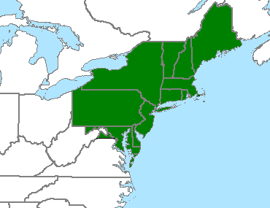Trading Region

Trades

- Typical OTC daily volume from 150 – 1,000 tons
- Extremely volatile at times (from 60-100+%)
- 171,000 tons transferred from 9/98 to 3/01

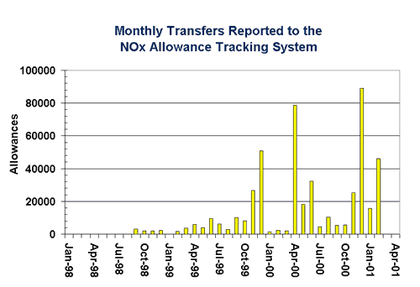

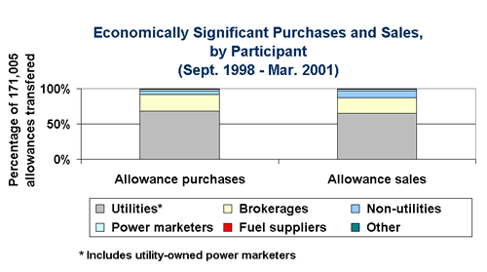

Transaction Types

- Immediate Settlement Transactions
- Forward Transactions
- Cross-commodity or Inter-pollutant Swaps
- Vintage Swaps
- Option Transactions
- Stream Transactions

Strategy

Enron has not been a major player in this market due to diminished liquidity and the looming program termination. There is a mechanism for distributing 25,000 allowances into the NOx SIP Call. However, the mechanism has not been officially determined leading to purchase uncertainty. Due to the uncertainty, Enron is currently buying immediate settlement NOx SIP Call allowances only.

NOx SIP Call

The Market

NOx trading programs are expected to expand considerably beginning in 2003 and 2004. Two issues are responsible for this expansion. The first is the EPA’s Call for State Implementation Plans (SIPs) to reduce the transport of ozone pollution over broader geographic regions of the country, while the second is to address Section 126 petitions under the Clean Air Act Amendments filed by several northeastern States to achieve the same objective. NOx emission reductions created by major sources in the Midwestern, Southeastern and Northeastern states in excess of a set base line over a projected 22 state region are expected to qualify as excess and tradable under these proposed EPA programs. The states that are currently affected under the program are: AL, CT, DE, GA, IL, IN, KY, MA, MD, MI, MO, NC, NJ, NY, OH, PA, RI, SC, TN, VA, WV and DC. The proposed trading programs involve the creation and implementation of seasonal state budgets and the allocation of NOx emission allowances to affected sources.

Trading Region

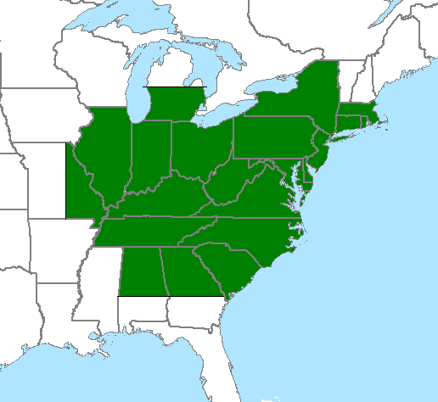

States’ Compliance Year

State | OTR | 2003 SIP Call* | 2004 SIP Call**
AL |  |  | X
CT | X | X
DC | X | X
DE | X | X
GA |  |  | X
IL |  |  | X
IN |  |  | X
KY |  |  | X
MA | X | X
MD | X | X
MI |  |  | X
MO |  |  | X
NC |  |  | X
NJ | X | X
NY | X | X
OH |  |  | X
PA | X | X
RI | X | X
SC |  |  | X
TN |  |  | X
VA |  |  | X
WV |  |  | X

* Only Non-EGUs will be required to reduce emissions during 2003 in those states slated for 2003 compliance in the NOx program.

** EGUs from the 2003 states are required to meet compliance in 2004.

NOx SIP Call Model

The objective of the model is to predict the compliance strategies of the holding companies affected by the NOx SIP Call. The model allocates control technologies (Selective Catalytic Reductions and Low NOx Burners) in the most efficient and economical fashion. The model also predicts the supply and demand of the market and assigns a price for the allowances.

NOx SIP CALL SYSTEM
Year | Tons out of compliance
2003 | (12,431)
2004+ | (35,447)

NOx SIP CALL SYSTEM
Top 10 Short | Allowances
Allegheny Energy, Inc. | (9,843)
DPL, Inc. | (9,066)
Cogentrix Energy, Inc. | (3,529)
International Paper Co. | (3,445)
Lafarge Group | (3,216)
Williams Companies, Inc. | (3,193)
Alcoa, Inc. | (3,108)
Weyerhaeuser Co. | (2,272)
Archer Daniels Midland Co. | (2,145)
Tate & Lyle plc | (1,786)
Top 10 Long | Allowances
FPL Group, Inc. | 2,056
Enron Corp. | 1,682
Sithe Energies, Inc. | 1,565
Buckeye Power, Inc. | 1,322
Calpine Corp. | 1,278
Duke Energy Corp. | 921
Public Service Enterprise Group, Inc. | 744
Oglethorpe Power Corp. | 710
TransCanada PipeLines, Ltd. | 678
Cinergy Corp. | 654

Trades

During the period of July 2001 through October 2001, 5,125 tons with a value of $24,300,000 have traded.

Transaction Types

- Immediate Settlement Transactions
- Forward Transactions
- Cross-commodity or Inter-pollutant Swaps
- Vintage Swaps
- Option Transactions
- Stream Transactions

Strategy

The NOx SIP Call Region will be a major focus for Enron Emissions Services. Virtually every major, high emission producing utility is in the program, and they have major capital commitments to get into compliance. There are also strong correlations between coal and power prices. Utilities will have to shutdown power plants for between 4 and 6 weeks to install NOx abatement technology. This will lead to a lower need for coal in the 2003–2004 shoulder months and an increase in sales of wholesale power. Through our work with East Power Trading this anomaly was discovered by the desk allowing them to adjust their positions accordingly and figure out the reason for the increase in power purchases in these months. We will employ different strategies towards gaining market share with the major utilities and the IPPs, municipalities and large industrials. NOx Tech will also be an important part of our trading strategy.

Business with the major utilities will revolve around the trading of allowances and related derivatives. The development of the market is unproven, but the potential for a relatively liquid market is there. Enron will be a key market maker, as we have taken an active role in developing the market. A strong middle marketing effort will be key as new positions are taken and new products develop. A different strategy than with SO2 will be paramount to success. Coal and SO2 allowance buyers are usually either the same person or in the same group. In the NOx market, the buyer is typically in a different business unit. Though some players do have emissions desks, most have their NOx buyer in a power purchasing or marketing group. This creates a strong disconnect that will have to be overcome. Leverage can be gained through current contracts, relationships within NOx Tech and a strong marketing presence.

IPPs will be attacked with a variation on the utility scheme. The middle marketing effort will be the same but the product line will be different. IPPs do not have the luxury of a large rate base to fall back on for compliance funding. This increases the need for creative products and efficient management of compliance issues. Enron is uniquely positioned to serve this market with creative commodity structures, including the NOx Tech peaker project.

Municipalities and large industrials offer unique opportunities as well. In many instances these entities do not have the manpower or sophistication to manage their emissions issues. Enron will create customized compliance strategies by providing system modeling, forecasting and planning, regulatory guidance and assessment, derivative products, allowances, credits, fuels and flexible payment structures. This will create multiple payment streams, recurring revenue and unprecedented knowledge of our clients systems. This knowledge should manifest itself in long-term fuel contracts and trading opportunities for coal, gas, and power.

Potential issues relating to this strategy are employee skill sets and scalability. Account management, sales and back office personnel will need to be added on an as needed basis with commercial skills being at the forefront for a new hire. Enron’s Environmental Strategy Group will provide the regulatory expertise and a breakdown of potential relationships follow below.

NOx Tech

NOx Tech is a NOx abatement technology that recently had a successful test in Scotland. The successful test, coupled with successful deployment, could add significant opportunities to establish positions in the NOx SIP Call market. NOx Tech will add value to the emissions desk in two distinct ways. The first is by providing market information gathered from utility contacts and the second is through the use of a NOx peaker.

By selling NOx Tech to power generators and utilities, NOx Tech personnel are privy to a vast array of both tangible and intangible information. Tangible information includes SCR degradation rates, system compliance numbers and budgeting information. Intangible information includes general compliance strategies, allowance price views and market trends. This information could be invaluable in Enron’s emissions trading effort.

A NOx peaking unit involves installing NOx Tech on a third parties power plant(s). Enron will finance the installation of the peaking units at no cost, or on a sliding scale, to the owner of the unit. In return Enron receives a four or five year Call option on a pre-determined amount of allowances. The strike date on the option would be for one month prior to the ozone season and the strike price of the option is equal to the projected operational cost of the technology. This price includes O&M, natural gas and ammonia and should fall near the $450 level, well within the projected price range for NOx allowances. At the end of the term the counter party will keep the technology and the relationship will be complete.

Generic Allowance Peaker Transaction

Initial Unit

- Enron will install at its own cost and expense a NOx Tech System at a unit during an outage in April 2002.
- Enron will receive a Call option on NOx tons with the following terms:
  - Number of NOx Tons per Period: The NOx tons will be set for all future Option Periods based on the actual NOx reduction achieved during the Completion Test at unit #1 from the initial baseline inlet NOx and using the expected heat input during a typical NOx season (May through September). The NOx tons will not be dependant upon future unit generation levels and/or unit performance.
  - Option Period: Enron shall have the option to call on the NOx tons for 5 years starting in 2004 and going through 2008.
  - Exercise Date: Each year prior to April 1st, Enron will notify the counter party of its desire to exercise its option for the NOx period for that year.
  - Strike price: If Enron exercises its option under the Agreement, Enron shall pay the counterparty a strike price equal to the expected operating costs of the NOx Tech Unit including natural gas or propane usage, ammonia and heat rate impacts as calculated based on the actual NOx Tech performance during the Completion Test. The Strike Price will then be set for all future Option Periods. (approximately $400-$500 per ton).
- The counterparty will provide all natural gas or propane, ammonia and operating costs required or associated with the NOx Tech system over the Option Period.
- After the 5 year Option Period, Enron will transfer title of the NOx Tech system, “as-is”, to counter party.
- The counterparty may purchase an option to terminate the Agreement for Unit 1 early by making a cash payment to Enron within 5 days after the Completion Test:
  - Premium for option to terminate on May 31, 2007 = $2 MM
  - Premium for option to terminate on May 31, 2008 = $1 MM

Other Units

- Enron will have an option to install NOx Tech Units at the other units designated by the counterparty prior to May 2004.
- Same general Call option terms apply to other units (i.e. Option Period, Exercise Date, Strike Price and Number of Tons).
- The counterparty will provide all natural gas or propane, ammonia and operating costs required or associated with the NOx Tech system over the Option Period.
- The counterparty may purchase an option to terminate the Agreement early on each Other Unit by making a cash payment to Enron within 5 days after the Completion Test:
  - Premium for option to terminate on May 31, 2007 = $2 MM
  - Premium for option to terminate on May 31, 2008 = $1 MM

- At the end of the Option Period, the counterparty will have the option to purchase the other units at the following prices:

  - Unit 2 = $.50 MM ($3/Kw)
  - Unit 3 = $1.0 MM ($6/Kw)
  - Unit 4 = $1.5 MM ($9/Kw)
  - Unit 5 = $2.0 MM ($11/Kw)
  - Unit 6 = $2.5 MM ($14/Kw)
  - Unit 7 = $3.0 MM ($17/Kw)
  - Unit 8 = $3.5 MM ($20/Kw)
  - Average Unit Cost to the counterparty = $10/Kw

By successfully implementing this structure, Enron will be able to acquire an advantageously priced long position in the NOx Sip Call market. We are in the process of determining the optimal amount of credits desired. This analysis will help determine the amount of allowances Enron Emissions Services should try and attain.

Houston-Galveston NOx Cap and Trade Program

Market

Starting January 1, 2002, NOx emission sources located in the eight county Houston - Galveston, TX area will be subject to a year-round NOx cap and trade (i.e., emission allowance) program. Required reductions from a 1997-1999 baseline are expected to be significant, some as great as 90 percent. The Texas Natural Resources Conservation Commission (TNRCC) will implement and administer the program. There are approximately 600 sites in the HGA program.

NOx Reduction Factor Schedule
 | Non-Utilities | Utilities
2002 | No reduction* | No reduction*
2003 | No reduction* | 32%
2004 | 30% | 75%
2005 | 70% | 86%
2006 | 79% | 86%
2007 | 88% | 89%
2008+ | 90% | 90%

* No reduction from baseline determined by fuel use in 3 consecutive years, usually from 1997 to 1999
Utilities vs. Non-utilities
 | Percentage of NOx in HGA
Utilities | ~ 28%
Non-Utilities | ~72%

HGA Field

- Brazoria | - Harris
- Chambers | - Liberty
- Fort Bend | - Montgomery
- Galveston | - Waller
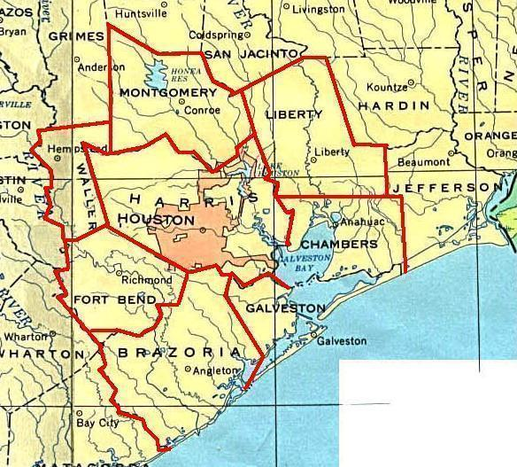

NOx HGA Model

The objective of this model is to predict the supply and demand. After the supply and demand was modeled, an allowance price forecast was created. Also, a target list is developed which contains the top ten projected longs and shorts.

Overall System

 | 2,002 | 2,003 | 2,004 | 2,005 | 2,006 | 2,007 | 2,008
Supply | 214,259 | 206,027 | 153,970 | 73,428 | 45,339 | 26,692 | 22,491
Demand | 199,274 | 199,274 | 200,831 | 202,704 | 203,331 | 204,061 | 204,253
Bank | - | 14,985 | 6,753 | - | - | - | -
Balance | 14,985 | 21,738 | (40,109) | (129,276) | (157,992) | (177,369) | (181,762)

Trading

Trading of allowances between utilities and non-utilities will be permitted. Allowances will not be placed into the TNRCC accounts until January 1st of each year of the program. The last day to trade is January 28th, of any year because it takes 30 days to finalize a trade with the TNRCC. All allowances must be finalized on March 1, of any year. A plant has until March 31st, of any year, to submit compliance forms to the TNRCC.

NOx allowances can be banked for one year. The current year allowances must be used completely before the banked allowances can be used. Any banked allowances not used during the first year after they were banked will expire. Allowances will not be delivered until the annual TNRCC allocation. They may be sold forward as evidenced by the following statement:

The owner or operator of a site receiving allowances on an annual basis may permanently sell those rights to any person. This request for transfer of ownership shall be completed by the executive director following the submission of a completed ECT-4 Form, Application for Permanent Transfer of Allowance Ownership. The executive director will issue a letter to the purchaser and seller reflecting this transaction. The transaction will be considered finalized upon issuance of this letter.

Title 30, Part 1, CH 101, Subchapter H, Division 3, Rule 101.356 (Texas Administrative Code)

Transaction Types

- Immediate Settlement Transactions
- Forward Transactions
- Vintage Swaps
- Option Transactions
- Stream Transactions

Strategy

Enron is poised to be a major player in this market. We’ve acquired DERCs, which can be used as allowances through 2005. This is our initial position, which will be enhanced as opportunities arrive. The strategy for this market will be the same as for the NOx SIP though with a far lower use of NOx Tech. We have instituted a middle marketing effort in this region and have been in contact, via phone or mailings, with over 150 of the largest emitters in the program.

Non-Attainment Regions

The Market- ERCs

Emission Reduction Credits (ERCs) are required for new major emission sources, or sources undergoing major expansions, by various state air agencies in regions that do not meet the EPA’s national ambient air quality standards (NAAQS). Offsets are available for a variety of pollutants, including nitrogen oxides (NOx), volatile organic compounds (VOC), carbon monoxide (CO), particulate matter (PM) and reactive organic gases (ROG). ERCs are a major concern for developers of new electric generation facilities or major industrial plant developers such as steel mills, chemical refineries, paper plants, arc furnaces, etc. ERCs are generated from reductions beyond those required and must be:

- Enforceable
- Permanent
- Quantifiable
- Real
- Surplus

Trades

Traded ERCs vary completely by region and emission source. The largest markets are Houston-Galveston, Atlanta, San Joaquin Valley, RECLAIM (South Coast Air Quality Management District), Bay Area, Chicago, Dallas-Fort Worth, Salt Lake City and New York-New Jersey. Due to the highly segregated nature of these markets, lack of liquidity and price discovery even the smallest air district can result in significant upside.

Transaction Types

- Immediate Settlement Transactions

New Generation and Non-Attainment/Regional Haze Areas

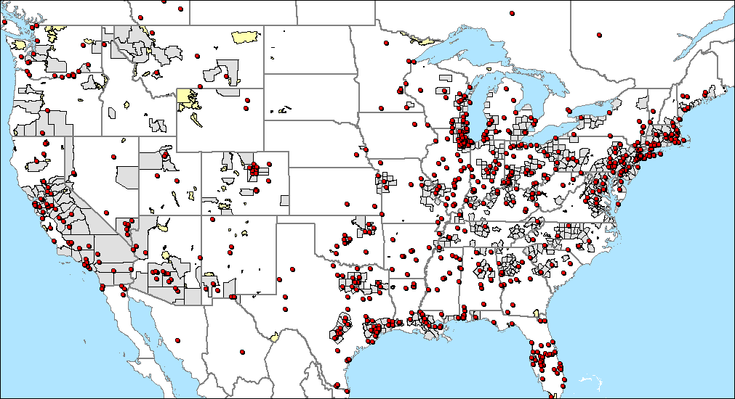

- New Generation
Non-Attainment/Regional Haze Areas

Plant Shutdowns and Non-Attainment/Regional Haze Areas

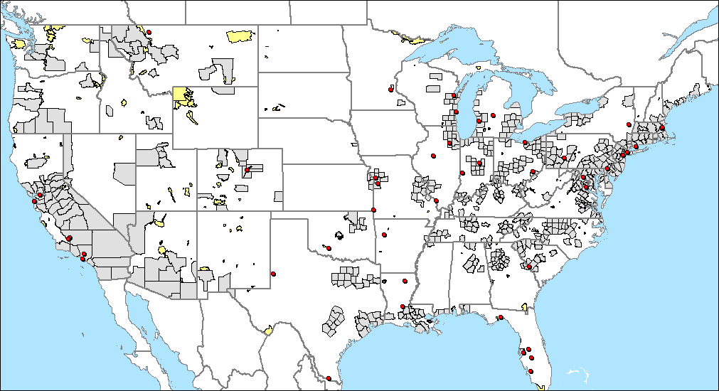

- Plant Shutdowns
Non-Attainment/Regional Haze Areas

Key Issues

The key issues in dealing with ERCs include regulatory risk and knowledge, knowledge of market participants, slow air board re-certification turnaround and the long time horizon for liquidating positions. Internal capital charges can diminish the value of ERCs as they have a relatively long carrying timeframe. With Enron being charged at 7.5%, and with the potential of this to increase to 15%, this may become an increasingly important issue. The arrangement with Barclays should significantly improve the cash flow and carrying charges associated with ERCs. The long time horizon is exacerbated by the high degree of regulatory risk. The local air boards are continuously pressured by major emitters in the area to relax ambient air standards. Thus far these overtures have been unsuccessful, but they are a very real risk. Finally, it is very difficult, if not impossible to hedge a position. The best one can do is build a portfolio based on solid due diligence, move in and out of positions as rapidly as is fiscally prudent and develop and enhance the network of buyers in the market.

Strategy

Enron is an active participant in many ERC markets. We have taken positions in multiple markets including Houston-Galveston, San Joaquin Valley and Maricopa County, Arizona. ERCs are becoming increasingly difficult to attain in many regions of the country. Air districts with particularly acute shortages include Atlanta, Maricopa County, the Bay Area, the San Joaquin Valley, Dallas-Fort Worth and Houston-Galveston.

The shortages will raise the opportunity for regulatory approved ERC creation projects. Examples of potential projects include compressor station electrification projects include retrofitting local transport sources, paving dirt roads and others. These projects are time consuming, carry a high degree of regulatory risk and are predicated on putting capital up front to prove the reduction. The upside to this strategy is the potential to create high volume, high margin ERCs.

We are currently developing ERC forecast models. These forecasts will help Enron target markets with low cost credits that will tighten significantly. A combination of power plant development, industrial development, population trends, shutdowns and others will be used.

To date, Enron has relied in large part on brokers. They have historically been the go to for both buyers and sellers as they have long histories in the business. Major environmental brokers we use include Cantor Fitzgerald, Evolution, Natsource and Prebon Energy. In a typical ERC transaction the fee is equal to 7.5% split equally between both parties. On a $2 million deal this equates to $150,000 brokerage fee and $75,000 from Enron alone. There is no way we could or would completely avoid using brokers. However, a strong middle marketing effort in the ERC markets can pay for itself with a few deals. This effort could also diminish price discovery leading to improved margins for Enron.

Initial marketing benefits include:

- Avoidance of broker fees
- Increased partner margins lead to increased Enron margin
- Increased market share, knowledge and information in different ERC markets
- Local source to push Enron Emissions products and services

Potential pitfalls include:
- No guarantee of success
- Slow pace of transactions can lead to market dispersion
We have been working with Jim Lewis of the EGM Finance group to see if it will be possible to place ERCs in the Barclay’s trust. This appears to be a viable option though recent events may make future deals less workable. By placing ERCs in the trust EGM will receive positive cash flow and the ability to carry the ERCs for a competitive rate. It is also believed that earnings can be generated though more work is necessary to ensure this. By successfully utilizing this asset EGM will receive a myriad of benefits that will greatly enhance our ability to become a major force in the ERC markets. To become a major player in the ERC markets will require up front capital outlay. The return on this type of transaction has typically occurred within one year and earnings are generated on a cash basis.

Market- DERCs
Discrete Emission Reductions Credits (DERCs) are granted under a state Open Market Trading System. A DERC is a discrete ton of emissions reductions generated by a reduction that is not necessarily permanent. Similar to allowances, DERCs are awarded to emission sources that voluntarily reduce their emissions below their permitted limits. DERCs can be generated for reductions of NOx, VOC, CO, SO2 and PM 10. DERC markets are state-specific in nature, although the programs tend to be similar in design.

Transaction Types

- Immediate Settlement Transactions

Strategy

DERCs will be part of the ERC/Non-Attainment strategy. Due to the market overlap the strategy will be virtually identical. DERC programs are more limited than ERCs, but still offer upside opportunities.
Market – MERCs

A MERC is a credit representing the amount of emission reductions from a mobile source. The emission reductions are voluntary and must be in addition to compliance with requirements of state and federal regulations. MERCs may be applied to the emission reduction obligations of another air quality source or to air quality attainment goals. NOx and VOC are the two applicable pollutants in the MERC program.

A MERC can be generated by shutting down a facility with mobile sources that total one-ton or more per year. This is only one example.

Transaction Types

- Immediate Settlement Transactions

Strategy

MERC programs are severely limited. We will continue to monitor the market.

Market - MDERCs

A MDERC is a credit that is surplus, generated by a mobile source. The emission reductions are voluntary and must be in addition to compliance with requirements of state and federal regulations. MDERCs may be applied to the emission reduction obligations of another air quality source or to air quality attainment goals. NOx, VOC, CO, SO2, and PM10 are the applicable pollutants in the MDERC program.

Transaction Types

- Immediate Settlement Transactions

Strategy

MDERC programs are severely limited. We will continue to monitor the market.

ZEV Program

Market

The California Air Resources Board (CARB) is the first air board to officially begin a Zero Emission Vehicle program. The program will begin in 2003, but manufacturers are given until 2005 to get in compliance, and New York, Massachusetts, Maine and Vermont are in the process of adopting similar programs. As of now, there is no inclination that trading will be allowed interstate. In the California plan vehicle manufacturers can earn credits for selling Zero Emission Vehicles (ZEV), this also includes Neighborhood Electric Vehicles (NEV), or partial zero emission vehicles (PZEV) in the state. ZEV credits are produced from zero emission vehicles such as the neighborhood electric vehicle or electric vehicles. PZEV credits are partially emitting vehicles produced from hybrid vehicles, which are part gas and part electric.

Large and intermediate manufacturers must meet similar requirements. In California, they are both required to have credits equal to 10% of their California sales. However, intermediate manufacturers, which sell between 10,000 – 60,000 vehicles in California annually, can fulfill their 10% requirement with all PZEV credits or any combination of PZEV and ZEV credits. Large manufacturers, which sell over 60,000 vehicles into California annually, are required to have at least 2%-4% of the 10% in ZEV credits. Once compliance is met both can sell their credits to other manufacturers. Small manufacturers have no requirements, but they can earn credits.

The program allows market forces to dictate prices up to a $5,000 fine for each credit that a manufacturer is short. The trading program starts in January of 2003, but manufacturers are given until the first quarter of 2005 to get into compliance. The program has declining multipliers in order to create more liquidity in the front years. Vehicles earn multiple credits depending on the type of vehicle and the year sold.

Multipliers

 | 2001-2002 | 2003 | 2004 | 2005 | 2006
PZEV | 4.0 | 4.0 | 2.0 | 1.33 | 1.0
ZEV | 4.0 | 1.25 | 1.25 | 1.25 | 1.0
NEV | 4.0 | 1.0 | .5 | .5 | .15

Supply and Demand

 | Total Credits Needed for 2003-05 (per year) | Credits already earned as of 1/1/01
GM | 22,434 | 1,350
Toyota | 19,872 | 500
Ford | 19,083 | 100
Honda | 16,356 | 20
Daimler Chrysler (own GEM) | 8,031 | 50
Nissan | 5,965

Players

Buyers of ZEV credits | Sellers of ZEV credits
Ford | Lido
Honda | Solectria
GM | Dynasty
Daimler Chrysler | Bombardier (small player)
Toyota
Nissan

Estimated Credits Earned Per Vehicle with Revised Regulation

Manufacturer | Model Year | Vehicle | 2001 Credit | 2002 Credit | 2003 Credit
Daimler Chrysler | 1999 | EPIC | 10.72 | 10.72 | 3.35
Ford | 2000 | Ranger | 9.12 | 9.12 | 2.85
GM | 1999 | EV1 | 13.78 | 13.78 | 4.31
Honda | 1999 | EV Plus | 16.03 | 16.03 | 5.01
Nissan | 2000 | Altra | 16.64 | 16.64 | 5.20
Toyota | 2000 | RAV4 EV | 18.78 | 18.78 | 5.87
Ford |  | Mail Truck | 9.12 | 9.12 | 2.85
Ford |  | Th!nk City | 4.48 | 4.48 | 1.40
Honda |  | City Pal | 8.80 | 8.80 | 2.75
Nissan |  | Hypermini | 5.60 | 5.60 | 1.75
Toyota |  | eCom | 5.60 | 5.60 | 1.75
Lido, Dynasty, etc. |  | NEV | 4.00 | 4.00 | 1.25

Estimated Vehicle Production to Meet Compliance with Revised Regulation

 |  | 2003 | 2004 | 2005 | 2006 | 2007 | 2008
ZEVs
 | If 100% full function EV | 4,650 | 4,650 | 4,650 | 5,800 | 5,800 | 5,800
 | If 100% City EV | 11,750 | 11,750 | 11,750 | 14,700 | 14,700 | 14,700
 | If 100% NEV | 15,450 | 30,900 | 30,900 | 128,700 | 128,700 | 128,700
AT PZEVS | If 20% (max allowed by regulations) | 10,700 | 21,500 | 32,200 | 43,000 | 43,000 | 43,000
PZEVS | Large manufacturers If 60% (max allowed by regulations) | 72,000 | 145,000 | 218,000 | 290,000 | 290,000 | 290,000
 | Intermediate manufacturers | 22,500 | 45,000 | 67,500 | 90,000 | 90,000 | 90,000
 | Total | 94,500 | 190,000 | 285,500 | 380,000 | 380,000 | 380,000

Trades

Only transfers between subsidiaries have taken place. We are awaiting the outcome on a bid to purchase a small amount of credits.

Transaction Types

- Immediate Settlement Transactions
- Option Transactions
- Marketing Agreements

Strategy

The Environmental Strategies Group is monitoring the market and providing us updates. We have spoken with the majority of players and will continue to maintain contact. The market probably will not become active for another year or two. We have discussed becoming exclusive marketers with a few small players. They still remain in the discussion stage at this point.

Greenhouse Gas

Market

The first section of this area describes the potential greenhouse gas market and trends in greenhouse gas reduction “credit” pricing. The second section outlines several objectives of current greenhouse gas emission reduction credit buyers and describes how a buyer’s motivation impacts the perceived quality and price of reduction credits. The third section provides information on macroeconomic and microeconomic greenhouse gas emissions market models.

Global Climate Change and Greenhouse Gas Emissions Trading

A greenhouse gas emission “credit,” either in the form of an emission permit or reduction credit, is not a well-defined commodity. Greenhouse gas emissions are recognized under several different regulatory programs and voluntary initiatives, each with distinct and evolving rules and evaluation criteria. While the goal of many of the programs is the development of a fully fungible commodity, it is unlikely in the near term. What exists now is a patchwork of different programs with different definitions of what constitutes a greenhouse gas emission credit.

Size of the Greenhouse Gas Market

The global greenhouse gas emissions market has the potential to be relatively large, with estimates running as high as several hundred billion dollars annually. However, there are various reasons why the market won’t reach this size in the near future.

The market could be large and liquid if governments resist restricting trades and using rules such that trading between jurisdictions is impeded. The current “market” is estimated to be a few hundred million dollars annually, but much of that represents projects that are funded by governments. The future market will depend on many factors that are currently not predictable with accuracy. Estimates range from $20 billion to roughly $500 billion annually.

Greenhouse Gas Emissions Prices

The data on prices flow from a variety of circumstances that change every week, thus they are essentially incomparable. However, the data that comes from today’s market reflect different types of reductions, of varying quality, and under varying regulatory circumstances.

Generally, in today’s market, high quality reductions usually command somewhere in the $3.00 to $4.00 range. Today’s prices for questionable greenhouse gas reductions ($.50-$1.50) may be somewhat close to the minimum for the future due to the heavy discounting for risk and uncertainty. The difference in price that derives from high quality reductions verses low quality reductions is fundamental to a keen understanding of the market for greenhouse gas reductions and credits. Quality is generally defined as the ease with which a reduction can be quantified and verified. Quality is also a product of subjective criteria based on the motivation of the buyer. For example, for speculative buyers, whether the reduction could be applied in multiple markets may impact price.

While the market for trading greenhouse gas emissions is in its very early stages and current prices do not tell us very much about what a full-fledged market could look like, various academic studies have attempted to estimate prices for greenhouse gas emissions reductions, as expressed in carbon dioxide emission reduction equivalents. Like any economic modeling process, the models should be scrutinized for their assumptions, what factors they account for and what factors they are unable to include in the model. As carbon is integrally and completely embedded in today’s capital stock and is a cornerstone of the economy, a complete analysis of cause and effect throughout the economy (domestic and global) is much too complex to undertake. Nevertheless, some interesting analyses merit consideration.

Factors that Impact the Price of Project-Based Greenhouse Gas Reductions

In the current environment, buyers of greenhouse gas emissions reductions generally seek to fulfill one or more of the following: 1) speculative investments/returns, 2) compliance hedging or 3) public relations benefits (marketing and/or goodwill). Project based credits command higher prices based on the perceived ties to the buyer’s specific objectives.

The price of a greenhouse gas emission reduction, as expressed in one metric ton of carbon dioxide equivalent (CO2e), is a function of the cost to create the reduction and its quality. However, given weak market signals and the lack of regulatory certainty on what constitutes a greenhouse gas emission reduction, the motivation of the prospective buyer will play a large role in the attractiveness and the price of a greenhouse gas reduction transaction. The extent to which multiple objectives can be met through a given transaction will also influence price.

There are few purely speculative buyers in the market today. Far more companies are interested in compliance hedging, especially as the rules for a European Union (EU) trading program develop and other countries seek to ratify the Kyoto Protocol. Public relations seekers are the largest group of buyers now, but they should decline proportionally as greenhouse gas risk management becomes more of a commercial issue.

Speculative buyers invest in greenhouse gas emissions with the expectation of selling the reductions in the future to gain a minimum rate of return. The time horizon on the re-sale will vary in each case. Factors that determine speculative transactions are market liquidity and the demand created by second hand buyers. Presently, there is little or no market liquidity and few buyers that wish to purchase second hand reductions. This could change slightly in the next year depending on how the U.K. and EU emissions trading programs evolve. However, market liquidity could be complicated by the framework laid out under the Kyoto Protocol’s international emissions trading program, which allows domestic governments to define what constitutes a credit under their domestic programs.

Compliance hedging is also a strategy of current buyers. In many cases, these transactions are private and proprietary. The quality of the reductions will vary. One scenario would be to buy inexpensive reductions, in expectation that they will qualify under future regulatory programs. Factors determining price would be the downside risk that the credits will have no value under future regulatory programs. In forward transactions, the likelihood that the credits will be generated due to associated project risks may also have an impact (country of origin, political risks, etc.).

Public relations benefits are another objective of current buyers. Attractive features that may influence price are the project’s novelty, category/type, geographic location and any corresponding synergies with commercial or corporate environmental strategies. Many buyers seek to reap significant public relations benefits from transactions. In these cases, the uniqueness and optics of the transaction play a role. For example, second hand purchases may be less newsworthy, and buyers may be averse to buying reductions that derive from controversial activities, like some forms of carbon sequestration activities.

An example is a recent forward transaction under the U.K.’s emissions trading program between Dupont and Marubeni. The deal was done mostly for public relations purposes. It is unlikely that Marubeni will retire these allowances in the U.K. and unlikely that these will be recognized and accepted in Japan. However, there could also be a speculative angle to the deal, where the allowances are re-sold for at least part of the initial investment cost. The deal was priced at £5 per ton (about $7.50) for 10,000 2002 UK allowances.

Future Greenhouse Gas Market Influences

Based on current regulatory uncertainty, factors including: 1) Kyoto Protocol ratification, 2) U.S. participation in international emissions trading, and 3) Russia’s compliance strategy are speculated to impact greenhouse gas emissions prices in the next decade and beyond. Further, prices would be impacted if targets under the Kyoto Protocol were adopted by additional countries (i.e., developing countries in the second budget period, 2013 – 2015).

If the Kyoto Protocol is ratified, greenhouse gas emissions reductions will likely have a higher price, as demand will increase and frameworks for trading will be established. Given the EU's political commitment to Kyoto Protocol ratification, the treaty entering into force and the establishment of a multilateral emissions trading program are viewed as more likely than even six months ago. Having said that, market liquidity is less certain and will depend on the actions of the EU and other national governments, like Japan, Australia, and Canada.
U.S. participation in a global emissions trading program through either the Kyoto Protocol’s trading program or via links with bilateral or regional programs will influence prices for greenhouse gas emission reductions. The U.S. is expected to be the largest net buyer under a global emissions trading program, either as part of the Kyoto Protocol or an emissions trading program that is linked to the Kyoto mechanisms. All other elements being equal, without the U.S., the price for reductions is expected to be dramatically lower.
Russian greenhouse gas emissions trading strategies are believed to be an influencing factor on prices under a Kyoto Protocol trading regime. Under the Kyoto Protocol, Russia has been granted an emissions reduction target based on its 1990 emissions. Since 1990, Russia has experienced severe economic decline --- locking in emissions allowances that are expected to greatly exceed what is necessary for Russia to meet its target. Further, some forecasts suggest that due to the increased accounting of carbon sinks for developed nations under the Bonn agreement in July 2001, the Kyoto Protocol’s targets between 2008 and 2012 can be met largely through the transfer of Russian emissions allowances.
Depending on Russia’s strategy, it could sell its allowances or bank them in the first budget period of the Kyoto Protocol (2008 – 2012). Most believe that there will be a direct relationship between the amount of reductions Russia sells in the first budget period and decreasing greenhouse gas emissions prices. However, Russia's strategy is uncertain. Russia may wish to cash out early by selling allowances (‘hot air”) or they could bank their emissions to command a higher price in the second budget period.

Economic Modeling and Analysis
Most of the models highlighted below were compiled assuming U.S. participation in the Kyoto Protocol. As stated previously, if the U.S does not participate, greenhouse gas emission credit prices would be considerably lower.
Macroeconomic Models
ZhongXiang Zhang at the University of Groeningen has estimated the size of the potential market for the Kyoto Mechanisms under various policies. When there are no limits on trading, the prices (marginal abatement costs) will equalize and there should be no distinction between international prices. In 1998 dollars, the world price is estimated to be $2.70 per ton of CO2e. If trading in “hot air” is not allowed the prices increase to $3.40 per ton CO2e. If limits on trading are imposed (which is unlikely given the Bonn agreement compromise), the demand for traded permits or credits will be suppressed and the price for traded reductions will be even lower. The latter scenario will evidently lead to differentials in the domestic and international prices of CO2e depending on national abatement costs. The scenario in which there are no limits on trading, marginal abatement costs in the U.S. are reduced by an estimated 85% from the case in which no trading is allowed.
Studies by economic forecasting firms such as Charles River, WEFA, MIT, EIA estimate costs of CO2e reductions per ton to be $27 to $95 in 2010 based on the costs of reducing carbon emissions from a business as usual scenario to meeting a 7% reduction in greenhouse gases (some estimates allow for trading and some do not).
Microeconomic Models
Project level analysis done by the World Bank looks at the average cost of reductions from different categories of projects – biomass energy, renewable energy, demand-side management – per ton of CO2e. The average cost among these different types of projects is $9.40 per ton of CO2e (based on project cost per ton saved), while from a ton-weighted standpoint (some projects yield larger quantities of tons and thus have lowered costs per ton) the portfolio of projects yields an average ton-weighted cost of $3.50 per ton. Attempting to weight the projects for quality ranking, the average energy supply project would be $7.70 and the average end-use efficiency or renewable project would be $3.50 per ton CO2e.

World Bank Prototype Carbon Fund (PCF)

The early lessons from World Bank’s PCF are mixed. Thus far, the PCF has received more than 100 so-Called Project Idea Notes covering every potential JI and CDM region. This resulted in a diverse pipeline consisting of over 40 projects with a potential value of about $250 million in emissions reduction purchases – which is beyond the PCF’s capacity to finance. The Project Idea Notes mainly originate from the Latin American and Caribbean region. Proposals from this region are for an emissions reduction acquisition of over $120 million. Demand from Africa, Europe and Central Asia and South Asia also exceeds the resource that can be reasonably allocated by the PCF. From this pipeline, the PCF has identified 15 - 20 potential projects for further investigation and five of these projects, to which about $30 million of the fund will be allocated, have already undergone preparations and are endorsed by the host country government and the PCF Participants Committee. Renewable energy technologies are well represented in the PCF pipeline. Among renewables, the PCF is reaching portfolio limits for wind energy and waste management. The proposals from Latin America and Caribbean have a number of biomass, small hydro and geothermal electricity proposals.

Purchase agreement in Eastern Europe

In Latvia an Emissions Reduction Purchase Agreement has been signed between the Government of Latvia and the PCF on the basis of the Solid Waste Management Project in Liepaja. This project will recycle 90% of the landfill waste and will use the methane to generate electricity. This is also expected to reduce the health hazards from open dumpsites and make the rates for collecting garbage for the local population affordable. It is estimated that the maximum price per ton of CO2e for this project will be $6.00. Generally, investors have indicated that they are willing to pay in the order of $5.00 per ton of CO2e. Actual costs have been higher than projected by transactions of mere reductions while still being lower than projected by many macro-economic models.

Strategy

Given current regulatory uncertainty and the patchwork of greenhouse gas emissions initiatives, a liquid market with a clearly defined commodity is likely several years (or more) away. However, given the growing interest in compliance hedging, opportunities to package and sell verifiable greenhouse gas emissions reductions could increase in the near future. Further, with the launch of the U.K. emissions trading program and rule development for the EU trading program expected next year, it is likely that the definition of a verifiable greenhouse gas emission credit will become more clear.

Given the range and varying circumstances under which current greenhouse gas emissions transactions are occurring, Enron business groups should begin to capture internal greenhouse gas reductions, look for opportunities to integrate greenhouse gas emissions into existing risk management products and, Enron assets that could be emissions sources, should assess and manage exposures. There is little else that can be accomplished in the short term, though the enormous size of the market leads to the emissions group closely following all new developments.

US CO2 Emissions

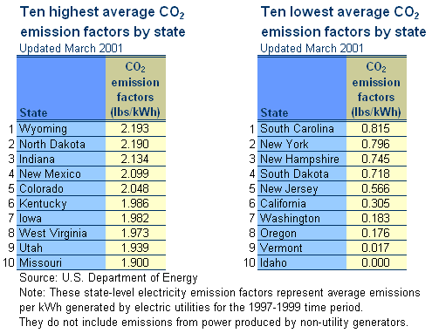

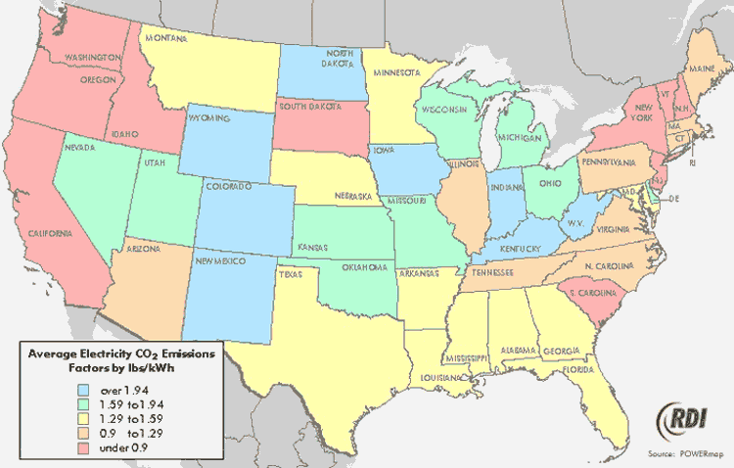

Environmental Strategies

We have been in discussions to figure out the best fit and working environment going forward. Currently, Environmental Strategies Group (ESG) resides in Enron Corp and serves customers in all business units. ESG’s focus is on air quality/emissions, global climate change, and renewable energy. There are several scenarios we have discussed that would allow Enron Emissions to further leverage ESG’s skill sets. Possible structures and arrangements include maintaining the current scheme, hiring dedicated ESG personnel, semi-integration of ESG into EGM and complete integration of ESG into EGM.

The current arrangement will be maintained until a more dedicated effort is necessary. A more dedicated effort will likely become necessary once a contract is signed and the strategy is implemented. As the business expands we will re-evaluate the best manner for working with ESG.

Pros and Cons of Environmental Strategies-EGM Structures

Option A:

ESG will further increase attention to Enron Emissions Services. ESG will continue to provide service to EGM and prioritize workload accordingly. Upon an increase in business ESG will shift resources from other business units and developed a more centralized role with the emissions group.

- Pros: Allows ability to incrementally see how new effort goes before making staffing/budget decisions that affect EGM costs.
- Cons: Potential for a large increase in workload in both organizations without staffing/budget changes. ESG may have difficulty in responding as rapidly as liked by commercial groups.

Option B:

Hire or dedicate ESG personnel to new EGM effort. In this effort ESG could hire additional staff to make sure EGM is properly covered. This would not be undertaken until there is proper deal flow to cover expense to EGM.

- Pros: EGM gets dedicated staff assistance without having to increase staff/budget itself, although Corp charges are allocated to EGM. ESG is able to serve new EGM needs while maintaining workload across Enron.
- Cons: ESG’s 2002 budget is already complete so it may be difficult to advocate for more staff. Revenues from associated projects would be needed to offset staff increase.

Option C:

Semi-integration of ESG and EGM functions: could include Corp/EGM co-funding of all ESG emissions functions, and have dual reporting or “dotted lines.”

- Pros: equal sharing of resources spreads the burden and may be easier to sell on both sides. Allows for incremental effort – see how things work out…if badly, then it is easy to go back to status quo.
- Cons: Dual reporting can be complex from a management perspective and dilute effectiveness of the group (although Corp groups ultimately answer to commercial groups, regardless of where they report).

Option D:

Complete integration of ESG and EGM functions: in the long-term, ESG functions could be completely integrated with commercial structure of EGM venture.

- Pros: particularly if EGM group evolves to serve a number of internal as well as external roles, integration of the analytical, strategic functions makes good sense. Experience of ESG in working across all Enron business units could provide EGM excellent contacts and “diplomacy” needed to de-fuse inter-business unit competitive tensions. It is also the chance to sell the efficiency and value of one group at Enron performing a comprehensive, coordinated function.
- Cons: currently, with ESG at the corporate level, it is sometimes easier to navigate the different business units and do work for a number of internal customers. If absorbed completely into a commercial group, it may be harder to penetrate all Enron businesses.

Environmental Consultancies

Environmental consultancies provide a wide variety of regulatory and monitoring assistance to utility and industrial clients. Consultancies work with utility and industry groups to affect improvements to pending regulations during the draft, proposal and promulgation process. They also assist clients with numerous emission standard and permit limitation issues, emission and compliance measurement techniques, reporting and record keeping requirements, control technology requirements and ambient air quality issues.

Enron Emissions Services has contacted consultancies about forming a joint partnership. The consultancies would provide an existing relationship and a track record with many industrials and power generators. Enron Emissions Services could provide our risk management expertise to the allowance portfolio.

URS Corporation

Company: | URS Corporation
Industry: | Engineering Services
Enron Spend: | $7MM FY2000
Contract Type: | PSA

Recent Company News: | URS has been selected by the Tampa-Hillsborough County Expressway Authority to provide construction management and construction engineering inspection services as part of the Lee Roy Selmon Expressway Expansion Project. URS estimates its fees under the new assignment will be approximately $24 million.

Business Overview | Provides a broad range of planning, design/program and construction management services. URS is one of the largest transportation firms in the industry. URS currently has projects with 8 of the largest US airports with a contract value of $21B. URS was awarded a $48MM contract with Dupont to provide environmental and remediation services.
Business Areas: | Organized into six areas:  - Surface Transportation  - Air Transportation  - Industry  - Facilities  - Air, Water & Environment  - Specialty Services
Customers/Industry Served | Transportation, hazardous waste, petrochemical/industrial processing, general building and waste/wastewater.

Key Corporate Statistics
Headquarters | 100 California St., Ste 500  San Francisco, CA 941111  415-774-2700  www.urscorp.com
Locations | 300 offices in 30 countries
Employees | 15,800
Executive Leadership | Martin M. Koffell – Chairman, President & CEO
 | Richard C. Blum – Vice Chairman
 | Irwin L. Rosenstein – President, General Engineering
 | Kent P. Ainsworth – EVP, CFO & Secretary
 | Jean -Yves Perez – EVP Business Development

Financial Strength
Revenues/Sales | 2,205MM
Total Assets | 1,427MM
Net Income | 49.9MM

ENSR International

Company: | ENSR International
Industry: | Environmental Engineering/Consulting
Enron Spend: | $1.5MM FY2000
Contract Type: | Professional/Environmental Service Agreements
Contract Term:

Business Overview | 33 years of experience providing consulting, engineering, remediation and related services to industrial and commercial companies, municipalities, and regulated government agencies throughout the US, Europe, Latin America, and Asia.
Business Areas: | Air Quality, Capital Project Permitting, Remediation and Regulatory Closure, Risk Assessment, Process Facility Engineering, Due Diligence and Environmental Health and Safety Management Services.
Customers/Industry Served | Energy, Petroleum, Aerospace, Chemical, Transportation, Forest Products, Automotive, and Manufacturing.

Key Corporate Statistics
Headquarters | 2 Technology Park Drive  Westford, MA 01886-3140  978-589-3000  www.ensr.com
Locations | 60 Worldwide, 4 US
Employees | 1,200 (in 60 disciplines)
Executive Leadership | Robert C. Petersen – President & CEO
 | Michael Decker – Chairman of the Board

Financial Strength
Revenues/Sales | $163.3MM
Total Assets | $82.7MM
Net Income | $3.3MM

Enron Emissions Clearing House

By operating without a central risk management desk and an emissions clearing house, Enron is running the risk of competing against itself, exposing the company to excessive risk and legal liabilities, and missing out on opportunities. A key initiative for the emissions desk will be to develop as the emissions clearing house and risk management group for all Enron emissions related issues. In the current form each group contacts it’s own brokers, consultants and contacts in order to procure offsets or allowances. Each group below uses its own legal documents. This leaves the company vulnerable to bidding against itself, portfolio uncertainty and rogue personnel making emissions deals. An active approach has been taken to consolidating positions and procuring credits and allowances. However, this is a project that will need executive support. Many groups, particularly those in California, are reticent to deal with the Emissions Desk as they see it as an invasion of their turf. We have made some progress, including acting as agent for East Development, but a more concerted effort is necessary. The desk’s expertise will help enhance opportunities (as we have regular interaction with all of the major brokers as well as a significant number of political and industrial contacts) and mitigate risk throughout Enron.

Enron North America

- Power Origination (regional teams): These deals take many forms, but typically involve a client’s need for compliance with environmental regulations and/or desire to have Enron manage those issues. Structures include Power Purchase Agreements, asset purchases/sales, investments, air compliance and allowance costs. These are all elements that would benefit from a central emissions risk management desk.

- Generation Development (East and West): All new generation deals involve air compliance, whether it is SO2/NOx allowances, cost analysis & permitting strategies, or ERCs in non-attainment areas. ENA East and West developers use their own people and external consultants for many of these issues. Environmental Strategies is consulted in some cases, many times on strategy for NOx compliance, ERC creation, etc. This would be another prime area to have a central commercial source for emissions strategy.

- Generation Services: Perform some origination and trading functions, but mostly under off-balance sheet structures. Generation Investments is trying to site/build coal generation, which entails significant emissions risk issues.

- Gas Trading/Origination: We have not done much work with the gas desks, but there could be opportunities for bundled origination deals including emissions products/services, as well as analytical/fundamentals needs of the trading desks.

Power Trading

- East: This group is very focused on emissions regulations and how they impact power curves. They have constructed models and analysis on emissions issues, particularly how SCR installation could affect markets, in concert with the emissions desk. In many cases the information tools they’ve developed are superior to those of emissions desk. A central emissions group could eliminate duplication of efforts, enhance information sharing and provide both groups with additional information.

- West: This group is very focused on emissions regulations and how they impact power curves. A key focus is on California where emissions regulations played a strong role in the 2000 power crisis.

- Renewable Power Desk: RPD jointly reports to West Trading and West Origination. They are very interested in emissions issues as there could be potential synergies between the two groups. Renewable Power deals could generate emissions credits and Renewable Energy Credit trading could involve emissions components.

Enron Energy Services

- Emissions Group: This effort is still in the formative stages, but there may be opportunities for creating credits and allowances through energy efficiency savings. Allowance/credit issues resulting from energy efficiency activities are still being debated in the policy context, but NOx emission credits, CO2 reductions, and “negawatts” could all be created. It appears these opportunities will be difficult to quantify in the short term.

- Distributed Generation: This effort has been ongoing for a number of years. There are currently a number of efforts underway to either perform new development or origination with Enron customers. Risk management, permitting, allowance and credit creation are all potential revenue drivers.

- “Xcelerator”: This unit has invested in a truck idling technology, which could generate mobile emission reduction credits. The “Xcelerator” is currently trying to find another group to sponsor this investment.

- Enron Building: We explored potential ERC generations based on energy savings in the new building. There does not appear to be an opportunity at this time.

Enron Global Markets

- Coal Trading/Origination: See above.

- Fuels/Petrochemicals/Plastics/Fertilizers: Emissions issues are a tremendous driver in the fuels business. From a trading perspective, emissions issues related to refinery compliance with low-sulfur diesel, gasoline “Tier II”, reformulated gasoline (MTBE, ethanol) and other regulations have significant price impacts that require risk management. Many of these fuel regulations also include future banking and trading programs that could evolve into good niche markets. From an origination perspective, air compliance concerns play much the same role for these sectors as they do in the power generation sector, so there could be many opportunities for bundling with upstream services. Industrial sources are an excellent target for origination efforts including emissions services alone or as part of a bundled package. There are also potential links between fuel issues and mobile emissions credit issues.

- Equity Trading: EGM Equity Trading invests in publicly traded companies. They have a utility group that focuses on IOUs, IPPs/Merchants, and power technologies. They’re interested in emissions issues and the impacts on these various sectors. Their needs are strictly informational and we’ve provided information and market guidance in the past.

- Weather: We have explored opportunities for developing bundled products and services. At this time it appears the need for a combination weather/emissions allowance product does not make sense. However, future opportunities may arise and we are in communication with the weather group as new products are developed on either side.

Enron Industrial Markets

- Forest Products/Lumber: Environmental issues make up a significant portion of these business’ regulatory concerns, with air issues making up the majority of the issues. Forest industry sources are a large part of the industrial boiler market, and represent a large potential market opportunity for emissions origination and product bundling. There may also be opportunities related to sinks/sequestration activities in future CO2 markets that could leverage EIM’s market/industry expertise.

Paper companies, such as International Paper, Meade and Stowe Woodward, represent an immediate opportunity for a complete outsourcing of environmental allowances. They are generally cash strapped, coal-burning industrials with large environmental issues. In meetings and phone Calls they all seem quite worried about the impacts of legislation such as the NOx SIP Call.

- Steel/Metals: This is another section with huge environmental impacts. We have had several conversations, and several canceled meetings, to discuss potential synergies.

- Enron Principal Investments: Similar to EGM Equity, Principle Investments invests in both public and private companies. Their interest in emissions issues relates to the impact on their investments. The relationship would be mainly for analytical services.

Enron Global Services

- Enron Transportation Services: There are potential emissions deals involving the pipelines and methane reductions, including a project in Argentina, they have made or can possible make on other systems in the U.S. or internationally. There’s also the potential for risk management related to emissions at their compressor/engine facilities. There are some firewall issues because of their regulated status, but these don’t appear to be insurmountable.

- Enron Wind: EWC is a generator of credits/allowances. The government issues one Renewable Energy Certificate (REC) for each Megawatt of electricity generated. The ENA Renewable Power Desk is working to leverage EWC wind development efforts. These opportunities still appear to be some time from creating relevant income opportunities.

- Portland General: PGE has generation assets, trading positions and some renewable energy & energy efficiency programs. There are currently some regulatory firewalls but these will likely be remedied with the potential sale to Northwest Gas. By developing relationships PGE could become a valuable partner after the sale.

- Methanol: We have submitted various proposals to the Enron Methanol Company for the marketing or acquiring all NOx and VOC ERCs or allowances generated by a shutdown.

- EOTT: Is believed to have risk management issues similar to those of EGM fuels. Their transportation of products generates environmental issues relating to compressor stations. EOTT also acquired the MTBE plant, which is a major source of emissions in the Texas SIP. Under the EGM-EOTT sale agreement EGM is responsible for providing capital towards emission reduction technology or allowances for the Houston Cap and Trade Program. EGM will not be responsible for installing control technology if there is material changes to the plant (something which may happen around 2005 as MTBE is banned). We will continue to meet with EOTT executives and EGM personnel to make the most cost effective capital allocation to the MTBE plant.

International Businesses

- Enron Europe: There are no established, large-scale NOx or SO2 markets in Europe. The focus in these countries is on CO2 reduction and renewable energy. There is a dedicated team in place now looking at participation in emerging Renewable Energy Credit markets with an eye toward future CO2 markets and risk management. There is also great potential for activity surrounding development/trading related to Kyoto Protocol mechanisms. We are currently evaluating the viability of the United Kingdom’s new GHG trading program. It is a small market but it may make sense for Enron to register and participate in the market as a pre-cursor to an international Carbon program.

- EGM: The focus of Europe and other countries/regions on CO2 could mean opportunities for bundled deals in coal and other products.

- EES: Is actively looking at deals to generate CO2 credits from customer contracts and the Enron London building.

- Enron Global Assets & Services (some of this resides under EGS): Holds a number of international energy assets that could represent an opportunity for CO2 emissions plays in the future. Could be involved in potential development/trading related to Kyoto mechanisms as well.

Lawsuits and Regulatory Action

New York SO2 Lawsuit

The state of New York passed a law in May of 2000 that imposes a 100% tax on allowances sold by NY sources to offset emissions by generating companies in 14 upwind states. The law is being contested in court but stands as legislated (in fact MA and CT have enacted copycat legislation).

The bill in effect restructures the SO₂ trading program by requiring a 100% tax and a price & covenant disclosure on trades between New York sources and 14 “upwind” states, including: New Jersey, Pennsylvania, Maryland, Delaware, Virginia, North Carolina, Tennessee, West Virginia, Ohio, Michigan, Illinois, Kentucky, Indiana, and Wisconsin.

The bill reallocates all monies received from the sale of New York SO₂ allowances to upwind states into an “Air Pollution Mitigation Fund” to support energy research. Only credits used to offset emissions are subject to the money reallocation. Fines can only be avoided if allowances are sold with restrictive covenants permanently precluding their use for compliance in the upwind states.

The lawsuit highlights the tenuous nature of the emissions trading business. It is very easy, and popular in some cases, for environmentalists to claim that emissions trading is bad for the environment. This has lead several groups to pressure legislators to move towards command and control programs. In the event that the groups are successful the emissions trading world will be wiped out, along with even the most substantial emissions portfolio.

The current state of Enron’s cash flow and appetite for financing arrangements make most financings undesirable. However, in the event that the earnings impact would justify the capital outlay we’ve put together one potential structure. The premise behind a financing is that Enron could gain desired commodities from our partner through the financing of emission reduction technology. Our partner would get financing at competitive rates while having flexible payment structures unique to Enron. There would be many potential structures and scenarios where this may work. It will not be a primary focus at the present time.

Marketing

Handouts

Enron Emissions Services has developed a one-page brochure highlighting the group’s core competencies. The brochure will be used for a variety of marketing efforts. The first effort was a targeted mailing to over 300 potential clients. Lists were generated from established contacts, emissions conference attendees and targeted searches. A simultaneous and continuous effort involves inserting the brochure in all EGM product packages. This will allow for a broad dissemination to fairly targeted potential clients. Other uses include personal delivery, use by coal middle marketers, and distribution by environmental strategies to targeted groups, further distribution to and through Enron business units.

Phone/Marketing

In the last 5 months, the Emissions groups middle marketing effort has made phone calls and meet with over 500 companies and individuals. This effort has directly resulted in over $ 2 million in earnings and has been instrumental in developing contacts for future opportunities. This effort will continually be expanded and focused on in order to market products and acquire and liquidate positions.

Targeted Email

A targeted email message will be sent out as a follow up to the mass mailing recently undertaken. The email will contain a reminder, or an initial message for first time contacts, as well as a PDF version of the brochure.

Internet Domain Names

Enron has registered the following domain names in an effort to protect future business interests and to drive internet searches towards our web page.

      - www.enronemissions.com
      - www.enronemissionsservices.com
      - www.enronemissionservices.com
      - www.emissionsservices.com
      - www.emissionservices.com

Google

www.google.com is the most popular search engine on the Internet. It is the search engine on sites such as Yahoo!, Netscape and the New York Times. We have explored the possibility of purchasing key words for placement in search results.

Details of a possible deal:

              - Google charges $40 CPM, which equals $40 for 1000 searches using key words Enron selects (emissions, trading, etc.).

              - Google would then perform a 2-3 month test run to discover the key words that work best for Enron Emissions. The initial data sample will include 150,000 - 200,000 searches. The initial test would cost between $7,000 to $8,000 dollars. After the tests are run, Google and Enron would decide the most effective key words for Enron to target.

              - On average, 3% of people, who view our banner on google, will click through to Enron Emissions’ website.

Implementation Strategy

Commercial Team

The group includes two managers and an analyst:
- John Massey, manager – trading
- Trevor Woods, manager – origination/marketing
- Michael Taylor, analyst – market analysis

Legal

Enron is part of a consortium with members of the Emissions Marketing Association to develop a standard contract for major emissions markets. The current state of developing unique contracts for each transaction leads to delays in finalizing deals. In the ERC and NOx markets this is particularly problematic due to the lengthy review process by the local air boards. We have had legal delays last nearly three months and are working to overcome these issues.

Our main contacts are currently Bob Bruce and John Boomer.

Contract Administration

Michelle Schultz is currently in charge of working between all parties and ensuring our contracts are completed.

Regulatory

We gather information from Regulatory Affairs as developments arise. We have had numerous meetings with members of this group.

Environmental Strategies

This relationship is detailed in the NOx SIP CALL section.

Human Resources

We are currently utilizing the EGM HR department, personal contacts and the Analyst-Associate program for potential candidates.
Growth Plans

In order to grow the business and meet earnings goals for 2002 a few key hires must be made. This includes an account manager, two marketer/originators for the ERC and regional trading markets, a full time trader and two analysts. The account manager will initially focus on the internal emissions clearinghouse. The focus of the job will be to work with each business unit to ensure all emissions related deals will flow through the desk and that Enron is acting in a unified manner. We will employ one marketer/originator in the east and one in the west. This will allow enhanced coverage of all markets and allow market share to be taken from traditional brokers. An analyst will support their activities. A trader will be employed to focus on SO2, ERC, DERC and regional cap and trade programs. An analyst will support the traders’ activities on a full time basis.

Organization chart for end of 2002

John Massey
Trevor Woods
Michael Taylor
Trader

Analyst
West Marketing/ Origination
Legal
East Marketing/ Origination
Analyst
Contract
Admin
Enron / External Account Manager
Support
Organization chart for 2003 - 2004

John Massey
Trevor Woods

Enron Account Manager
Analyst
Trader

External Account Manager
Analyst
Contract
Admin
Midwest Marketing/ Origination
Northeast Marketing/ Origination
Support
South Marketing/ Origination
West Marketing/ Origination
Analyst
Analyst
Legal

Historical Balance Sheet

