May 9, 2001

Mr. Jeffrey K. Skilling
Chairman & CEO
Enron Corporation
1400 Smith Street
Houston, TX 77002

Dear Jeff:

Enclosed is the proposal on the sourcing exercise for productivity gains of in-direct sourced expenses. Our initial estimate indicates the likely gain could be close to $0.5 Billion US.

I will look forward to discussing AT&T, your Board and this proposal on Thursday May 10, 2001 in Atlanta.

Best regards,

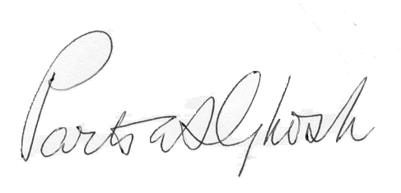

Partha S. Ghosh
VP, Leader, Global Information Industrial Practice

Cc: Mr. Kenneth Rice
Chairman & CEO
Enron Broadband Services

PSG/mms

