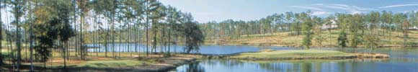

Southern Company

Generation and Energy Marketing

Bruno’s Memorial Classic
Customer Outing

Schedule:

Wednesday
4:30 p.m. – 7:00 p.m. Reception – Sheraton
Special Guest: Doug Jones, Vice President, Energy Marketing
Special Guest: Joe Inman
Sr. PGA Golfer
7:00 p.m. Dinner – Kobe Japanese Steak House

Thursday

Breakfast On your own

8:00 a.m. Golfers meet in lobby
(Two buses will take golfers to the golf courses. Buses will be located on the back side of the hotel outside the meeting rooms. Coffee, muffins, and danish will be available outside the meeting rooms. Soft drinks and juice will be available on the buses.)

8:15 a.m. Shooters meet in lobby (Van will take shooters to Selwood Farm)
8:30 a.m. Golfers depart/ Shooters depart

9:30 a.m. Shooters begin – sporting clays

10:00 a.m. Golfers at driving range

11:00 a.m. Golf begins – Capitol – Prattville

11:00 a.m. Box lunch provided for golfers

12:00 p.m. Shooters – lunch at Selwood – BBQ
1:00 p.m. Shooters Begin – Five Stand

2:30 p.m. Shooters depart to meet golfers for dinner

5:00 p.m. Dinner at golf course

Return to hotel

Friday

Breakfast On your own
Bruno’s Tournament – arrange with your host

Golf Course Information:

www.rtjgolf.com
from the website:

Capital Hill – Prattville/ Montgomery
“The Senator is a traditional Scottish-style layout. Over 150 pot-hole bunkers are situated throughout the 18 holes, and mounds 20 to 40 feet in height engulf the landscape, cleverly hiding the cart path or any other hole from the fairway. The Senator’s bent-grass greens provide exceptional conditions 12 months a year.
“The other two championship courses are very different in appearance. The Legislator will rival some of the more famous courses in North Carolina, with huge pine trees and elevation drops of more than 200 feet.
“The Judge plays alongside the Alabama River with 12 holes bordering the water providing some of the most spectacular scenery and golf holes in the world.”
Directions:

To Corporate Headquarters in Birmingham

From the East

Take I-20 into Birmingham.
I-20 merges with I-59 before reaching downtown Birmingham.
When approaching downtown area, navigate into the left lane.
Exit 22nd Street
At the bottom of the exit, turn left onto 22nd Street.
Follow 22nd Street to 6th Avenue North. Turn right on 6th Avenue North.
Follow 6th Avenue North until reaching APC at the corner of 6th Avenue North and 18th Street.

From the West
Take I-20/ 59 into Birmingham.
When approaching downtown area, follow Gadsden/ Atlanta signs.
Exit 17th Street.
At the bottom of the exit, go straight on 17th Street.
Follow 17th Street to 5th Avenue North.
Turn left onto 5th Avenue North and go one block.
Turn left on 18th Street North.

From the South
Take I-65 into Birmingham.
At the interchange, take I-20/ 59 toward Gadsden/ Atlanta.
Exit 17th Street.
At the bottom of the exit, go straight on 17th Street.
Follow 17th Street to 5th Avenue North.
See map on the following page.

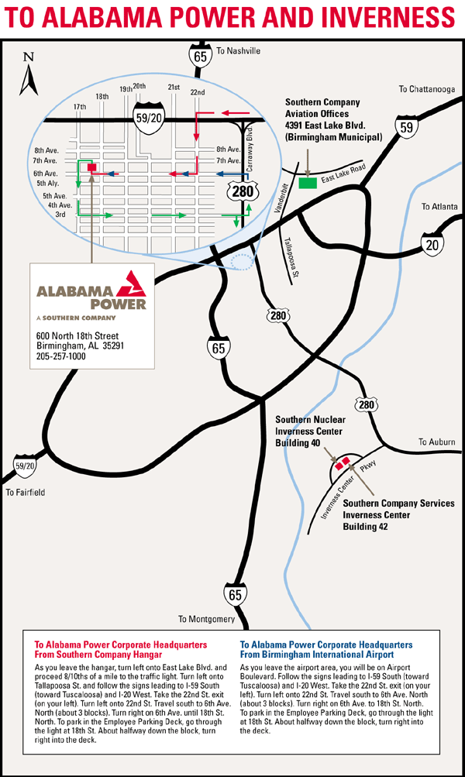
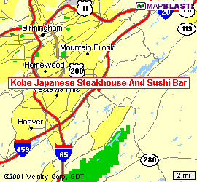
Maps and Directions to Kobe Japanese Steakhouse:
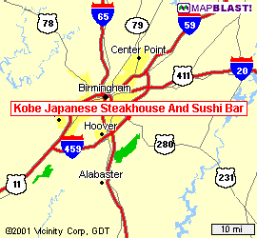
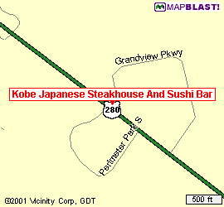

Get on I-20 East and go 2.8 miles.
Continue on ramp at sign reading, “Exit 136 – I-459 to Montgomery/ Tuscaloosa/ Gadsden” and go 0.7 miles.
Bear right on I-459 and go 8 miles.
Continue on ramp at sign reading “Exit 19 U.S. – 280 to Mtn. Brook/ Childersburg” and go 0.9 miles.
Turn right on U.S.-280, AL –38 and go 0.3 miles.
Turn left and go 70 feet.
Bear left on Grandview Parkway and go 50 ft. to Kobe Japanese Steakhouse.

Directions to Selwood Farm Childersburg

Exit the hotel and make a right (east) on U.S. Highway 280
Continue on U.S. 280 approximately 23 miles through Inverness, over Double Oak Mountain, through Chelsea and Harpersville to Childersburg.
Cross the Coosa river into Childersburg. Watch for the sign to Desoto Cavern.
Turn left onto County Highway 76, also called the Desoto Cavern Parkway
Continue on County Highway 76 through the old town of Childersburn for approximately 7 –9 miles (about 2 miles past Desoto Cavern to Selwood Farm.
Turn right into Selwood Farm.

Map and Directions to the Sheraton
Exit Airport and travel East on I-20.
I-20 merges with I-459.
Take the I-459 S. ramp towards Tuscaloosa/ Montgomery.
Merge onto I-459 S.
Take the U.S. –280 exit, exit number 19, towards Mtn Brook/ Childersburg
Keep Left at the fork in the ramp
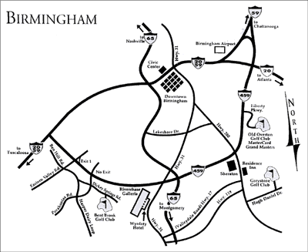
Keep right at the fork in the ramp
Merge onto U.S. 280 East
Turn right onto Perimeter Park S.Turn right onto Perimeter Park S.

Guest List:

- AEC - Cassady, Mike 49. SCANA – Hancock, John
- AEC - Chandler, Chad 50. SCANA – Kleckley, John
- AEC - Graham, Ron 51. SCANA – Leaburn, Lois
- AEC - Gunter, Ralph 52. SCANA – Thompkins, Nicole
- AEC – Walker, James 53. TECO – Brown, Lynn
- AEC – Williams, Herman 54. Tenaska – Lood, Erik L.
- AEP – Moreland, Marcus 55. Tenaska – Smith, Kevin
- Ameren - David Chevalier 56. TVA – Goza, Stuart
- Ameren - Fitzgerald, John 57. TVA – Harmon, Clyde S.
- Aquila – Darby, Ben 58. TVA – Homberg, Scott
- Aquila - Forsen, Kay 59. TVA – Walker, Glenn G.
- Aquila - Via, Troy 60. Dominion Pwr – Muchhala, Chimon
- Axia - Egan, Mark 61. Dominion Pwr – Humphrey, Chip
- Axia - Weisman, Scott 62. Williams – Lapham, Melinda
- Cargill - Hiller, Mike 63. Williams – Manley, Brigid
- Cinergy - Hughes, Donald 64. Williams – Woodard, Jake
- Cinergy - Hughes, Mike 65. WRI – Gaumer, Doug
- Coral - Serri, Becky 66. WRI -- Joey, Hoytol
- DETM - Black, Brandi 67. WRI – Lane, Henry
- DETM - Jones, Jordan
- DETM - Odum, Marcus
- DTE - Booze, Dana
- DTE - Whitener, Sue
- Duke - Johns, Melisa
- Duke - Perry Sams
- Dynegy - Pollard, Byron
- Dynegy – Calhoun, John
- El Paso - Buckles, Sanford
- TEA - Heidi Giustiniani
- Enron - Garcia, Miguel
- Enron - Hernandez, Juan
- Exelon- Zednick, Bill
- FP&L - Tammy, Ed
- LEM - DePaull, Tom
- LEM - Hinson, Dale
- LEM - Murphy, Maria
- LEM - Tompkins, Ray
- LG &E - Balmer, Chris
- LG&E - Krebs, Tom
- Mirant - Blankenship, Chris
- Mirant - Norman, Jason
- Progress Energy-Campbell, Philip W.
- Progress Energy-Carver, Wayne
- Progress Energy-Keen, Michael
- Reliant – Powers, Bill
- Reliant - Georgio, Jackie
- SCANA - Folsom, Eddie
- SCANA - Ballentine, Sally

