November 13, 2000
Confidential & Proprietary

Information Memorandum

The Brownsville and Caledonia Plants

The Brownsville and Caledonia Plants

This information memorandum (this “Memorandum”) and the information contained herein are subject to the confidentiality agreement (“Confidentiality Agreement”) entered into between you on the one hand and Enron North America Corp. (“Enron North America”), on the other hand.

Certain information included in this Memorandum contains forward-looking statements identified by such words as “expect”, "anticipate”, or “project.” Such statements are based on current expectations and involve a number of known and unknown risks and uncertainties that could cause the actual results and performance of the power generation plants (“Plants”) to differ materially from any expected future results or performance, expressed or implied, by the forward-looking statements, including expectations regarding the future results of operations of the Plants. Enron North America has identified important factors that could cause actual results to differ materially from such expectations, including development uncertainty, operating uncertainty, acquisition uncertainty, uncertainties relating to power and gas markets, weather, uncertainties relating to domestic and international economic and political conditions and uncertainties regarding the impact of regulations, changes in government policy, industry deregulation and competition. You have an obligation to evaluate all such risks for yourself. Enron North America does not assume responsibility to update forward-looking information contained herein.
This Memorandum does not purport to be all-inclusive or to include all information that you may desire in investigating the Plants or to evaluate the transactions described herein. Any estimates and projections contained in this Memorandum involve significant elements of subjective judgment and analysis, which may or may not be correct. Neither Enron Corp. nor any of its affiliates, employees, shareholders, members or representatives makes any representation or warranty, express or implied, as to the accuracy or completeness of the information contained herein or any other information (whether communicated in written or oral form) transmitted or made available to you. Enron North America and its shareholders, affiliates, employees, members and representatives expressly disclaim any and all liability which may be based on the information contained herein (or any errors or omissions therefrom) or relating to or resulting from the use of this Memorandum, the information contained herein or such other information received by you or any of your affiliates or representatives.

Nothing in this Memorandum is, or shall be relied upon as, a promise or representation, whether as to the past or future. Enron North America does not intend to update or otherwise revise this Memorandum following its distribution, and you should not expect Enron North America to do so. You are expected to conduct an independent investigation and evaluation in connection with any proposed transaction.

Enron North America does not assume responsibility to update any projections or forward looking statements contained herein. Enron North America expressly reserves the right, in its absolute discretion, to: (1) reject any or all offers or terminate discussions with you for any reason or no reason (in Enron North America’s sole discretion); (2) negotiate with one or more potential purchasers at any time and enter into definitive agreements for the sale, or other transaction involving, all or a subset of the Plants without prior notice; and (3) discontinue, amend, or modify, at any time, in its sole discretion, any procedures relating to this process.

NEITHER THIS MEMORANDUM NOR ITS DELIVERY TO YOU SHALL CONSTITUTE AN OFFER TO SELL ANY SECURITY OR ENTER INTO ANY OTHER TRANSACTION OR COMMERCIAL AGREEMENT.

Table of Contents

1. Location of Plants
2. SERC-TVA Subregion
3. Operating Information
- The Brownsville Plant
- The Caledonia Plant

Location of Plants

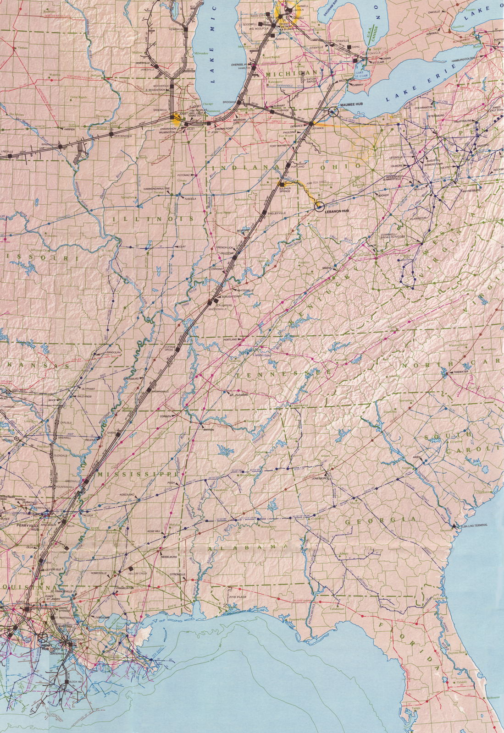
Brownsville, TN

SERC-TVA Subregion

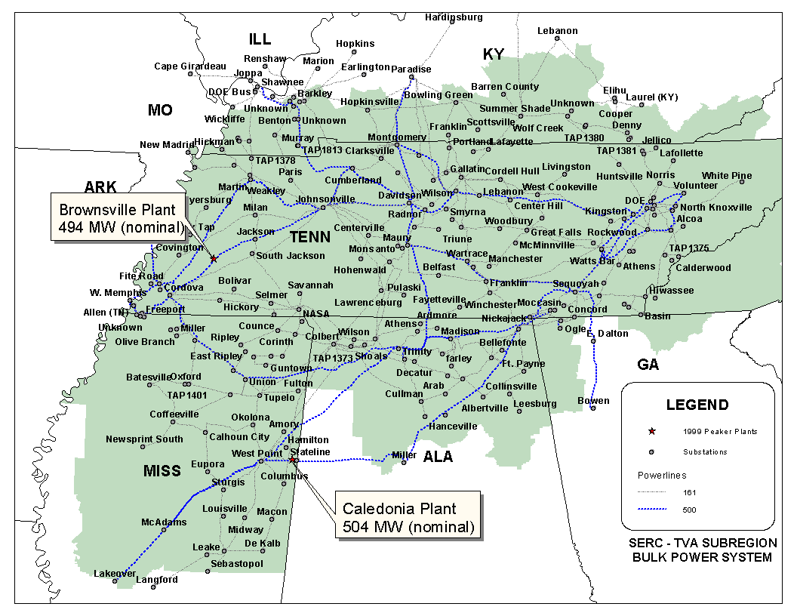

Operating Information

Summary of Key Data

 | Brownsville Plant | Caledonia Plant
Region | SERC | SERC
Interconnected Area | TVA (500 kV) | TVA (500 kV)
Control Area Name | ENSE | ENCA
Turbine No./Type | 2 x W 501 D5, 2 x W 501 D5A | 6 x GE 7EA
NO_{x} Compliance Technology | 2 x Water Injected D5A, 2 x Steam Injected | DLN
NO_{x} (Per Unit) | < 15 PPM (501 D5), < 25 PPM (501 D5A) | < 15 PPM
CO (Per Unit) | < 25 PPM | < 25 PPM
Capacity @ 90⁰ degrees (MW) | 480 | 470
Heat Rate @ 90⁰ (HHV, Btu/KWh) | 11,406 | 12,300
Gas Interconnect | ANR | Tennessee Gas
Approximate Maximum Annual MWh | 674,000 | 558,000

The Brownsville Plant - Haywood County, Tennessee

Overview

General. The plant is a 494 MW (nominal) natural gas-fired, simple-cycle merchant generation facility (the “Brownsville Plant”). The Brownsville Plant has been designed to facilitate a future plant expansion or conversion to combined cycle.

Ownership. The Brownsville plant is owned by Brownsville Power I, L.L.C., a direct, wholly-owned subsidiary of Enron North America.

Location and Plant Site. The Brownsville Plant is located on an approximately 134-acre tract of land, five miles east of the city of Brownsville in Haywood County, Tennessee. The Brownsville Plant site is located along Beach Grove Road, less than two miles south of Interstate 40. The plant is located in the TVA subregion of SERC. The Brownsville Plant has been certified as a control area in accordance with NERC policy. The control area is designated ENSE.

Plant Equipment and Layout. The Brownsville Plant consists of two Westinghouse Model 501 D5 gas turbines each rated at 119 MW (nominal), and two Westinghouse Model 501 D5A gas turbines each rated at approximately 128 MW (nominal). The plant was constructed by NEPCO and achieved commercial operation in June 1999. At 90 degrees Fahrenheit and at full load, the Brownsville Plant has a net heat rate of approximately 11,406 Btu/kWh, HHV, and a net capacity of approximately 480 MW. Water usage is approximately 450 gallons per minute (“gpm”) during operation. Water is supplied by on-site wells.

Interconnection

Transmission. The Brownsville Plant is interconnected to 500 kV TVA line that traverses the site.

Gas Transportation. The Brownsville Plant is fueled by natural gas. The facility is interconnected into a natural gas pipeline system owned by ANR Pipeline Company (“ANR”). ANR transports and delivers natural gas and provides gas parking and lending services to the Brownsville Plant, pursuant to an interruptible transportation service agreement and an interruptible parking and lending service agreement. The term of each of these agreements ends on March 31, 2009. The interruptible transportation service agreement and the interruptible gas parking and lending service agreement will continue on a month-to-month basis after March 31, 2009, until terminated by either party.

Wholesale Revenue Opportunities

Brownsville Power I, L.L.C. is qualified as EWG and has the authority to sell energy and capacity at market based rates. The Brownsville Plant’s location in TVA and its access to the eastern US electricity market will provide sales opportunities in the wholesale power markets.

Plant Permits

Air Permits. The Brownsville Plant is considered a minor source emitter (per EPA 40CFR51) and operates under a non-PSD air permit which allows annual emissions of 249 tons/year for NO_{x} and CO as measured by certified Continuos Emission Monitoring System (“CEMS”). Based on these limitations, the expected maximum annual operating hours of the Brownsville Plant, at full load, is approximately 1,365 hours.

Baseload Emission Information
NO_{x} (Per Unit): < 15 PPM (501 D5) and < 25 PPM (501 D5A)
CO (Per Unit): < 25 PPM

Zoning. The Brownsville Plant site is zoned as industrial.

BROWNSVILLE
ENSE
G3
G2
G1
G4
B
B
B
GSU T1
GSU T2
Summer
Nominal
Winter
Unit MW Rating:
115
119
124
125
128
133
Gas Transporter:
ANR
Gas Daily Index:
ANR (LA Onshore)
Between Chicago LDC's & ANR ML7
B = Breaker
GSU = Generator Step-up Unit
B
Bus 1 (500 kV)
B
B
B
B
Bus 2 (500 kV)
Jackson
Substation
Cordova
Substation
500 kV

Site Pictures

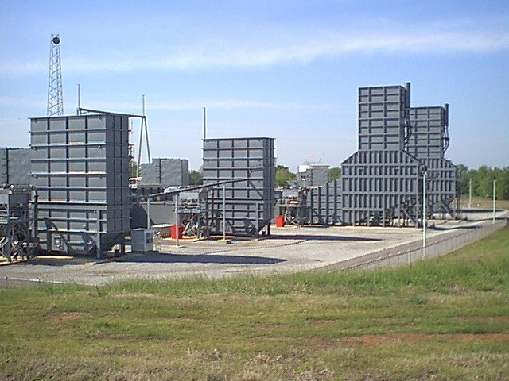

Exhaust Stacks

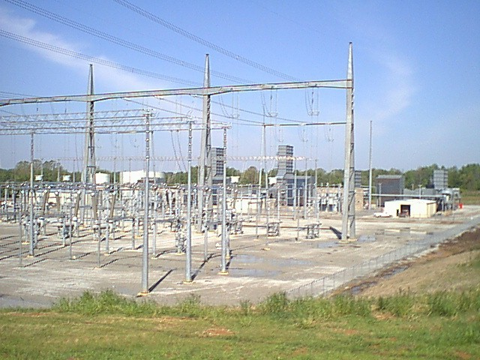

TVA Switchyard (500 kV)

The Caledonia Plant - Lowndes County, Mississippi

Overview

General. The plant is a 504 MW (nominal) natural gas-fired, simple-cycle merchant generation facility (the “Caledonia Plant”). The Caledonia Plant has been designed to facilitate a future plant expansion or conversion to combined cycle.

Ownership. The Caledonia plant is owned by Caledonia Power I, L.L.C., a direct, wholly-owned subsidiary of Enron North America.

Location and Plant Site. The Caledonia Plant is located on an approximately 60-acre tract of land, 15 miles northeast of the town of Columbus, Mississippi. The Caledonia Plant site is located along Caldwell Road, near the intersection of Caldwell Road and Seed Tick Road. The plant is located in the TVA subregion of SERC. The Caledonia Plant has been certified as a control area in accordance with NERC policy. The control area is designated ENCA.

Plant Equipment and Layout. The Caledonia Plant consists of six General Electric 7EA gas turbines, each rated at approximately 84 MW (nominal). The plant was constructed by NEPCO and achieved commercial operation in June 1999. At 90 degrees Fahrenheit and at full load, the Caledonia Plant has a net heat rate of approximately 12,300 Btu/kWh, HHV, and a net capacity of the plant is approximately 470 MW. Enron North America has the option to peak fire the units which adds 50 MW plant-wide of output (520 MW total) at 90 degrees Fahrenheit. Water usage is 120 gpm during evaporative cooling (fogging) operations. Water is supplied by the local municipality.

Interconnection

Transmission. The Caledonia Plant is interconnected into 500 kV TVA line at the Lowndes substation.

Enron North America submitted an interconnection request to Southern Company and TVA to allow dual interconnection at the Plant. Southern Company is anticipated to complete an interconnection study by the end of November 2000. TVA is projected to complete its interconnection study by January 2001.

Gas Transportation. The Caledonia Plant is fueled by natural gas. The facility is interconnected into a natural gas pipeline system which traverses the site and is owned by Tennessee Gas Pipeline Company (“Tennessee Gas”). Tennessee Gas may terminate the facilities agreement upon sixty days notice to Caledonia Power I, L.L.C. if:

- gas has not flowed through the interconnection facilities during the previous twelve months; or
- Caledonia Power I, L.L.C. has caused the interconnection facilities to be disconnected or removed.

Tennessee Gas performs certain services relating to the interconnection facilities for Caledonia Power I, L.L.C.. Tennessee Gas transports and delivers natural gas to the Caledonia Plant pursuant to both interruptible and firm gas transportation agreements. The term of the firm gas transportation agreement began on June 1, 1999, continues until May 31, 2009 and is automatically renewed for successive five year periods unless Caledonia Power I, L.L.C. provides Tennessee Gas with one year’s prior written notice of termination. The term of the interruptible gas transportation agreement began on April 1, 1999 and will continue on a month-to-month basis until terminated upon thirty days notice by either party.

Wholesale Revenue Opportunities

Caledonia Power I, L.L.C. is qualified as EWG and has the authority to sell energy and capacity at market based rates. The Caledonia Plant’s location in TVA and its access to the eastern US electricity market will provide sales opportunities in the wholesale power markets.

Plant Permits

Air Permits. The Caledonia Plant is considered a minor source emitter (per EPA 40CFR51) and operates under a non-PSD air permit which allows annual emissions of 248 tons/year for NO_{x} and CO as measured by certified Continuos Emission Monitoring System (“CEMS”). Based on these limitations, the expected maximum annual operating hours of the Caledonia Plant, at full load, is approximately 1,088 hours which includes approximately 200 hours of peak-firing.

Baseload Emission Information
NO_{x} (Per Unit): < 15 PPM
CO (Per Unit): < 25 PPM

Zoning. The Caledonia Plant required no local zoning.

CALEDONIA
ENCA
G3
G2
G1
G4
G6
G5
B
B
B
B
B
B
Summer
Nominal
Winter
Unit MW Rating:
78
84
90
Gas Transporter:
Tennessee
Gas Daily Index:
Tennessee, 500 Leg
Chicago LDC
B = Breaker
GSU = Generator Step-up Unit
GSU 1
GSU 2
GSU 3
500 kV Bus
B
B
B
500 kV line to:
TVA
Lowndes
Substation

Site Pictures

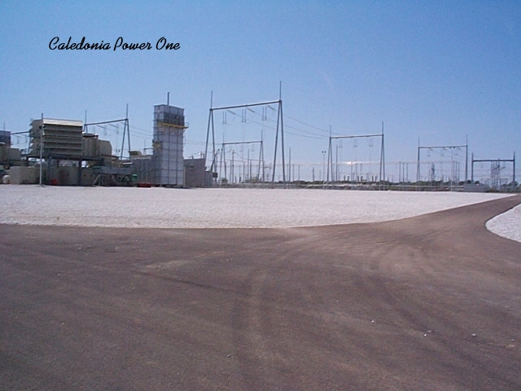

Unit 1 and a portion of TVA Switchyard

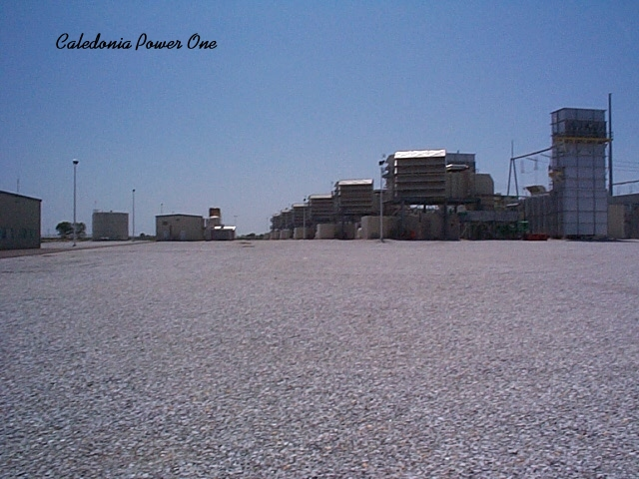

Plant View from Unit 1

