November 6, 2001

VIA EMAIL

To: Board of Directors
Center for Houston’s Future

Dear Fellow Directors:

We will have a called meeting to elect a President and CEO at 4 p.m. on Tuesday, November 13 (at the Partnership office, as usual). Please try to attend as the selection of a CEO is one of the most important responsibilities of directors. Also, assuming the recommendation of the Committee is followed, it would be very fine to welcome in person our first President and CEO and to let him know he has our utmost support. The meeting should be no more than an hour.

If you cannot attend, please use the enclosed proxy and return it to me, reserving the right to vote in person should your plans change.

Also on the proxy is the opportunity to vote on:

- The Compensation Plan of the President and CEO, as recommended by the Structure and Process Committee
- Change in requirement for Written Consent in Lieu of Meeting to 85% instead of 100/%
- Approval of the 2002 Work Plan, which was presented and discussed at the October 18 Board meeting
- The members of the Executive Committee for the balance of this year

Enclosed is the final report of the ad hoc Structure and Process Committee, chaired so well by Rufus Cormier. I will leave revealing their recommendation to Rufus’ report but I want to say, as all would expect from a Committee of this caliber, they conducted the search with thoroughness, fairness and complete dedication to finding the best full-time leader of The Center. They have unanimously recommended a person of prodigious intellect, passion and work ethic who possesses unsurpassed love of Houston and the Center for Houston’s Future.

This is indeed a watershed time in the life of The Center—going from a volunteer-dependent start-up with scant resources to an organization with full-time leadership, strong financial resources and capability to conceive and complete its laudable aspirations.

How grateful I am to those stalwarts as yourself who believed and worked so hard to bring The Center to this grand moment of translating dreams into reality.

With appreciation,

Sincerely,
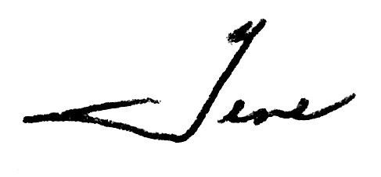
Eugene H. Vaughan

EHV/cjr
Enclosures:

- Final Report of Ad Hoc Structure and Process Committee
- Attendance Response
- Proxy to elect President and CEO

