October 24, 2001

VIA EMAIL

To: Board of Directors
Center for Houston’s Future

Dear Fellow Directors:

There will not be a called Directors meeting Thursday, October 25 as previously announced.

The ad hoc Structure and Process Committee, chaired by Rufus Cormier, yesterday held interviews, as planned, with four excellent candidates. The Committee narrowed the choices. However, as no minorities or women had emerged as candidates and some other potential candidates had not had sufficient time to fully think it through, it was decided that the selection process be continued an additional two weeks. Tom Simmons, head of Spencer Stuart, who is assisting the search pro bono, believes he can within that time period determine if there are additional bonafide candidates. The Committee will meet again on November 6 and commits to a definite recommendation to the Board of one President and CEO at that time.

A lot of effort is going into this process and with some patience we soon will have an outstanding President and CEO.

Please call Rufus (713/229-1544) or me (713/224-2545) if you have questions, suggestions or observations.

Sincerely,
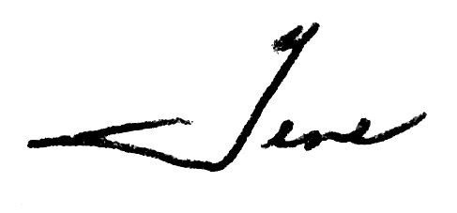
Eugene H. Vaughan

EHV/cjr

