1) $US Chart: As per the last recession, the $US dollar (yellow) was strong once the Fed (white) ended their major easing cycle in 1992. Note that the gold stocks (green) performed well despite this. Also note that the gold stocks seemed to accelerate once the US dollar had an interim peak (early 1993 as per the chart). Gold stocks rose months before bullion did (orange). Finally, the gold stocks peaked when the Fed threatened to tighten (in late 1993). However, there were good opportunities to trade the gold stocks for several years after that.

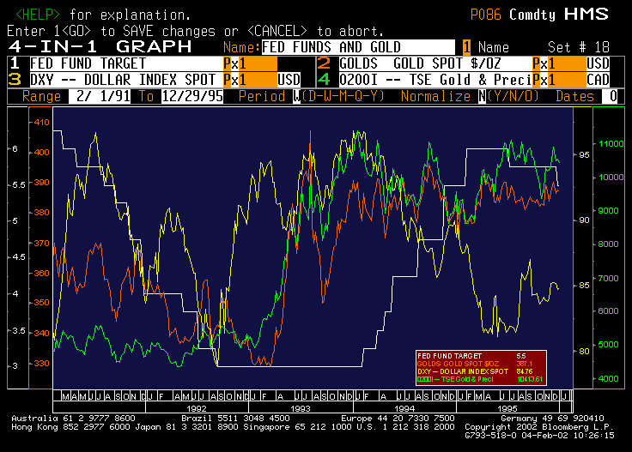
2) CRB Chart: We can see in the following chart that the CRB Industrials (yellow) lagged the gold stocks and bullion. In other words, gold fulfilled its role as a good leading indicator in this case.

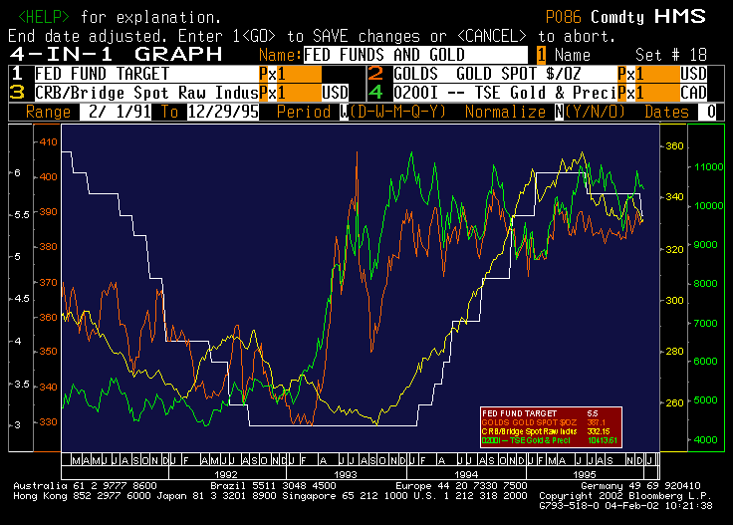
3) CPI: Although gold was purchased as a hedge against inflation (amongst other reasons surely), the inflation rate (CPI; yellow) in circa 1992-1995 was very benign. It is the threat of inflation that propelled gold in this case.

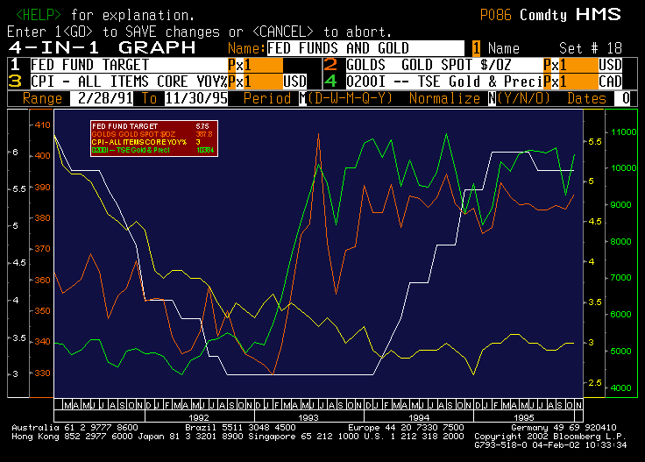

4) Metals and Minerals Index: Like the CRB, gold was a good leading indicator for metal stocks (yellow) as well…

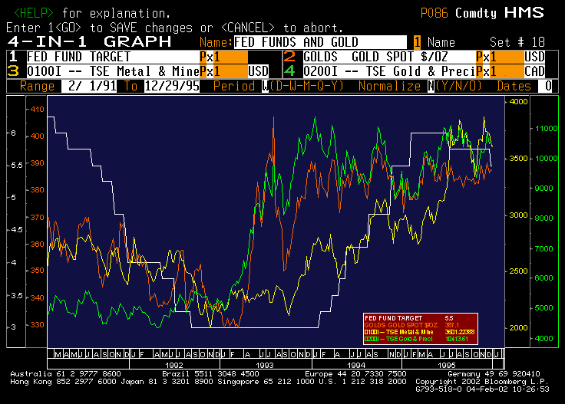

Chad Williams
TD Newcrest
416-308-2360

