Installing Black ICE AGent for Click @ Home PCs

1. Insert CD and click on Start/Run and click on Browse.
2. Find the "BlackICE-CLick@.exe" file (maybe under D:\ or E:\, depending on what your CD-ROM is labeled) and double-click it.
3. Now click on OK. and your program should install.
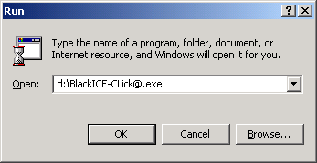

Note: An installation window may not come up, program simply starts running. You can tell if it was successful if the following is in your Taskbar (Next to the Start button):

4. Click on the Close button to hide the BlackIce Agent for Workstation.
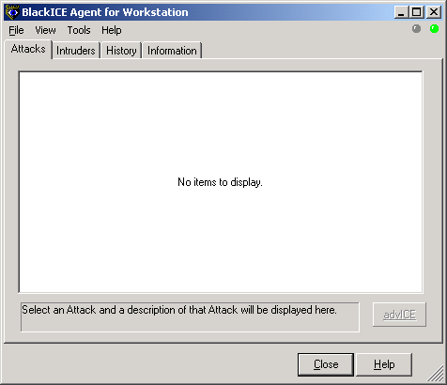
Note: Agent will still be running (Seen by clock on Taskbar's System Tray).

5. Right-click on BlackIce icon in SystemTray and click on "Advance Firewall Settings", select the "IP Address" tab and click on the Add button. In the Add Firewall Entry, type in the following IP Address: 192.189.171.56. Make sure that "Accept" under the Mode section and "Add Trusted Address Entry" is selected. Then click Add button. Repeat for the following IP Addresses: “192.189.171.57” and “172.16.7.0 – 172.16.7.255” (type in as series, without quotations using hypen inbetween”
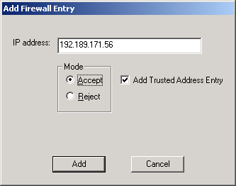
Final screen should look like this. Click OK to close.
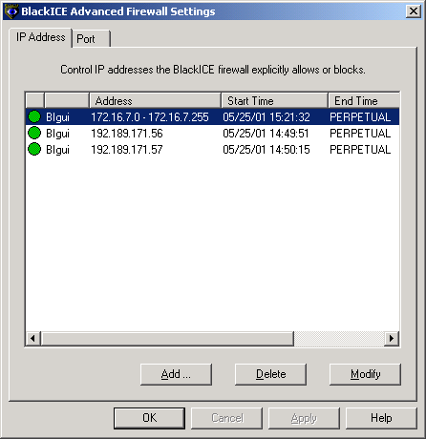

7. Install and configuration is done!

