Monkey Bid’nes !!!

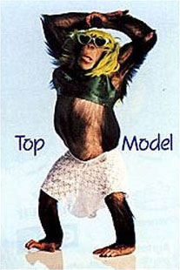

Come and Hang out at Russell’s

“BIG 30”

When: Saturday, December 1st

Where: Talia & Russell’s Place

5454 NewCastle #1235 (directions attached)

Time: 8:30

**No Gifts !!- Just “Unripe” Cards!
Barley and Wheat Beverages available.

