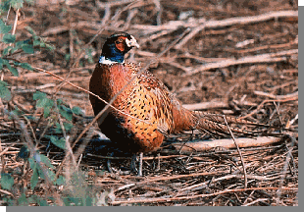

Bird Hunting

Description: Some of the best hunts you will ever experience. You will be able to shoot more birds in some of the finest habitat to be found.

Pick up time: 6:30 a.m.
Drop off @ hotel: 12:30 a.m.

$500.00 per person

This includes: hotel pick-up (approx. 1-1/2 hour drive), breakfast, guns, ammo, dogs, hunting of an assortment of pheasant, chukar and quail, orange hat, lunch and return transportation to hotel.

