

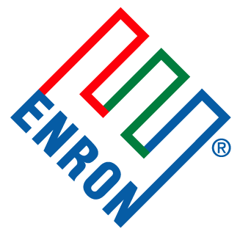

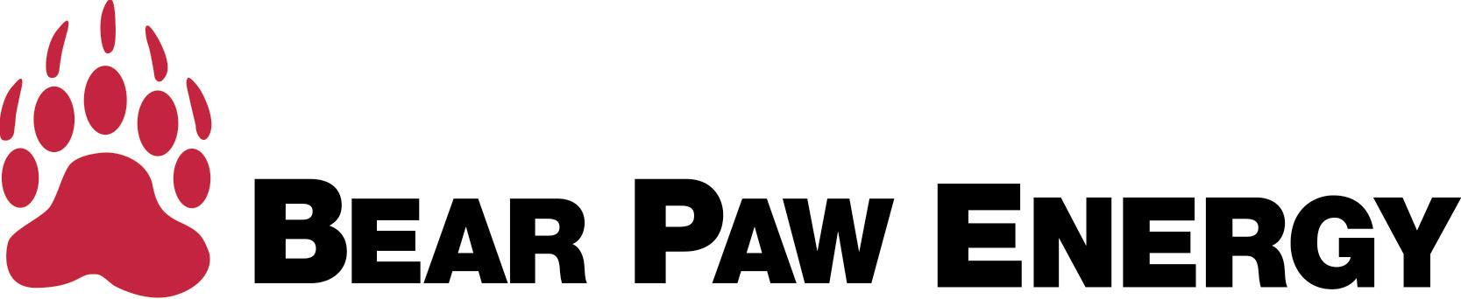

INVITES YOU TO JOIN US AT THE
1ST REGULAR SEASON

DENVER BRONCOS
GAME
AT THE NEW

INVESCO FIELD

AT MILE HIGH

DENVER BRONCOS
VS.

NEW YORK GIANTS

MONDAY, SEPTEMBER 10TH
7P.M.

[…are you ready for some football!]

Please RSVP to Dan Bump (720-946-3632; dan.j.bump@enron.com) or Mark Whitt (303-575-6473; mark.whitt@enron.com) by August 10th


