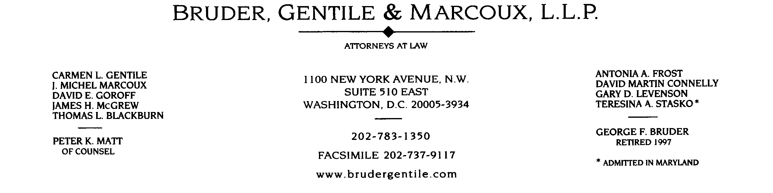

jhmcgrew@brudergentile.com

November 20, 2001

The Honorable David P. Boergers
Secretary
Federal Energy Regulatory Commission
888 First Street, N.E.
Washington, D.C. 20426

Regarding: San Diego Gas & Electric Co., et al.
Docket Nos. EL00-95-045, et al.

Dear Mr. Boergers:

In response to Judge Birchman’s November 15, 2001 order, the City of Pasadena informs the Commission that no portion of the testimony of Eric R. Klinkner filed on November 6, 2001 was filed under seal. The testimony and attached exhibits are not confidential.

Very truly yours,

James H. McGrew
Counsel for the City of Pasadena

cc: Presiding Administrative Law Judge Bruce L. Birchman
All Participants by ListServ

/mnt/main-storage/datasets/enron-docs/doc/BLF1008.DOC+

