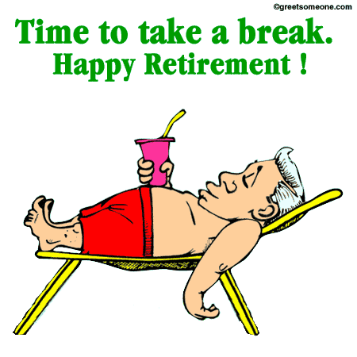
BILL MOORE IS SEMI-RETIRING!
Please join us on Wednesday, May 30th from 1:30 - 2:30 p.m. in EB 4701 for cake and ice cream to celebrate his 27 years of service. He will be returning to Government Affairs on June 4th as a consultant

