Enhancement Request Document
Prepared By: | Tammy Lee-Jaquet | Business Contact: | Tammy Lee-Jaquet
Enhancement Item: | SIRP00067 | Company: | ENA
Priority Status: | High 4/1/01 | Networks Contact: | Ben Nguyen
Supporting documents attached (Y/N): | Y | Date completed & moved to production:

Automate Load of Scheduled Quantity

Draft 10/15/01

CURRENT PROCESS:

Currently during the month and month end a draft of Unify is performed requiring the Logistics’ schedulers to be tracked and balanced on their prospective pipelines. To maintain their balanced position, the electronic scheduled quantities are not loaded into Unify. The process of not loading the electronic scheduled quantity is managed manually by changing the “Schedule Quantity Method” from X12 to X12 log in Unify under Admin/Pipeline by pipeline. When the draft is completed, the schedulers manually enter the schedule quantity information for the days the electronic files were not loaded and the “Schedule Quantity Method” it manually changed back from X12 log to X12 by pipeline.

PURPOSE AND DESCRIPTION OF REQUEST:

The proposed process would provide a view to enter a date(s), select a pipeline(s), and shipper(s) where the scheduled quantities will be moved from X12 to X12 log and from X12 log back to X12. When the switch is made from X12 log back to X12, there should be an option by pipeline(s) to indicate the scheduled quantities sent to X12 log during this period will be loaded into Unify in sequential order.

REQUIREMENTS:

- Both test and production scheduled quantities use the X12 log for the “Scheduled Qty Method”. To distinguish the scheduled quantities we are testing with versus the scheduled quantities in production, add a new “Scheduled Qty Method” of testing to Unify/Admin/Pipeline. See Exhibit 1.
- For an example of the new view “Scheduled Qty Log” see Exhibit 3.
- From new view “Scheduled Qty Log” Select an EDI (only) pipeline(s) and shipper(s) to perform the changing of the “Scheduled Qty Method”. See Exhibit 2 for an example of pick list for shipper and pipeline.
- When the Scheduled Qty Method is changed in new view it will automatically update the Scheduled Qty Method in the Admin/Pipeline/Pipeline Details view.
- New view will contain “Scheduled Qty Method” selection list containing the two below options.
  - X12 Log
  - X12
- Once a “Scheduled Qty Method” is selected, a second option is available ONLY if the X12 is selected. The second option is “Load logged schedule qty”. The “Load logged scheduled qty” option will load the logged schedule quantity. (Note: how do we mange the dates since they will be different than the commencement and termination dates of the X12.)
- A commencement date/time field and termination date/time field to enter dates for changing the “Schedule Qty Method”.
- Validate the commencement date/time must be equal to or greater than the current date but not to exceed the termination date. Error message will be displayed.
- Validate the user cannot have a termination date/time less than the commencement date or less than the current date. Error message will be displayed.
- Validate the user cannot have a termination date greater than 30 days. Error message will be displayed.
- Validate the user cannot have a commencement date greater than 30 days. Error message will be displayed.
- If a date range is entered and no data is available, error message will be displayed.
- A new report will be designed to display status of scheduled quantities. The information contained on the new report is shown in Exhibit 4. The report should provide the ability to print, sort by column headings.

Exhibit 1

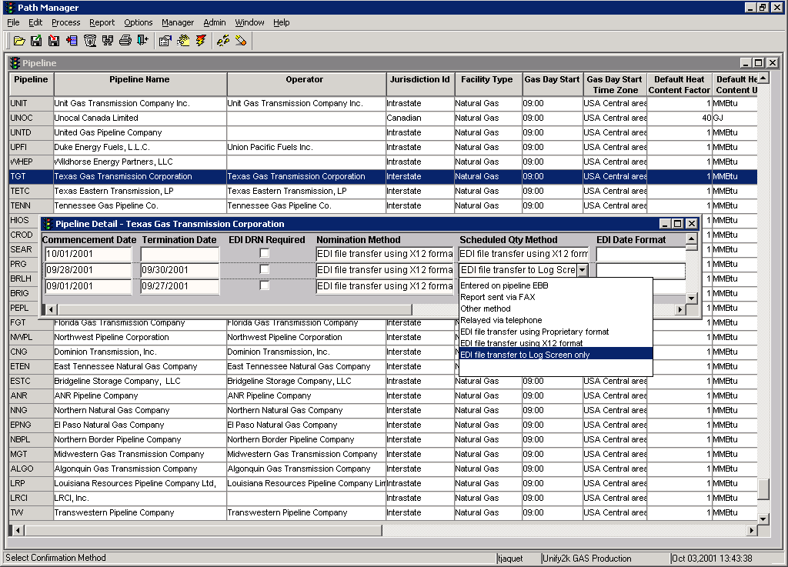

Exhibit 2

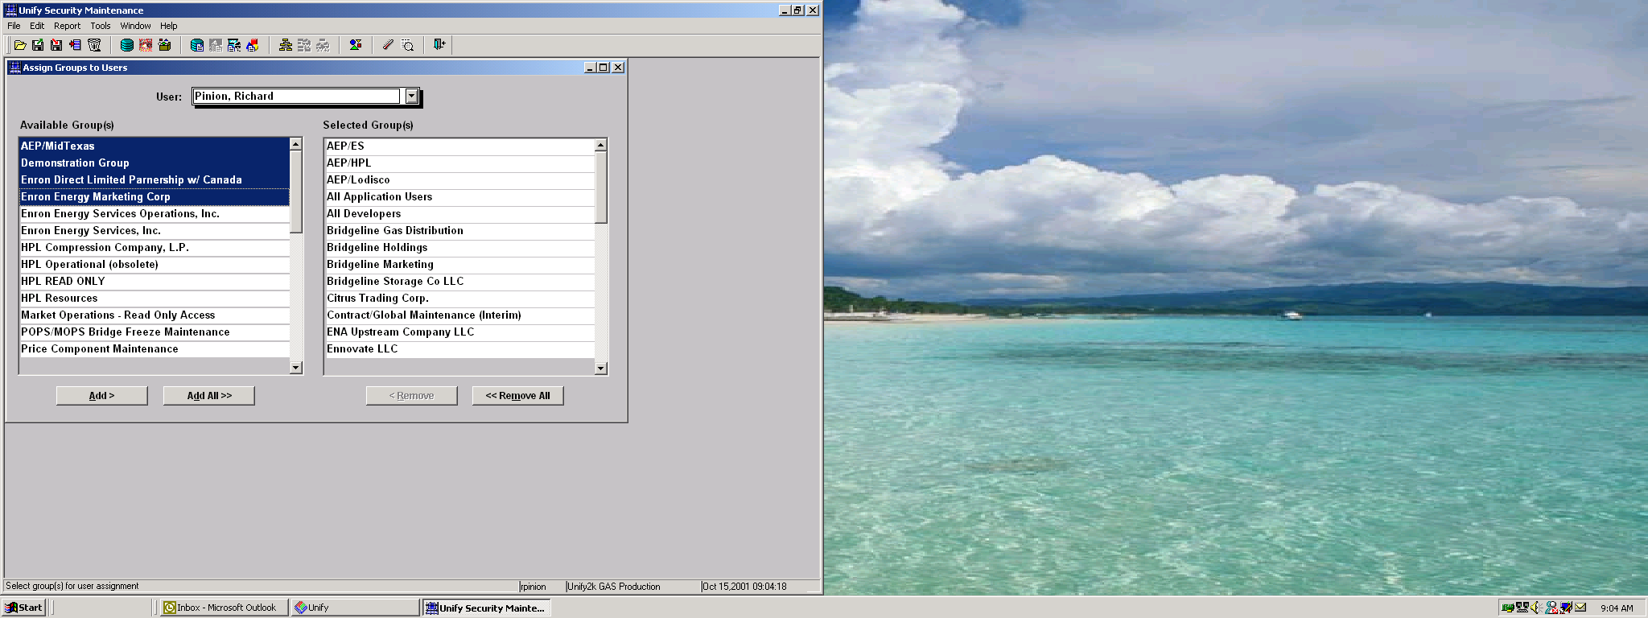
Exhibit 3

Scheduled Quantity Log

Commencement Date/Time: Termination Date/Time:

Pipeline: (see Exhibit 2)

Shipper: (see Exhibit 2)

EDI Scheduled Qty:

X12 Log X12 Load logged sched qty

Exhibit 4

Schedule Quantity Log Status Report

Sched Qty Load

Commencement D/T Termination D/T Pipe Name Shipper Method Sched Update D/T User Id
10/29/01 1:00 p 10/31/01 8:00 a FGT ENA X12 log Yes 10/28/01 4:30 p tjaquet
10/29/01 1:00 p 10/31/01 8:00 a ANR ENA UP X12 log Yes 10/28/01 4:30 p tjaquet
10/29/01 1:00 p 10/31/01 8:00 a EPNG ENA X12 log No 10/28/01 4:30 p tjaquet
10/31/01 8:01 a FGT ENA X12 log Yes 10/28/01 4:30 p tjaquet
10/31/01 8:01 a ANR ENA UP X12 log Yes 10/28/01 4:30 p tjaquet
10/31/01 8:01 a EPNG ENA X12 log No 10/28/01 4:30 p tjaquet

