Dec 29 2000

Stinson Gibner and Sandeep Kohli
Enron
Houston, Texas
USA
By E-mail.

29 December 2000
Re: Response To Enron’s Request For Proposal For Complete Detailed Analysis Of The India Electricity System And To Evaluate The Dhabol Plant Performance.

Dear Stinson and Sandeep

On behalf of Henwood Energy Services, Inc (“Henwood”), I have pleasure in enclosing our proposal to provide a detailed study of the performance of the Dhabol plant in the Indian Electricity System.

Henwood is able to assemble an exceptionally strong team that can bring the expertise required to successfully meet your needs. Key members of the Henwood team include Robert Schenck, Cosimo Coscia and Elizabeth Aitken.

Robert Schenck will provide direct practical experience in market analysis and market modelling of many Asia-Pacific electricity markets. He will be supported by Elizabeth Aitken who has developed considerable expertise in the development of Asian data bases. Cosimo Coscia will provide technical assistance and supervise the building of the data base. In addition, an analyst will be provided to assist with the modelling and extraction of data.
The Henwood team provides a good balance of market and regulatory knowledge together with the most up to date market modelling skills and tools. These skills and tools have been developed because of Henwood’s extensive practical commercial knowledge and experience in the energy industry in Australia and overseas. As such, our team will be able to provide a very professional level of contributions to Enron.If you have any further queries please feel free to call me on (+61) 8 8179 2001 or (+61) 412 234 366.

I look forward to an opportunity to working with your company on this project

Yours faithfully,
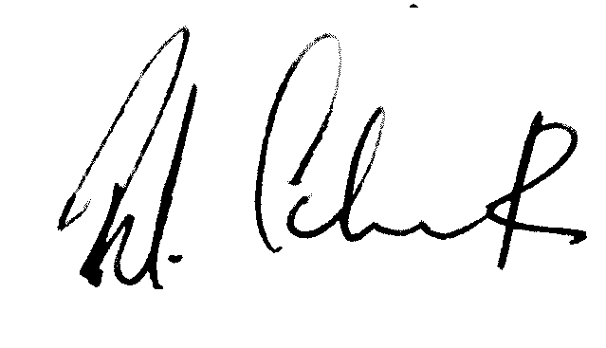

Robert Schenck
Director – Asia Pacific Region

Authorisation

I authorize Henwood Energy Services, Inc. to provide, for the commercial terms stated in the proposal dated 29 Dec 2000, the for complete detailed analysis of the India electricity system and to evaluate the Dhabol plant performance.

Contact Details for Billing:

(Signature) |  | (Signature)
(Name) |  | (Name)
(Title) |  | (Title)
(Date) |  | (Date)

