August 2001 Short Circuits - Electricity by Rita Hartfield
Short Circuits

A combination of under investment in transmission and distribution (T&D) assets over the last decade as well as unprecedented growth in demand for high-quality power has created an increasing imbalance between the demand for electricity and the grid’s ability to deliver that electricity. According to Edison Electric Institute, 94% of power outages are due to inadequate transmission and distribution rather than a lack of generating capacity.
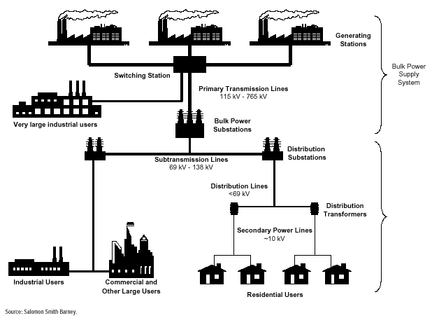

Transmission investments have declined on average about $115 million per year, in 1997 real dollars, for over 20 years.

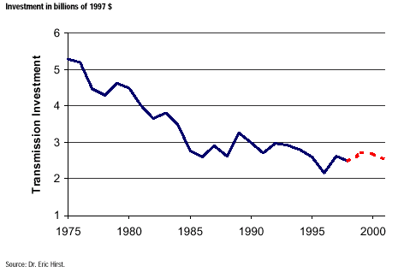

T&D Asset Ownership
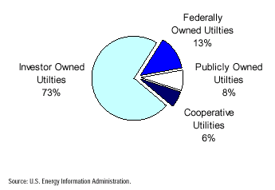

As the complexity of electronics increases, so do the devices’ sensitivity and vulnerability to “dirty” power, such as power surges, spikes and blackouts. Even dips in power may be enough to harm connected devices. While the overall grid’s reliability is estimated at 99.9% reliability, equivalent to over eight hours of downtime a year, much of the problem is rooted in the T&D system.

The Huber Mills Digital Power Report states that reliability demands for the telecom and dot com world start at “six nines,” or 99.9999%, uptime. This means that in a year, the acceptable downtime is about a half of a minute. A power interruption of less than a second is enough to cause a critical system failure, resulting in possible material costs and lost revenues, not to mention intangible costs such as business reputation.

Why hasn’t T&D infrastructure maintenance and growth kept up with the increasing demand?

Investing in T&D assets yields a low return for the investing utility company and cost recovery can take from 3 to 5 years for distribution assets and up to 28 years for transmission assets. The cost of a new transmission line can run from an average of about $1.5 million per mile to as high as $80 million per mile in a typical dense urban environment. About 70% of this amount goes to excavation, construction, permitting, and other infrastructure costs. According to RDI, a 3.3 mile, underground transmission line upgrade across part of urban Boston took a Boston-based company 5 years from project start to finish. The company held more than 130 neighborhood and community meetings.

A return of 10%to 11% is expected on T&D investments while a return of 18% to 20% can be expected on new generation investments.

How long are users willing to wait?

For a residential user, the occasional rolling brownout or blackout is an inconvenience, but not a disaster. On the other hand for a microchip manufacturer or online business such occurrences can be disastrous.

Even in regions across the country where power plant construction is at a fever pitch, without incentives to improve transmission links, inefficient, high cost plants may remain economically viable for some time to come.

What are the alternatives?

For commercial users, and quite possibly residential users as well, a quick solution is distributed generation. Some compelling reasons for adopting distributed generation include high quality power, time to deploy, reduced transmission line loss, and more equitable costs – those that need high quality power are the ones that pay for it.

For those not willing to invest in distribute generation, an awful lot rides on finding a workable approach to regional transmission issues. The chart below illustrates current regional transmission systems (RTOs).

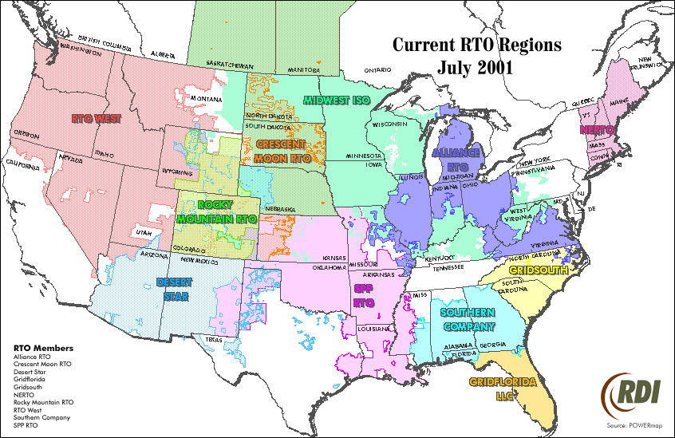

The Federal Regulatory Commission's Order 2000 requires electric utilities to transfer operating control of their transmission assets to RTOs. This represents a major change in the management of the nation's transmission grid.

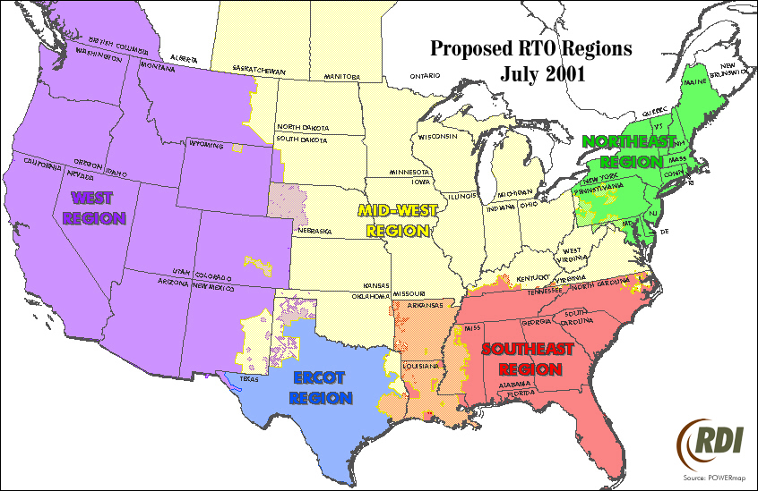

The Largest IOU Holding Companies

Mergers and acquisitions have dropped the number of utility holding companies from 92 in 1999 to 80 in 2000. These 80 utility holding companies had total revenues of $561 billion with net income of $13.4 billion in 2000.

Enron Corp. topped RDI’s list of investor owned utility holding companies with $100.8 billion in total revenue and nearly $1 billion in net income in 2000. Duke Energy Corp. is the number two with $49.3 billion in total revenue and $1.8 billion in net income. Dynegy is a distant third with $29.45 billion in total revenue and nearly $0.5 billion in net income followed closely by Reliant Energy with $29.34 billion in total revenue and $1.9 billion in net income.

When electric operating revenues are used to determine the leading investor owned utility holding companies, the picture changes dramatically. American Electric Power (AEP) becomes the top utility holding company with $13.7 billion in total revenue ($12.3 billion from electric operations) and $2.0 billion in net income. The Southern Company is second with $10.1 billion in total revenue ($10.2 billion from electric operations) and $2.4 billion in net income.

Source: SalomonSmithBarney, Electric Equipment/ Power Technology, June 4, 2001; RDI, Enron Tops List of Largest IOU Holding Companies, August 22, 2001; RDI, Transmission Lines: a local issue, May 18, 2001.

