August 2001 Gas Flows - Natural Gas by Rita Hartfield
Gas Flows

The spot price for both natural gas and crude oil have been on a general downward trend since the beginning of the year.

U.S. Natural Gas & Crude Oil Spot Prices
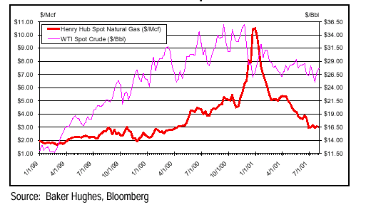

Industrial demand, including fertilizer and chemicals, fell an estimated 2.5 Bcf/d, on average, over the January to April time frame. It is unclear what gas price is required to recapture this demand -- 1) some if this demand will be permanently lost to overseas producers as U.S. natural gas prices are no longer as competitive as they once were, 2) some of this demand will be recaptured as falling gas prices decrease the incentive of customers to conserve, and 3) some gas demand will come back as economic activity picks up.

Merrill Lynch analyst, in their August 9, 2001 Natural Gas Weekly Perspectives, believe that residual fuel in the $3.00/MMBtu range will offer some resistance to lower natural gas prices over the near-term as fuel-switching finally kicks-in. The addition of 40,000 MW of new generation through 2002 combined with the oil and gas industry’s muted supply response (1.5% expected gain for 2001 despite record drilling levels) should keep long-term supply and demand in balance. Merrill Lynch’s 2001 - 02 Henry Hub price deck stands at $4.50-$3.75/Mcf.

Lehman Brothers believes that natural gas prices will trade, over the next several years, between the price of residual fuel oil (the “floor”) and number 2 fuel oil prices (the “ceiling”).

In its August 16, 2001 monthly briefing, CERA projects the price of Henry Hub natural gas to drop from an average price of $4.25/MMBtu in 2001 to $2.80/MMBtu in 2002. CERA believes once the heat subsides and summer is declared over, nothing fundamental in the market will prevent a significant slide in price to well below $3.00/MMBtu. Absent storm activity in the Gulf, storage injections will remain strongly. Without heat stimulating power generation consumption, demand for natural gas will be very weak. Price recovery from this decline could be long in coming. The forces dampening demand—a weak economy and accompanying weakness in key industrial sectors—are not likely to reverse until next year. [See demand forecasts are on the following page]. Supply is building even though it is less than expected.

For September, CERA expects a pronounced decline in price, to an average of $2.85 per MMBtu at the Henry Hub.

Natural Gas Storage Volumes

Natural gas storage volumes are currently trending to a level above the historical 5-year average of storage injection. Storage volumes could reach the 3.1 to 3.4 Tcf range by November 1. This would the highest level since 1998 and the second highest in the post-Order 636 era.
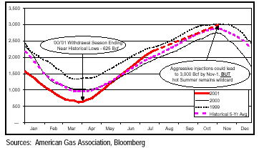

Natural Gas Consumption by End-Users
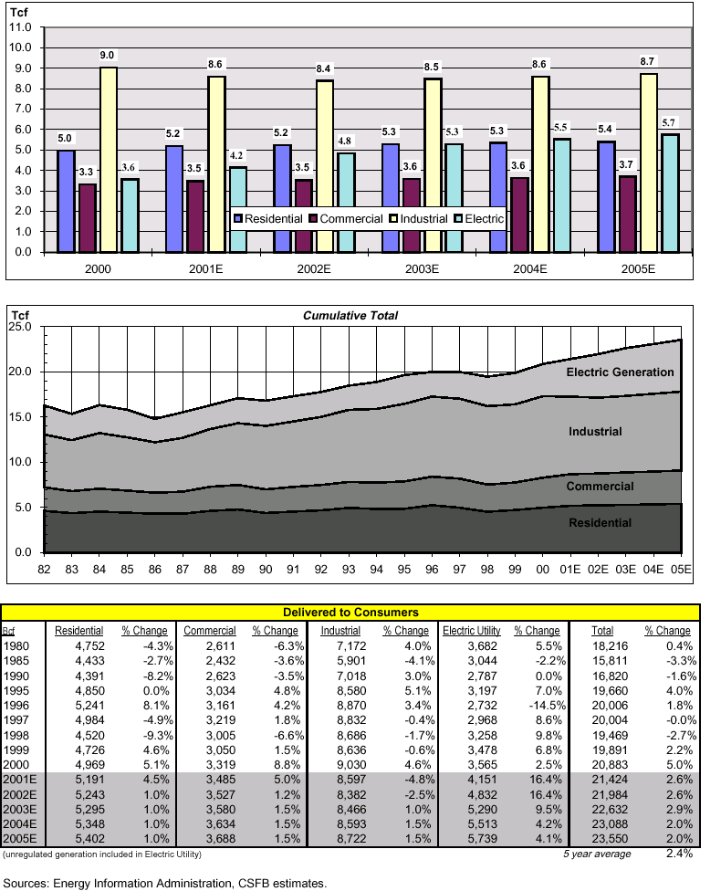

Source: CERA Monthly Briefing, Gas-on-Gas Competition, August 16, 2001; Merrill Lynch, Natural Gas Weekly Perspectives, August 9, 2001; Credit Suisse First Boston, Natural Gas & Power, Upside Catalyst, August 13, 2001; Lehman Brothers, Natural Gas Demand Elastic, June 1, 2001.

