Kovair Architectural Overview

Technical White Paper
August 2000

Kovair, Inc.
2665 N. First St
San Jose, CA 95134
408-546-2000
www.kovair.com

Title, Subject, Last Updated Date, Reference Number, and Version are marked by a Word Bookmark so that they can be easily reproduced in the header and footer of documents. When you change any of these values, be careful not to accidentally delete the bookmark. You can make bookmarks visible by selecting Tools->Options…View and checking the Bookmarks option in the Show region.
To add additional approval lines, press [Tab] from the last cell in the table above.
You can delete any elements of this cover page that you do not need for your document. For example, Copy Number is only required if this is a controlled document and you need to track each copy that you distribute.

Contents

Contents ii
Introduction 3
What does a STRATEGIC relationship entail? 5
How do you conduct a customer relationship via the Web? 6
Attempts to Solve the Problem 8
Traditional Application Structures 9
The Kovair SRM Platform: Web Application Structure Designed for Scalability and Flexibility 9
Kovair Business Services: Overview 11
Kovair Business Services: Fundamental Services 11
Single Sign-on Security and Authorization 13
Customizable Authentication Service (CAS) 14
Roles and Access Control Lists 15
3rd Party Integration with a Single Sign-on 15
Kovair Presentation Services 16
The Kovair Open Interoperability Engine (KOIE) 17
VIPCenter Services 18
EJB Framework, Enterprise-Class Database, and High-Availability Platform 19
Conclusion 19

Introduction

The ability to create an intimate, highly personalized connection between you and your customer directly impacts your revenue and valuation. Refining the customer interaction process is the first critical step in developing a CRM strategy.

Yet, customer interaction today remains ad-hoc, labor-intensive, error prone, expensive and above all, not customer-centric.

More and more companies realize that the Web is a perfect medium for providing customized service and building superior relationships. These companies are providing customized websites through which their key customers interact and obtain information relevant to them. Dell, for instance, has developed such mini-sites, dubbed “Premier Pages”, for its top business customers. Dell pulls in $40 million per day in Internet sales, the majority through its customized pages. According to Dell, these sites 1) save its customers time and money finding relevant information, 2) save Dell support and personnel costs and 3) they build more direct relationships. Such early efforts validate the concept and the value of conducting customized relationships via the Web.

Unfortunately, providing such customized service has not been easy. Due to a lack of commercially available software, companies have pieced together solutions manually. These systems are limited in functionality, difficult to deploy on a large scale and require extensive money and Web expertise to manage and maintain.

Until now, no one has directly addressed this problem head-on with a comprehensive, out-of-the box Strategic Relationship Management solution.

The Kovair VIPCenter enables you to easily and quickly create a direct, truly intimate customer connection.

The VIPCenter acts as a Relationship-Specific Window that brings the people, information, and relationship-specific applications together in one place. It is a multi-directional, B2B relationship portal that allows you to build a special environment on the web, branded and tailored by you for each of your key customers.
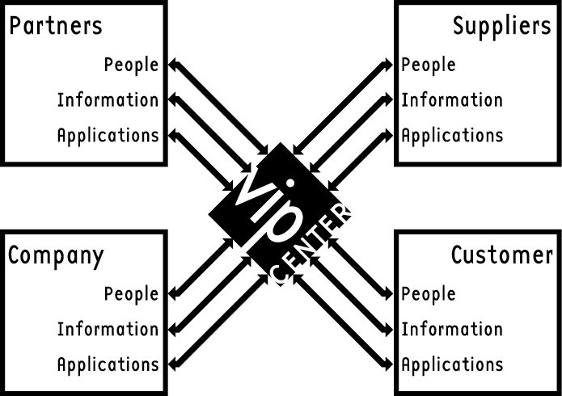

Through this portal, you can collaborate, interact, and transact. It gives you, your customers, and partners secure, role-based access to the content and functionality you all need to do business with each other.

The VIPCenter is not a tool kit, or is it an inflexible, pre-packaged solution. Rather, it is an extensible architecture that allows you to deploy today, while still retaining flexibility for tomorrow.
It is built on an enterprise-class, scalable, secure and robust platform developed on an Enterprise Java Beans (EJB) architecture and built from the ground-up for the web. It was designed to be an extensible system so that with minimal integration effort, the VIPCenter becomes a window into your enterprise, pulling together all the data and transactions relevant to your customer in one place. For the customer, this means a unified seamless experience. For you it means quick time-to-market while leveraging existing and future investments.

Kovair’s VIPCenter is an out-of-the-box solution that enables companies to cost-effectively conduct customized relationships via the Web. Through VIPCenter’s innovative point-and-click interface, a sales rep or an account manager can create customized websites for their key customers in minutes, without any Web programming expertise. Each website serves as a customized forum through which the partner or customer interacts, exchanges, transacts and obtains information pertinent to its needs. The VIPCenter also automates the processes associated with conducting customer relationships, eliminates rote administrative tasks, and dramatically reduces management costs and time.

What does a STRATEGIC relationship entail?

The customer relationship lifecycle can be broken down into four stages. They are:

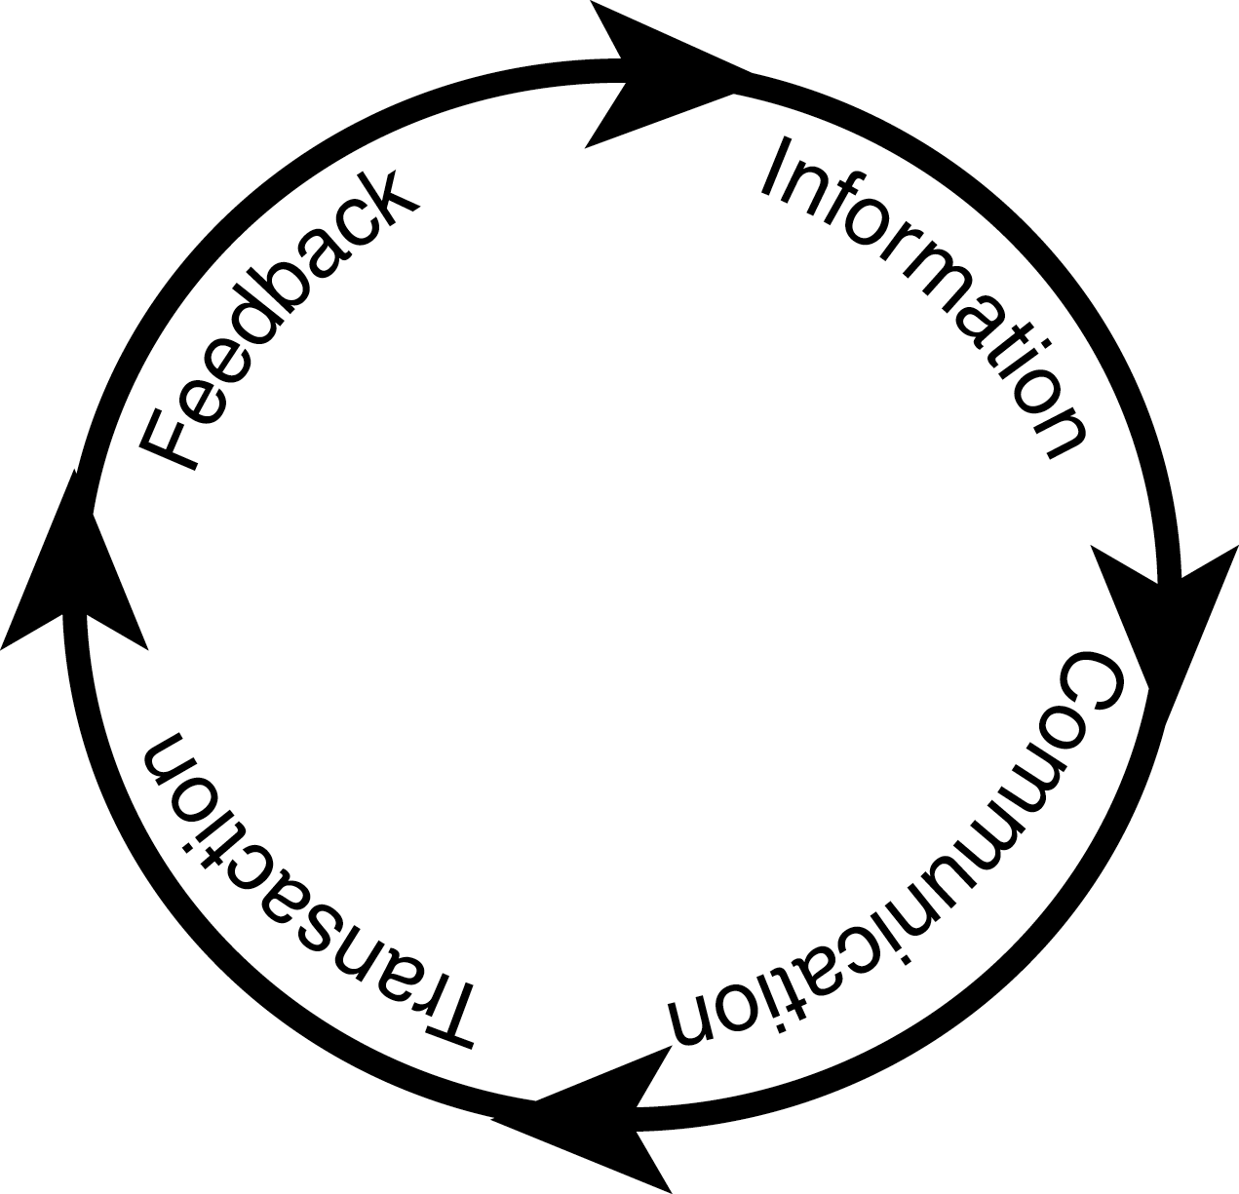
- Providing Information – Providing the customer or partner team with all the information relevant to their needs on a need-to-know basis.
- Communicating & Interacting – Interacting with the customer team to better understand their requirements, communicating how your solution can meet their needs, and pulling together your internal team to provide timely results.
- Transacting – Making the actual sale, processing the order, and providing self-service features like the ability to check order status.
- Getting feedback and providing support – Getting the customers’ feedback on how the process can be improved, troubleshooting, and providing on-going support services.

Managing relationships with strategic customers, suppliers, and partners is complex, but crucial to your success. Strategic relationships are complex and difficult to manage for several reasons:

Each strategic relationship is unique. Each strategic customer has different needs, is organized differently, and has a unique business relationship with you. For instance, the pricing offered to one strategic customer might be different from that offered to another. Hence, a cookie-cutter approach to targeting information to a strategic relationship based on profiles or rules does not work.
Strategic relationships are mission-critical and sensitive. Since strategic relationships are core to your business, they often have sensitive information that cannot be shared with others. Hence, security is crucial – information within one strategic relationship should not be accessible from any other.

Many roles are possible within a Strategic Relationship. Strategic relationships between 2 businesses are really between the people at those businesses. Different people involved in the relationship play different roles. One transaction in a high-tech OEM relationship might involve teams from sales, engineering, legal, finance, post-sales deployment, and support. Based on the role a user plays in the relationship, they need access to different sets of information and interactions. For instance, the legal contracts within a partnership might be accessible only at the executive management level.

Strategic relationships are complex and ongoing, involving many different stakeholders. Decisions are made at a variety of different levels, involving many different people. These decisions have ramifications for other departments down the line. For example, while you and your customer’s legal departments collaborate on a contract, the result of that contract has repercussions on how post-sales deployment is conducted. Knowing what’s going on in the organization across departments can be very complicated. Hence, to manage these relationships successfully, you need cross-company visibility.

Strategic Relationships involve bi-directional cross-company workflow. To manage strategic relationships effectively, you need something that allows both parties to exchange information, not just push information from company to customer. Mechanisms to smooth and track cross-company deliverables and workflow are needed.

Strategic Relationship information is often scattered throughout different applications. Vital company and customer information is scattered across departments, applications, and companies. There is no single sign-on, role-driven view of relationship-specific data. For example, SFA systems have prospect information, support databases have post-sales trouble tickets, email systems have individual messages exchanged across the teams, and ERP systems have order status information.

How do you conduct a customer relationship via the Web?

Personalized customer relationships can be conducted over the Web by providing each customer or partner with a website tailored to their needs. The website serves as the single go-to forum where the customer interacts, transacts and obtains information relevant to them throughout the relationship. A successful SRM solution will do the following:

Provide a bi-directional, secure multi-directional 360-degree window on the web into all the transactions, communications, and interactions specific to that relationship
A successful SRM management tool should allow you and your customer or partner team to post and exchange specific information relevant to their needs, to interact with each other via such tools as web conferencing and email discussions, and to transact business and check on orders.

Empower the relationship stakeholders to create and maintain the solution.
Creating the site, posting new information, finding the documents to be posted, and updating the contents should all be done in real-time through an intuitive, point-and-click interface so that day-to-day interactions are controlled by the relationship managers and participants, who have the best understanding of the relationship.

Provide a comprehensive history of the relationship
The solution should contain an easily searchable, comprehensive history of the relationship across the two organizations of all information, interactions and transactions.

Automate rote processes and administrative tasks.
For instance, when a website is updated with important information, the solution should automatically generate an email and a list of recipients for the site manager to edit and tweak. Once the site manager approves the email, it should be individually sent to each recipient.

Provide accountability and workflow
A robust solution should incorporate approval workflow, deliverable tracking, and notification mechanisms to enable cross-company processes and accountability. It should enable you to assign action-items and create approval chains across companies. It should automatically remind users and track cross-company deliverables – saving money and time.

Provide a flexible, automated mechanism to enforce access policies.
Each piece of information, transaction, or interaction should have its associated access permissions automatically enforced. For flexibility, the site manager, if s/he has the privilege, should be able to change the access permissions on a per-site basis. You should be able to control access on a need-to-know basis and predict with 100% certainty what each party in the relationship can see and do.

Leverage commonality among strategic relationships.
The solution should be able to leverage commonality among the sites. Custom solutions should not need to be built every time a new, similar relationship is begun.

Allow for seamless, multiple system integration
The solution should provide an API to allow the application to expose, in a controlled way, existing front-office, back-office, and other third-party systems. For example, if you have a support application, you should be able to tie it in with your solution, allowing a single sign-on, with workflow, dynamic views and permissions automatically generated by role. Users should be able to move smoothly from module to module.

Provide a single, consolidated library
The solution should provide a single consolidated library in which the company can store all the collateral and documents needed. This library should be indexed and searchable making it easy to find the information. The library should track changes to the collateral and automatically updates the websites and sends notifications as needed. This further reduces management costs and time.

Dynamically generate views based on roles.
The solution should dynamically generate the web pages seen by a user. When a user accesses a website, he or she is first validated and then only the information to which the user has access should be shown. Through this mechanism, the solution should provide a customer-centric view of the site to each customer, providing a different, internal, sales-centric view to the sales staff.

Be platform and application-neutral
The solution should be based on open standards, allowing implementation regardless of company-specific platform and architecture specifications. For example, the solution should be able to be run on Linux, Windows NT, or Solaris systems, and should be able to integrate with various databases and other programs.

Attempts to Solve the Problem

Packaged CRM and help-desk solutions like Siebel and Remedy are backwards-facing and are not flexible. While they are relatively rapid to deploy, it is difficult to add functionality and third-party systems to them.

“Push-only” solutions like BroadVision are only one-way. They are designed to sell to thousands of anonymous customers, not to provide an environment for strategic relationships.

Portal building solutions, databases, EJB servers, and personalization engines merely provide a foundation that you can build a solution on top of. This results in long development times.

Kovair’s VIPCenter is an extensible application, designed to being immediate benefits out-of-the box, while allowing you to add functionality as your needs require.

The VIPCenter was designed to enable companies to conduct and manage all the stages of the relationship via the Web. The VIPCenter builds customer, supplier, and partner intimacy. It enables all parties to exchange information throughout the relationship cycle. It provides secure, role-based access to your back-end solutions. This allows teams to act as one entity to solve mutual business problems and create superior value.

Traditional Application Structures

The prototypical first web-based application consisted of a web browser communicating directly back to a database through a CGI script. This solution closely resembles a traditional client/server model. In this case, the client is really the CGI script; it just projects the UI out to the browser. This architecture suffers from the same drawbacks as that faced by traditional client server computing. The main drawback is that the client is too closely coupled to the database. This hinders the overall scalability of the system, because there are only two real places to speed things up -- at the client and in the database. It is very expensive to increase the database's capacity, and can be both expensive and logistically difficult to upgrade the clients. In addition, since the functionality of the client and database are very closely tied, it is very difficult to change the application when business changes, and nearly impossible to reuse pieces of the database and client for other applications. So, client/server offers a quick way to get small volume applications up and into production, but it doesn't offer a scalable solution for large deployments.

The next iteration of web-based applications used a three-tiered architecture. The pure application of this architecture has only data storage in the database, business logic in a middle tier, and presentation and application logic at the client. This increases the scalability of the application by minimizing the time the application spends in the database. In addition, this architecture can accommodate many instances of the middle-tier allowing it to support many more clients. While this design offers a much more scalable solution, it doesn't address the tight coupling between client middle tier and database that prevents reuse and business change.

The Kovair SRM Platform: Web Application Structure Designed for Scalability and Flexibility

Today’s successful applications are built of flexible, interoperable modules. The Kovair SRM platform is a services-based architecture, sometimes referred to as n-tiered. Unlike the first two solutions, the services are not tied to a specific application. This architecture creates many generic services, potentially running on a single or multiple machines, talking to many different databases.

The Kovair SRM Platform consists of:

- A Business Server that provides the business logic and the fundamental services needed for SRM solutions. Fundamental services provide authentication and authorization.
- A Presentation Server that manages the application flow, caching to reduce response times and increase throughput, and UI engines that provides multiple modes of access to the VIPCenter. It outputs the information in HTML, WML, and other formats.

- Kovair’s Open Interoperability Engine (KOIE) that allows a company to expose their backend systems, their custom applications and even their partner’s systems in a unified, seamless and controlled manner.
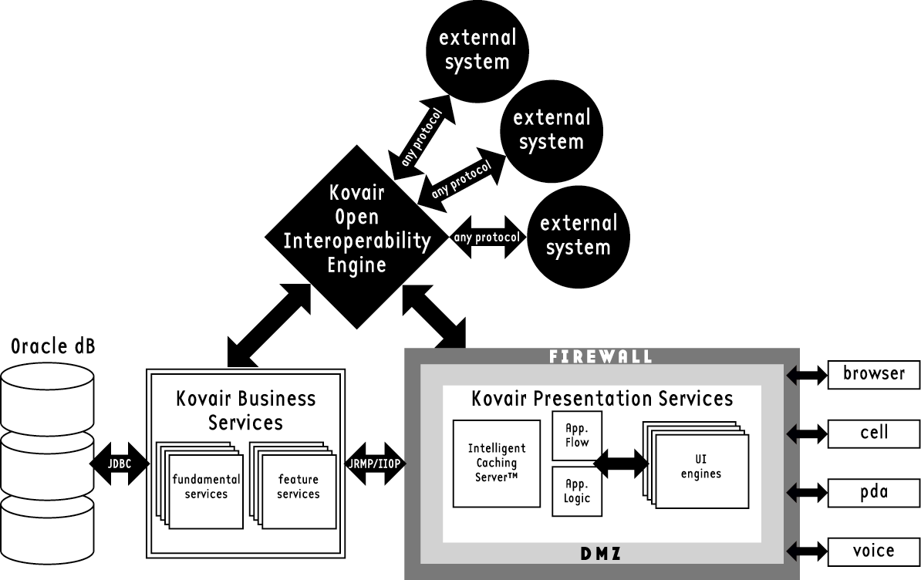

Kovair Business Services: Overview

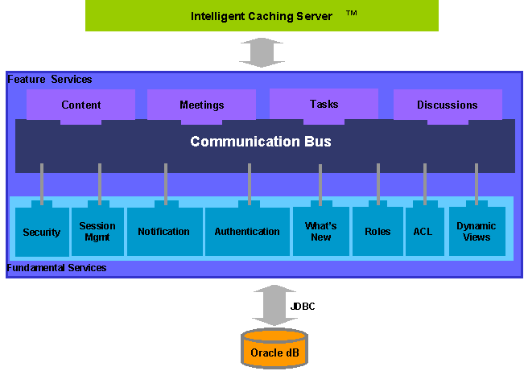
The Business Server is divided into two main components – Fundamental Services and Feature Services. Fundamental Services are the building blocks for SRM features. Feature Services are the visible features of the VIPCenter Application (tasks, meetings, etc), and are built from the Fundamental Services.

By separating the Fundamental Services from the Feature Services, the SRM platform allows for customization with minimal effort and impact. For example, if you change the authentication service to use LDAP, all of the Feature Services will automatically use LDAP for authentication.

Both Fundamental and Feature Services can be distributed across multiple systems. This provides a scalable, enterprise-class solution.

Kovair Business Services: Fundamental Services

Fundamental Services are composed of such services as:

- Authentication and Authorization – The default scheme uses 128-bit encryption and Verisign certificates to authenticate the server. Every request performed by a user is authorized before the response is generated. VIPCenter comes with its own usernamepassword authentication scheme. However, the authentication module can ve replaced with LDAP authentication or any other scheme. For more details, see the security section below.

- Workflow – Workflow enables content review and approval by specified personnel (such as account managers) before they are posted to a VIPCenter. When a member posts a content piece subject to workflow approval, that content piece goes into a staging area. The approver is automatically notified via email that the content is awaiting their approval. Once the item is approved, it automatically is routed from the staging area to the appropriate VIPCenter.

- Access Control (ACL) – Access control policies are uniformly implemented across all services. Access control is a feature that allows managers to restrict privileges on VIPCenter facilities such as documents, email discussions, or task items. Access control can be done at the group-level, role-level, or individual-user-level.

- Notifications – Built in to the SRM Platform, members of the team can receive automatic email notifications on a variety of actions. For example, you can specify members to receive notifications of new posted content, action items, or task due dates.

- Role-based privileges – Roles allow easy management of the user population and virtually eliminate any administration. The Kovair SRM platform instructs the VIPCenter to provide a different set of privileges based on the role played by the user on the account e.g. an Account Manager has the ability to add or remove people from an account and post content. An account contributor can only post content.

- Dynamic Views –Views are generated that are specific to each user. When customer users log into the VIPCenter, they get a unique view of the VIPCenter based on the specific privileges assigned to each of them by the account team. For example, a decision maker on the customer side may see sensitive information such as pricing discounts that the rest of his or her team may not. This keeps content relevant to the user and enforces corporate policies automatically.

- What’s New – This feature allows users to get an instant “at a glance” view of all the latest activity in the VIPCenter, such as new content, new tasks, and new customer meetings. This ensures that new site content is always visible to the company and customer teams, which keeps the site fresh and up-to-date.

Single Sign-on Security and Authorization

Kovair’s Fundamental Services, contained within the Business Server, incorporate sophisticated security and authentication schemes. This allows single sign-on across all of a user’s VIPCenters, standard features, custom VIPCenter features, and third party systems that have been tied into the VIPCenter.

Security is key to any SRM solution. In basic HTTP authentication, passwords are transmitted “in the clear”, with no encryption. In Digest HTTP authentication, tokens are passed rather than actual passwords, but these tokens can be replayed. Also, in both cases, tokens are passed automatically --- there is no way to completely log out.

Kovair’s approach is signficantly more secure than either of these. User authentication is done over an encrypted line, so that logins and passwords are never revealed. Kovair’s SRM platform uses 128-bit Secure Sockets Layer (SSL) over HTTPS to ensure that every bit of data flowing between the user and the server is encrypted with the highest level of commercial encryption. This is the secure “private/public” technology used to protect nuclear missile codes.

Kovair uses VeriSign’s digital certificates for encryption. By using a Secure Server ID, available from VeriSign, we are enabling our site to conduct authenticated, encrypted on-line commerce. Users visiting our site will be able to submit credit card numbers or other personal information to our site, with assurance that they are really doing business with us (and not an impostor) and that the information that they are sending to us can not be intercepted or decrypted by anyone other than the intended recipient. All transmissions that subsequently occur proceed in this superior, fully encrypted fashion.

In addition to authentication, the security layer is also responsible for authorization. For every action or request made by the user, the security layer compares the nature of the request or action with the identity of the person logged in and completes the request only if the person has the appropriate access privileges to conduct that action or request. This individual-request-level authorization is seldom found in most commercial systems.

Customizable Authentication Service (CAS)

To integrate with your corporate authentication systems, the CAS is comprised of a standard interface for authentication, combined with pluggable authenticators that can be selected in real-time. This approach allows for integration with corporate authentication schemes such as LDAP, RADIUS, Security Dynamics, retinal scans, and so forth. The authenticators pull the appropriate data (such as username and password for the Kovair schema and Secure ID from Security Dynamics) from the appropriate data store. It then feeds this data to the Authentication Engine.
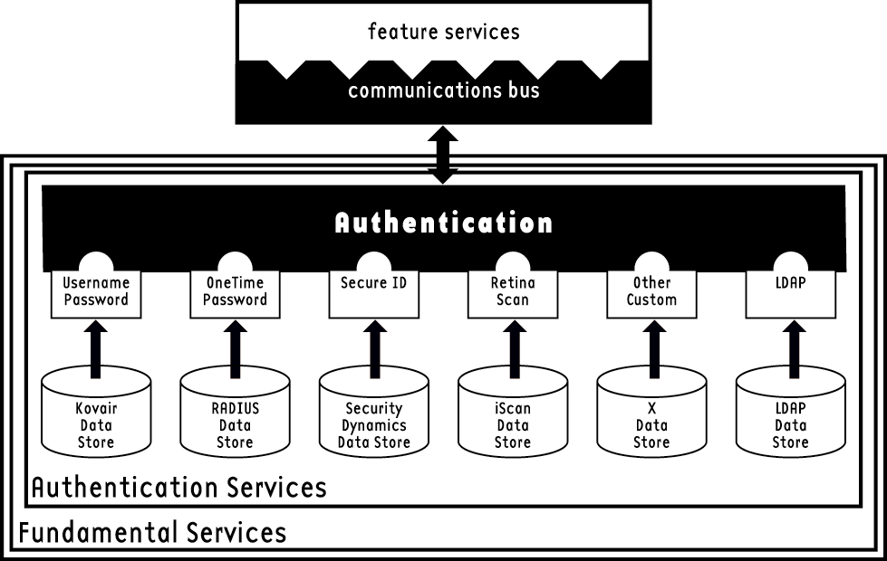
The Authentication Flow proceeds according to the drawing below:
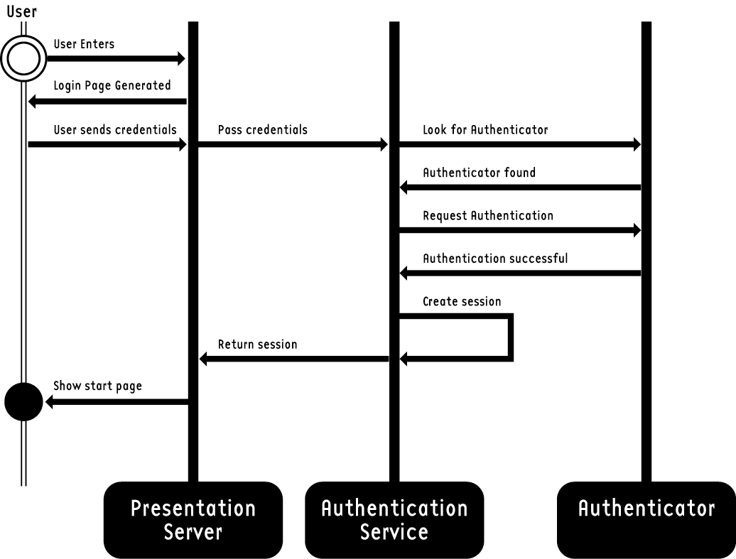

Roles and Access Control Lists

To control who can see what and who can do what, Kovair uses roles. A role is an entity that has specified permissions and privileges. To assign what different parties can see and do, you can assign each person in the organization a role. Roles allow easy management of the user population and automate administration. The Kovair SRM platform instructs the VIPCenter to provide a different set of privileges based on the role played by the user on the account. For example, a person assigned to the Account Manager role would have the ability to add or remove people from an account and post content. If that person were assigned to the account contributor role, he or she would only be able to post content. With roles, you can predict with 100% certainty what a party can see and do.

Access Control Lists (ACL), based on the Java security model, are uniformly implemented across all services. Access control is a feature that allows managers to restrict privileges on VIPCenter facilities such as documents, email discussions, task items, or third-party systems.

For example, I may assign a role to a person allowing them to post and read all documents or to view the order system. However, I can use the ACL feature to prevent that person from viewing a particular document or from viewing orders other than his or her own. Access control can be done at the group-level, role-level, or individual-user-level.

3rd Party Integration with a Single Sign-on

The Kovair SRM platform’s integration modules offer rapid access to different pieces of enterprise data from legacy, web-based, and other third-party systems, automatically enforcing any enterprise-level business rules, including roles and security. It provides 24x7 access to all services with a single sign-on. For an in-depth look at Kovair’s Interoperability Modules, see the Interoperability White Paper.

Kovair Presentation Services
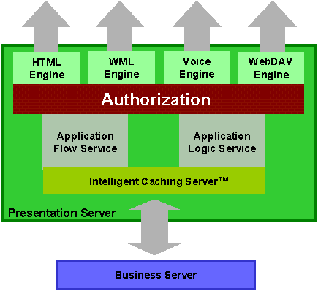
Many web-based solutions are specifically designed to only handle HTML and thus can only be used with HTML browsers. But because of today’s rapid changing technology, The Kovair Presentation Server separates the display format from the application logic and flow. This allows rapid deployment of the VIPCenter to new technologies. Today, a VIPCenter can be accessed via a desktop browser or a cell phone browser. Soon, it will be voice-accessible via a regular telephone. It is this type of forward thinking design built into the VIPCenter solution that will help you stay ahead of the technology curve.

In addition, the Presentation Server provides action-level authorization for enhanced security. This allows you to control access to features; for example, you can restrict access to administrative functions. It also protects against URL spoofing.

Proprietary Intelligent Caching Server™ technology is contained within the Presentation Server, optimized for the EJB environment and designed to work with the SRM platform to deliver rapid response, even under heavy loads, ensuring flexibility and extensibility. The intelligent caching server dynamically caches content as users add new content, such as meetings, tasks, documents, and so forth. Additionally, intelligent caching algorithms that take advantage of the common functionality of an SRM solution have been devised to further optimize performance. These algorithms include pre-fetching of content, pooling and reusing of objects. The result is significantly optimized communication with the Business Server, providing optimum performance.

The Kovair Open Interoperability Engine (KOIE)

The Kovair Open Interoperability Engine (KOIE) is a part of the SRM platform. It is a comprehensive solution for leveraging existing backend systems and new systems that are in development today. The KOIE is highly customizable and very open. This allows you to work in a controlled way so that customers get only the exposure that you want them to have.

The Kovair solution offers three levels of integration.

- HTTP level integration through the Kovair Web Interoperability Messenger (KWIM). With this approach, you can rapidly interoperate with existing web-based applications. KOIE provides the mechanism whereby you can embed any web-based application directly into the VIPCenter in a controlled fashion where you only expose those controls and functions of the application that is relevant to the specific customer user. This approach is very powerful, allows for rapid integration and works across firewalls so that you can easily tie in with a partner’s system, and any services available on the Internet (e.g. FedEx Package tracking, web-based SFA, Yahoo financial stock quotes).
- Functional integration. This approach allows you to interoperate with a non-web-based application by making function calls directly into the application. Logic that runs in the KOIE serves as a proxy. It will translate requests made by the user into function calls into the application and it will take the responses and show them to the user. As such, it will allow the user to directly interoperate with non-web-based applications through the VIPCenter. The KOIE can speak many different languages, including CORBA, JDBC, RMI, RPC, SAP, and RFC. You can also load your own connections.
- Data integration. With this integration approach, you can leverage data from existing systems and repositories for use within the VIPCenter.

For more details on the KOIE, see the Interoperability White Paper.

VIPCenter Services

The VIPCenter solution is built on top of the Kovair SRM Platform and can be accessed via a browser or cell phone. Soon, the VIPCenter will be accessible via a simple telephone. In all cases, no software needs to be downloaded or installed in order to use the VIPCenter.

The services built into the VIPCenter include:

Information –The library is a single, enterprise-wide place where documents can be stored. This library is indexed and searchable making it easy to find the information. Because it uses platform-independent technology, the library will integrate with a company’s existing databases. When you “post” an item to a particular VIPCenter, it creates a virtual link to the item in the library. This means that if you wish to modify an item (such as a price list) posted to 50 VIPCenters, you need only change the item in the library, and it will be automatically updated across all the VIPCenters.

Interaction – Tools such as task lists, web meetings, and email discussions help all the members of the relationship interact. Tasks lists provide a single place to track commitments by due date and owner. Auto-reminders can be sent out. Email discussions provide an archivable forum for the exchange of ideas, leveraging your current email systems.

Transaction – The VIPCenter can be the gateway to your order entry system or support system, enabling customers to check their support tickets or enter orders using the VIPCenter. The basic Kovair SRM platform is designed to support extensibility to existing back-end systems.

Analysis – Analysis tools give users a 360-degree view of what is happening in a relationship over time or at a specific point in time.

Communication services are provided across the Information and Interaction Services. When new content is added, VIPCenter users can get automatically notified about them. Similarly, when tasks are assigned or due or overdue, the entire team can be notified so that the there is no slip in the interaction between the company and the customer. These emails can be tailored to enhance the personalized experience of VIPCenter.

EJB Framework, Enterprise-Class Database, and High-Availability Platform

Kovair’s embedded EJB framework means that the system has the ability to work on NT, Solaris, or other Unix systems. It supports RMI over JRMP and IIOP. Java clients are supported via RMI, while Corba clients are supported via IIOP and Web clients through servlets and JSP.

All data is stored in Oracle8i, an enterprise-class database. Built on a highly scalable and robust platform, the database architecture has been designed to provide the highest level of data integrity, security and availability. We recommend running the entire system on a Sun or NT high-availability platform for superior performance.

Conclusion

Kovair's VIPCenter is a secure B2B relationship portal, personalized for each of your key customers and partners. It was engineered to provide the on-demand information, communication, and transactions critical to strategic relationship management. Best of all, it is an out-of-the-box solution that can be up and running in days and it is an extensible system so that you can leverage your existing investments and provide a seamless, unified and yet controlled access to your backend ERP, legacy and custom designed systems.

Most importantly, the VIPCenter solution is the first 100% web-based solution for strategic relationship management. It was designed from the ground-up specifically to leverage the power of the Internet to provide an intimate, highly personalized customer connection. Innovations such as our extensible presentation layer and KOIE ensure that the solution will continue to serve your needs for years to come.

CIO Magazine, August 15, 2000. p. 150

