Network Design Optimization
Application Specification
 Enron Corp.

Version 1.2
Chonawee Supatgiat
June 12, 2000

Table of Content
Network Design 2
Overview 2
General Specification 2
User Input 2
User Output 3
Optimization Program Capability 3
Detailed Information 4
Input Information 4
Node Information 4
Cable Information 5
Demand Information 6
Channel Size Information 6
Designing Process 6
Mesh design 7
Ring design 7
Algorithm 7
Output Information 7
User Interface 8
Input/Edit data 8
Optimization Setting 9
Displaying Results 10
Network Expansion 11

Network Design
Chapter
1

Overview

Communication network elements can be simply categorized into two parts; which are nodes and cables. The costs associated with the nodes are construction cost, land cost, recurrent maintenance and management cost, and switching equipment cost. The costs associated with the cables are construction costs, bandwidth cost, port costs, and equipment costs such as mux/demuxor, amplifier, and regenerator. We consider a network design problem where we want to build or buy a minimal cost communication network that can satisfy a given set of traffic demands.
There are various types of demand. Demand can be protected with 1+1 line protection or BLSR ring protection. Two lines, called working and protection lines, are used to satisfy a protected demand. If the working line breakdowns, the protection line will be used. User can specify a diverse route option where both working line and protection line cannot share the same physical path. Demand can also be specified as a concatenation, which means that it cannot be sub-divided. That is, a demand for one OC-12 concatenation cannot be satisfied by four fibers of OC-3 size.
We developed a program to help designing the network. The program determines the network so that the total cost is minimized and the traffic demand is satisfied. The user can also select Ring mode to tell the program to find an optimal combination of network rings.
Due to the exponential growth of Internet demand, the program supports the expansion of an existing network. The program can optimally determine the expansion—which nodes and fibers to be added. In the expansion case, the user inputs the demand and the information of the existing network. The program then determines the fibers, cables, and nodes that are needed to be added.
In a multi-period mode of the program, demand forecast is given as a function of time. The program determines the initial optimal network to handle current demand and the future expansion to handle future demand growth. The program finds the network and expansion policy that minimizes NPV of all current and future costs.

General Specification

User Input
Users must be able to input and update the following data:

- Node information: contains physical location, cost, and capacity information of each node.
- Cable information: contains size, carrier, operational period, diverse route group, cost, and capacity information of each fiber. Port cost will be reflected in the fixed cost of the fiber and bandwidth cost will be reflected in its variable cost.
- Demand information: contains demand information of each logical path. User can also specify protection level, route diverse option for each path. In addition, the users can provide demand as a function of time. For example, this year demand for NY-LA is two OC-12, next year is three OC-12. The program then can find the optimal network that minimizes total future costs.

User Output
After running the program, the users will receive the following outputs:
- Graphical interface showing a map of the optimal network (links and nodes) that minimizes total cost and satisfies the demand.
- Sizes of fibers and nodes in the network. It also tells which link should we build or buy from whom.

Optimization Program Capability
The problem is modeled as a mixed integer program by using a C++ code. The optimization is done by CPLEX, a commercial mixed integer program solver. The C++ code translates users’ input data into a mathematical language that CPLEX can understand. After CPLEX solve the problem, the C++ code translates CPLEX’s results into users’ output data.

- The program can detect the physical location of the line so that it can handle the diverse route option.
- At this time, it cannot handle the fractionality issue. That is, it cannot detect a partly filled fiber. If we have four slots left in an OC-12 fiber, we should input this fiber as a one OC-3 fiber. Of course, the user can specify the fixed and variable costs for this particular fiber.
- The program can handle the protection demand, including rings.
- The program can handle the concatenate demand.
- In the case of long term contracts, the program should build the network so that it minimizes the cost of satisfying the future demand.

Detailed Information

Chapter
2

Input Information

Node Information
For each node, the user must provide
- the name of this node
- the location of this node
- fixed cost for using that node
- variable cost per link connected to that node
- available capacity of that node
The NPV of construction cost and future operating expenses should be divided into 2 components, which are fixed and variable. The fixed NPV usually includes the building construction cost, all discounted future space rental cost, all discounted future expenses that are independent of the number of links connected to it. The variable NPV is usually the cost of connecting a link to the node, the cost of activating the port. This cost does not include port cost, which will be included in a fixed cost of a fiber.
Node capacity has two components:
- Port capacity – number of ports of a particular type and size available to connect links to the node.
- Switch capacity – capacity that can be switched through the node core. (the core manages how ports are connected)
The size of a node is limited by its fabric size. The capacity of a node can be increased by adding more fabrics. Fabric is a platform that provides slots for port connection. The bigger fabric with higher number of slots is more expensive than a smaller one. Each time a node is upgraded, this fabric cost is incurred. Users can input cost and capacity data as a staircase function, as shown in the following example.
The program can handle different detail levels. If a user inputs each POP’s data as a node, the program will treat each node as a POP and it can solve at the POP level. If the user input a group of POPs as a node in the program, the program will treat each group as a node and it can solve for the group level.
This grouping is a good idea to reduce complexity of the problem. The users can group the POPs manually. The user needs to find the appropriate fixed cost, variable cost, and capacity for this group of POPs and then input those data into the program as for a single aggregated node. In case that the user wants to optimize in detail POP levels, he/she just inputs their POPs as nodes in the program. For the case where the user wants to optimize in a more general view, such as the whole country, he/she just aggregates all their POPs into one node per city.

Cable Information
The user must gather the information of all possible fibers that can be used in the network. This fiber pool is the input information to the optimization program. The program finds the combination from this fiber pool that minimizes total cost and satisfies the demand. For each available fiber, the user must provide
- the two nodes that are connected to it
- the size of the channel, e.g. OC12
- how many channels available in this fiber
- start date for the availability of this line
- end date for the availability of this line
- Diverse route group of this line. The lines in the same group share the same physical path. If two lines are in different groups, they do not share the same physical path.
- The fixed cost for using this fiber.
- The variable cost per channel used in this fiber.
The fixed cost includes the cost for lighting/laying the fiber. It does not depend on how many channels it is used. The variable cost includes the bandwidth cost and port cost, which is a linear function of the number of channel used. The bandwidth of a cable is limited by the amount of fibers and their sizes available for use. All the future recurrent costs must be discounted to a present value and added to the current costs. The fix and variable costs must represent NPV.

Demand Information
Demand represents an amount of data to be transferred between any two nodes. The amount of data is specified as the number of channels of a specific size. The demand that requires concatenation cannot be subdivided into multiple demands of smaller sizes. For example, if the user requires two OC-12, this demand cannot be supplied by eight of OC-3. The user can specify the protection for the demand, such as BLSR ring or 1+1 line protection with diverse routes. For each demand, the user must provide
- the two nodes of this demand
- the channel size for this demand
- the demand amount, which is the number of cables needed
- Whether this demand is concatenated.
- The protection scheme of this demand.
- Whether this demand requires route diverse protection
- Start date and end date of this demand in the case of long-term multi-period contract
The user may require the program to find a network and future expansion that satisfy the future demand growth. For example, the user can provide a demand-forecast similar to the following table:
The program then finds the network that can supply the current demand and future expansion networks that handle demand growth. These networks are chosen so that the NPV of the current and future costs is minimized.

Channel Size Information
The channel size information, which contains the Mbps for each channel size, is initially stored in the same directory as the program. This table is a master table and cannot be modified by regular users

Designing Process
Network design function has two modes, which are Mesh design and Ring design. The user can select the mode in the optimization setting window.

Mesh design
Mesh design is cheaper than ring design. The network is a group of fibers linking with each other at the switching nodes. There are two kinds of protection level available in this design. The first one is 1+1 protection where the protection line must be dedicated to the protected demand and cannot be shared with the protection line of another demand. Moreover, the protection line must have the same channel size and same capacity as the working line. Since there is no dynamic routing in the physical SONET layer, the protection must be end-to-end. That is, the working path and the protection path cannot share any same line segment. With this protection level, all the working lines of the demands can be broken down at the same time without any communication interruption.

The second protection level is 1:N protection, where N is an integer greater than or equal to 1. In this level, N demands can share the same protection line, thus reducing the fiber cost. In the case where N>1, if the working lines of the two demands that share the same protection line break down, there will be a service interruption. Because of the probability of this double breakdown event is very small, the 1:N protection level might be economically better than the 1+1 protection. The 1:N protection, however, requires high-tech switching technology. The switching equipment must be able to re-route the traffic in real-time when a breakdown occurs.

The optimization program can handle both protection levels. It treats the demand with same protection scheme number as a 1+1 protection and treats the demand with different scheme number as a 1:N protection, where N is the total number of protection schemes. Therefore, if the user wants 1+1 protection level for all demand, he/she just assigns the same scheme number to all the demands. If the user wants 1:N protection level, he/she should assign different scheme numbers to the demands.

Ring design
Most of the design projects that our sales engineers are working on are Ring design. The ring design is less cost efficient than the mesh design. The ring network is a combination of rings. Each ring must have the same capacity throughout the whole ring. It should have less than 12 and more than 2 add/drop multiplexers. Rings can share the same node but cannot share the same fiber channel. A ring with two add/drop multiplexers does not have to be route-diverse. Both ring lines can share the same physical path.

The user can indicate to have BLSR protection, where the connections between network elements are bi-directional. In this BLSR protection, the overall capacity of the network can be split up for several paths each with one bi-directional working line.

Algorithm
The program formulates the design problem as a mixed integer program. It then calls CPLEX to solve this mathematical program. It can solve to optimality but the computational time may be long. We also develop an alternative method to solve for each demand iteratively. This method yields near-optimal solution but takes significantly less computational time. The user can choose any of these methods or somewhere between them in order to trade-off between the solution quality and computational time.

Output Information
The program provides two outputs. The first one is a graphical map showing network topology. The second one is an output file describing which fibers and nodes are used and the amount and size of channels used in each fiber. In Ring design, the output file also contains the topology of each ring and its capacity. An example of the output file is shown in Section 3.

User Interface

Chapter
3

Input/Edit data
The users can input and edit data through the program interface. The node information is input in the node data view window.
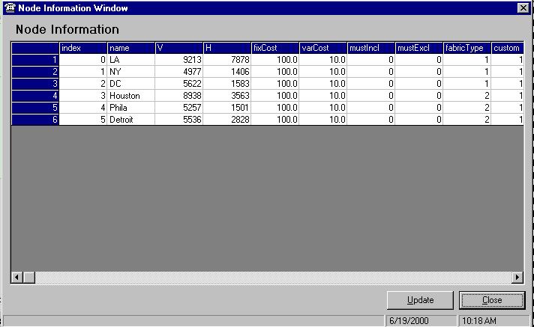
Node fabric cost is a staircase function of its capacity, which can be defined in the fabric data view window.
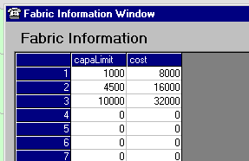
The demand between any city pair can be added or edited in the demand window. The protection scheme for each demand can be defined in this window as well.
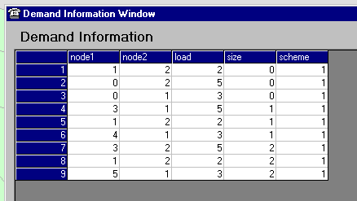

The cable and channel information is input in the channel window.
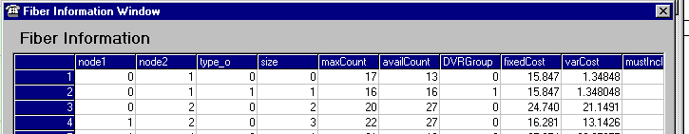

Optimization Setting
Once the user input all information, he/she can run the optimization. The ring option can be chosen at this time. The computation time increases with the optimality level of the solution. Solving for optimality may require longer running time than solving for near-optimal solution. The user has to trade off between the computation time and solution quality. The trade-off level can be set in the Time/Optimality Preference box.
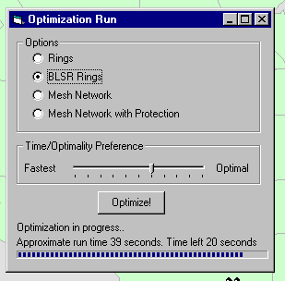

Displaying Results
When program finishes running, the solution is shown on the map.

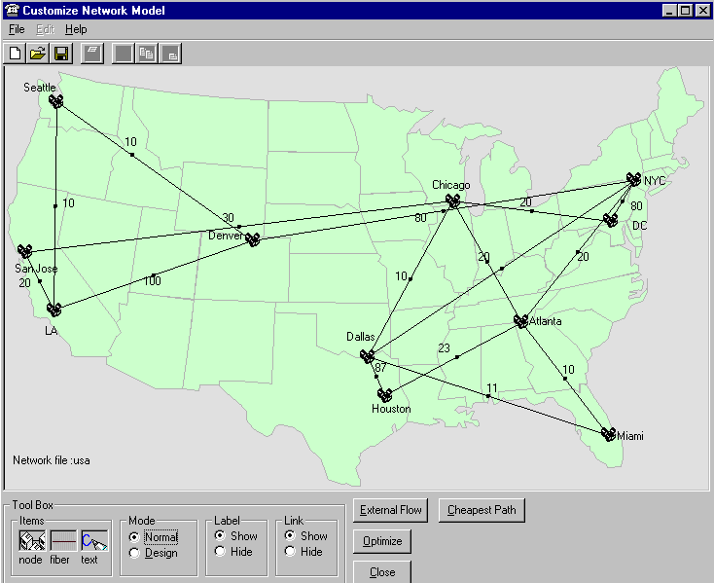

Beside the graphical map result, the program generates an output file. The output file indicates the size and capacity of each ring/fiber to be used in the network. An example output file is shown below.

********************************** output.txt ******************************************
total cost = 706.336862
total solution time = 2.000000 seconds

ring#0, (0 - 1 - 2), is used with 3 channels of size 0
ring#1, (0 - 1 - 5 - 3 - 2), is used with 3 channels of size 0

cable #0 at link (0,1) type 0, size 0 is used for 6 channels
cable #1 at link (0,2) type 0, size 0 is used for 6 channels
cable #2 at link (1,2) type 0, size 0 is used for 3 channels
cable #6 at link (1,5) type 0, size 0 is used for 3 channels
cable #7 at link (2,3) type 0, size 0 is used for 3 channels
cable #14 at link (3,5) type 0, size 0 is used for 3 channels

node 0 is used
node 1 is used
node 2 is used
node 3 is used
node 5 is used
****************************************************************************************

Network Expansion
In the case of network expansion, the users will be able to compare the result of optimization with the existing network. By clicking at a button, the program displays the existing network. By clicking at another button, the program displays the new optimized network. The program can also display the expansion, which is the different between the two networks.

