NA Version 1 - August 10, 1999
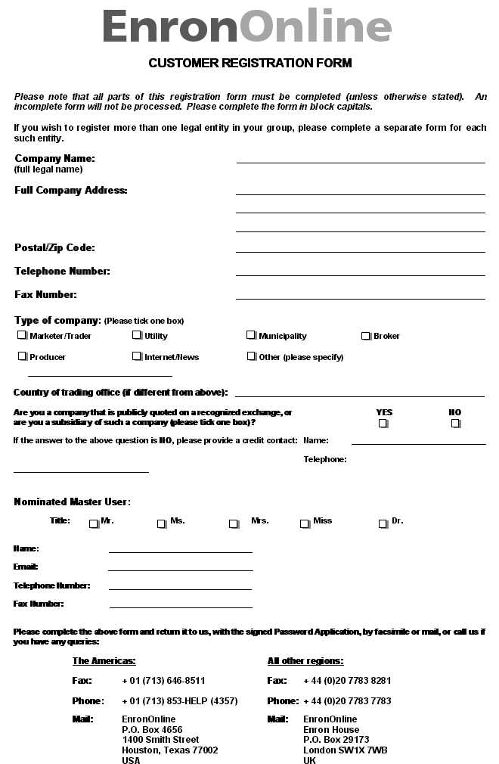
PASSWORD APPLICATION
WHEREAS, Enron North America Corp. and/or its affiliates (referred to herein collectively and individually as "Enron") from time to time have established or will establish one or more websites or other internet-based electronic trading facilities (collectively, the "Website") for the trading of products and instruments based on energy products or other commodities (including derivative products) (collectively, "Transactions"); The counterparty identified below ("Counterparty") wishes to access and utilize the Website; and Enron is willing to provide such access on the terms and conditions set forth herein, Enron and Counterparty hereby agree as follows:
Enron shall issue to Counterparty or activate a password and/or userid (which may allow Counterparty to create additional passwords and userids, collectively the "Passwords") that will enable Counterparty to access and utilize the Website. Counterparty understands and agrees as follows: (1) Any additional Passwords that Counterparty creates are permitted solely as an administrative convenience to Counterparty, which will be solely responsible for the creation, monitoring and use of any such additional Passwords and, without limitation, Enron will have no responsibility whatsoever for controlling or monitoring the use of such Passwords and no liability for any use of such Passwords. (2) It shall be solely responsible for any and all acts or omissions with respect to access and use of the Website (including the execution of Transactions) by any person using the Passwords, and it shall only provide the Passwords to its employees who are authorized by the Counterparty to access and use the Website and execute Transactions, and not to any third parties. It will implement and enforce reasonable measures to protect the confidentiality of the Website and shall immediately notify Enron of any unauthorized disclosure or use of the Passwords. Use of the Passwords outside of the country previously identified by Counterparty as the country in which its trading is situated is strictly prohibited. (3) Its access to and use of the Website will be subject to the Electronic Trading Agreement available on the Website (the "ETA"). Prior to Counterparty’s first execution of Transactions through the Website, it will be required to indicate its agreement to the ETA by "clicking" on the designated spaces and, thereafter, any access and utilization of the Website using any of the Passwords will be governed by this Password Application and the ETA. (4) The ETA, any General Terms and Conditions ("GTC’s") and any Transactions executed on the Website will be deemed to be "in writing" and to have been "signed" (and any record of the ETA, any GTC or any Transactions will be deemed to be in "writing" for all purposes). Without limitation of the foregoing, Counterparty agrees that it will be bound by any Transactions executed on the Website through a "click" agreement (or other action specified by Enron) by any person using the Passwords, subject to and in accordance with the terms of this Password Application and the ETA. Counterparty represents, warrants and covenants that all information provided by Counterparty to Enron is true, accurate and complete in all respects and that Enron shall be entitled to continue to rely on any information previously provided to it by Counterparty in connection with the execution of Transactions through the Website.
This Password Application will be governed by and construed in accordance with the laws of the State of New York.
Date:

Signed: Signed:

Name: Name:

Title: Title:

For and on behalf of For and on behalf of

ENRON NORTH AMERICA CORP.
COUNTERPARTY

Proposed Initial Password – PLEASE COMPLETE

Counterparty hereby requests the following as its initial password which must be 8 to 10 characters long:
(Note: The Website will require that the initial password be changed when it is first used.)

