Analyst Report: ATL. 5

Stock Price: $88.78
S&P Credit Rating: BBB

Industry Overview

The Olympus industry consists of a diverse ecosystem of six companies providing a variety of technology-based products and services to industrial customers in the milling industry. The current products and services offered by the industry are used to automate manufacturing processes. The Olympus companies build products such as C-It, a high-speed workstation used to program and control standard milling equipment and other automated machinery; and MillSys, an automated milling robot used on assembly lines throughout the world. They also sell VisControl, a software product, which controls the C-It milling machines and robots. The industry also offers three services to its customers, Maintenance, Training, and Facilities Management. Components required for the products are also produced by most of the companies in the industry. As an alternative to producing their own components, companies either buy components from the spot market or partner with another company for component supplies. The component portion of the business, while less visible, has great potential to add revenue to the businesses. Research suggests that if more components were sold on the open market, they would generate almost as much revenue and margin as the current products do. Although Components can be a big Revenue earner in this industry, success from sale of Components will be realized mainly through partnerships.

There are three existing Component contracts between companies in this industry currently. Atl. 3 sells Storage, Capacity and CPU to Atl. 4. These contracts are due for renewal in Year 12. All component and software contracts in this industry are subject to renewal each year unless it is stated to be a multi-year contract.
Competitive Information:

Atl. 1: Produces high quality Proprietary Software. Has average Plant capacity. High quality Component and Products manufacturer with good margins.

Atl. 2: Does not produce Components. Has low Plant capacity. Offers two services, with more to offer in the near future. Good Service Reputation and Customer Support Reputation. Average Product quality.

Atl. 3: Big player in the Components market. Sells Components to Atl. 4 and has highest market share in the Components spot market. Has highest Net Plant capacity. Average Quality Product offering.

Atl. 4: Produces Proprietary Software. Buys Components from Atl. 3 and the spot market. Has relatively small Net Plant capacity. Offers one service currently, but may offer more in the coming years. Has a high quality Product offering. May bring out new Products to market before competitors.

Atl. 6: Produces some Components in-house and buys the rest from the spot market. Produces high quality Components, Products and Software. High Software Innovation, but Services Customer satisfaction not the highest.
Company Overview

Financial Highlights

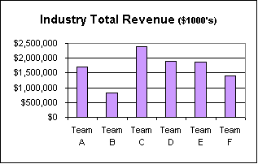  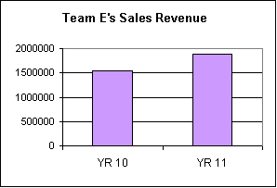 |  |  |  |  |  | Atl. 5 Sales Revenue
 | 1 2 3 4 5 6
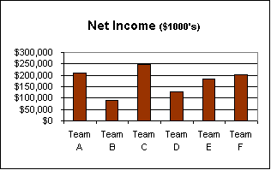  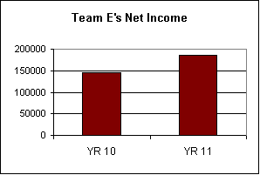 |  |  |  |  |  | Atl. 5 Net Income
 | 1 2 3 4 5 6
Atl. 5 had a very successful year with Revenue going up 21% and Net Income going up 26%. The market reacted well to the profitable year and the stock price was up $30.08 to $88.78. The increase in profitability was possible by controlling costs. Although SG&A went up, the increase in Revenue kept operations profitable. Shareholders are expecting to see another year of continued growth.
Atl. 5 has managed its Cash relatively well. Atl. 5 has the second highest Total Assets figure in the industry, and 71.3% of Atl. 5’s Total Assets is Net Plant. Judging from the size of Atl. 5’s Plant, it appears to be positioning itself as a high volume producer in the industry. Atl. 5 also has the highest level of Debt, which is why its Economic Profit is lower than it could have been with the increasing Operating Profit.
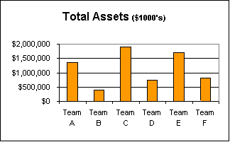

1 2 3 4 5 6

Operations Highlights

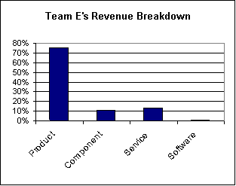

Atl. 5 Revenue Breakdown

The chart above shows the breakdown of Atl. 5’s Revenue source as it stands at the end of Year 11. At present most of Atl. 5’s Revenue is coming from the sale of Products. However, that does not imply the other business lines are not profitable for Atl. 5.

Atl. 5 currently produces its own Components. It has average market share in the Components spot market, with a lower than average quality rating and the second highest capacity for Component production. Atl. 5 can be a big player in the Components market given its capacity for production, but as of now, Atl. 3 seems to be dominating that market. Atl. 5 is maintaining investment in all Components.

In the Services market, Atl. 5 offers Maintenance and Training. Starting Year 12, Atl. 5 will be able to provide Facilities Management, Consulting, and Custom Design to customers as well.

In the Products market, Atl. 5 has the highest and second highest market share in Mill Sys and C-It respectively. However, with the lowest quality ratings in the industry, it is questionable how long they will stay in this position. In Year 11 Atl. 5 offered two Products, Mill Sys and C-It to its clients. Starting Year 12, it will be able to add Speednet to its product portfolio. Atl. 5’s philosophy in new Product Development has been to be a follower in the market but to maintain R&D investment on Mill Sys, C-It and SpeedNet.

Atl. 5 currently makes below average quality VisControl, and it has about 5% of the VisControl market. Software has clearly not been a focus point for Atl. 5 as reflected by their low investment to date in feature upgrades. Atl. 5’s R&D strategy on Software has been to maintain investment on VisControl and Encryption and to abandon investment on any other Software. It may start offering Encryption, AI and My Tutor to customers from Year 12.

Atl. 5’s salespeople are paid an industry average salary, and the company relies much more on direct sales by salespeople than on dealers. Atl. 5 does not appear to have an aggressive e-commerce strategy as the company’s clients and dealers cannot place orders or get any support via the company’s website.

Shareholder Value Highlights
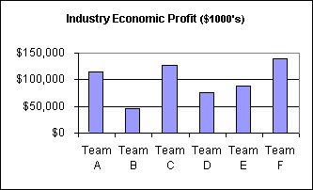  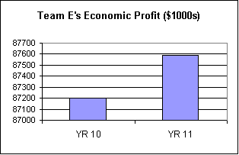 |  |  |  |  |  | Atl. 5 Economic Profit ($1000s)
 | 1 2 3 4 5 6
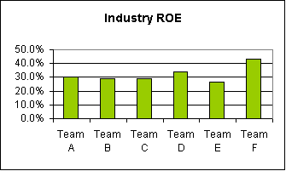  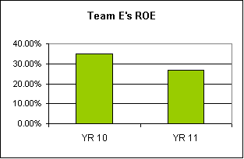 |  |  |  |  |  | Atl. 5 ROE
 | 1 2 3 4 5 6
Shareholders have confidence in Atl. 5’s future performance as they bid Atl. 5’s stock price up over 60% last year. Atl. 5 has a dominant position in the products market, and that should serve as a solid base to expand operations. Shareholders believe that with a focused strategy the company has a high potential for continued success in the industry. With promising Economic Profit and Return On Equity (ROE) figures, Atl. 5 is well positioned to create shareholder value. However, in the Olympus Scoreboard, which summarizes the operational, qualitative and service measures that the market observes, Atl. 5 has an overall “Average” rating. Atl. 5 leads on such measures as “Ability to Customize”, “Employs Current Technology”, “Unique Consulting Process” and “Service Reputation”. It lags on such measures as, “Control of Distribution”, “Product Innovation” and “Software Innovation”. Shareholders expect the new management team to establish Competencies that give the company a leading edge over the other companies in the industry. Shareholders hope that the new management team taking charge of the company will be able to give the company some direction and focus, thereby increasing the overall value of the company.

