Connecting to Enron via Analog

Dialing in thru Win2000

Step A: Configure Dial Up Connection

- Click Start > Settings > Network and Dial Up Connections

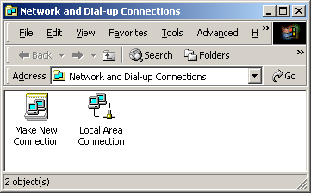

- Double click Make New Connection and click on Next
- Select Dial-up to Private Network and click Next

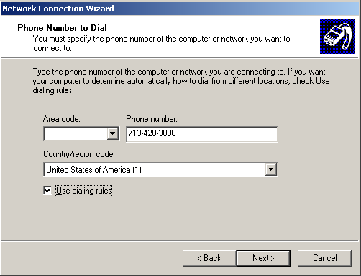

- Add the following: 713-428-3098 for the Phone number and add a check mark for Use Dialing Rules
- Select For All Users and click Next

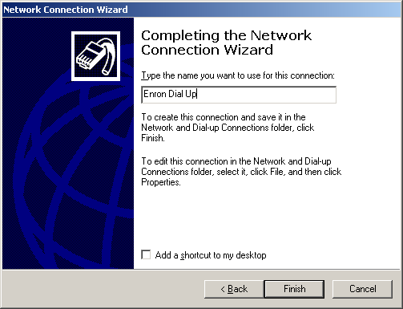

- Type Enron Dial Up for the name of the connection and click Finish

Step B: Dial Up via Telephone

- Hook up the telephone cord to your Modem behind the Dell PC.
- Click Start > Settings > Network and Dial Up Connections > Enron Dial Up

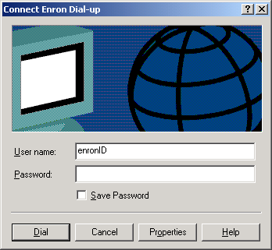

- Enter your CORP user ID/password from work and click Dial

Step C: Connecting to Enron Corp

- Open Internet Explorer and browse to http://remoteservices.enron.com/
- Click on General Purpose Cluster 2 – Notes R5 and login as normal.
- Once logged in, you will be able to access some applications you normally use at work. Everyone should be able to run Lotus Notes.

Attention Outlook users:
- Open Internet Explorer and browse to http://mail.enron.com
- Enter your user ID after corp\ and network password
