Snake… THIS IS FOR REAL!!
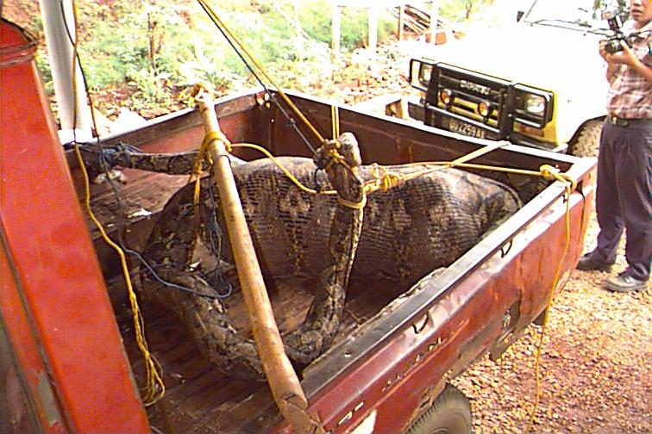

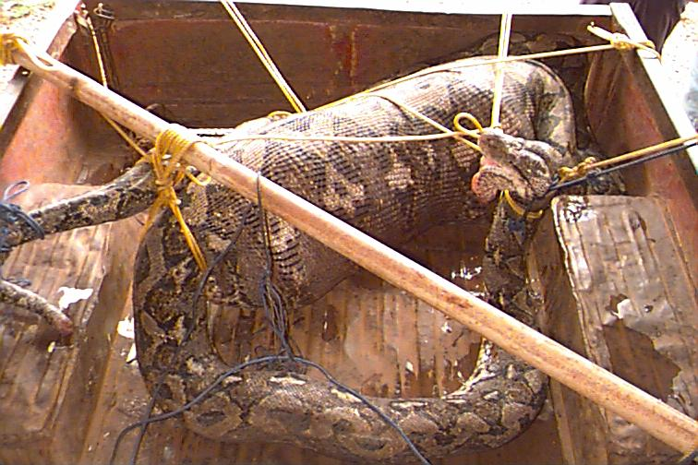
A CREW MEMBER ON A LAND OIL RIG IN NOUAKCHOTT WENT OUT AND TOOK A NAP. YES, A NAP. HE WAS MISSING AND THIS IS WHAT THEY FOUND.

SEE NEXT PAGE…

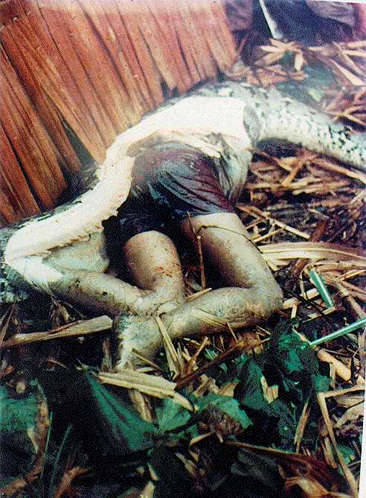
ANYONE WANT TO GO TO NOUAKCHOTT????

