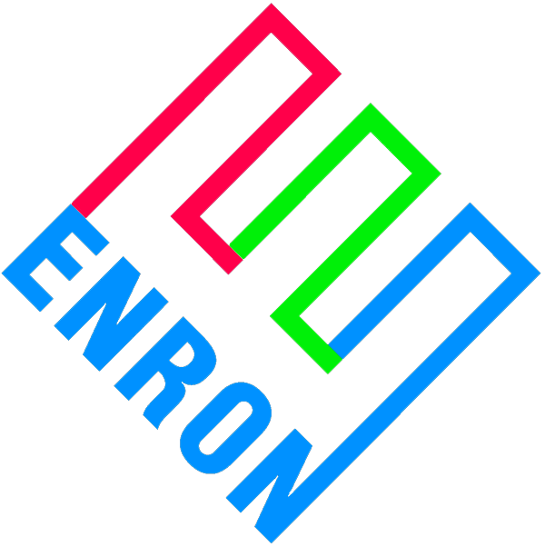
Enron Compression Services
1400 Smith Street
Houston, TX 77002-7361
(713) 853-3463

March 15, 2000

Transwestern Pipeline Company
P.O. Box 3330
Omaha, NE 68103-0330

Re: Request by Transwestern Pipeline Company ("TW") for alternative electric energy supply arrangement with Continental Divide Electric Cooperative (“CDEC”).

Attn: Steven Harris

The terms of that certain Compression Service Agreement between TW and ECS dated October 18, 1999 (the "CSA") pertaining to compression service are based on the TW's ECS' expectation that ECS will be able to receive energy services under CDEC's Rate Schedule 21. The availability of Rate Schedule 21 is dependent on the outcome and completion of the merger between Plains Electric Generation and Transmission Cooperative, Inc. ("Plains") and Tri-State Generation and Transmission Association, Inc ("Tri-State") (the "Merger"). As of the date of this letter, the expected Merger completion date is June 30, 2000.

The expected in-service of the Gallup facility is May 1, 2000 with service to be made available and coordinated with CDEC as early as April 1, 2000 for testing of the stations electrical drive system. Due to the representations that the Merger would be completed for July 2000 service, ECS proposes to utilize alternate electric service under CDEC’s Rate Schedule 19 prior to the Merger. Attached is a copy of Rate Schedule 19 for your review.

Under Rate Schedule 19, Transwestern will recognize a cost of compression service similar to the Rate Schedule 21 with the major difference being the interruptability of the Rate Schedule 19. Demand cost under Rate Schedule 19 will include a base rate of $2.61 per kW plus the additional cost of $1.00 per kW for the optional 20-minute notification charge. The Limited Hour Charge is no longer available because it did not provide a cost-effective option for large electrical loads. There is a substantial penalty for failure by the consumer to interrupt upon notification by the Utility. Consumer will have the option to continue service, during any interruption under Rate Schedule 19, by making provisions for a Continuation Rate prior to an interruption event. Threshold pricing can be established and termed a "Continuation Rate" where the CEDC's Wholesale Supplier will continue to provide service outside of their generation capacity up to the established price. Similarly, the "Right to Continue Service" can be established whereby the Wholesale Supplier will advise the consumer of the price to resume full or partial service during any such period of interruption. We will need to establish TW’s position relative to the Continued Service alternatives prior to May 1st. Any incremental costs associated with the Continuation Rate or the Right to Continue Service would be passed on to TW in accordance with Section 3.4 of the CSA.

CDEC has agreed to provide us with a 12-month historical report of interruptions. Our conversations yesterday with Plains and CDEC notionally indications 4 interruptions annually of 1-hour duration each under Rate Schedule 19.

The Alternative Arrangement negotiated by ECS with CDEC as per TW's notification to ECS dated February 29, 2000 will utilize Rate Schedule 19 upon execution and then Rate Schedule 21 with the Rebate Structure upon completion of the Merger. Due time constraints, I plan on finalizing the Alternative Arrangement based on this structure by March 17, 2000. If TW agrees with the utilization of Rate Schedule 19 prior to the completion of the Merger and the Alternative Schedule, please acknowledge by executing the letter below. Your prompt response would be greatly appreciated.

Sincerely,

ENRON COMPRESSION SERVICES
COMPANY

By:________________________________
Name:______________________________
Title: ______________________________

AGREED TO this __ day of March, 2000.

TRANSWESTERN PIPELINE COMPANY

By : _______________________________
Name: _____________________________
Title: ______________________________

