Anita Yelton Corporate Leadership Development

Crotonville
Project Leader Old Albany Post Road

Ossining, New York 10562
914-944-1858
e-Mail: anita.yelton@corporate.ge.com

Date: October 24, 2000

To: Mr. Kenneth Lay, Chairman and CEO

Subject: REQUEST FOR EUROPEAN BASED BEST PRACTICE SHARING SESSION WITH GENERAL ELECTRIC

GE Crotonville, General Electric's Leadership Development Center, would like to request to meet with Enron to participate in a short Best Practice Sharing (BPS) Session in Europe. The session would be scheduled between November 14-16 and November 27-29 with GE Executives from our Business Management Course (BMC). This session would take place at your office, or at a location of your choice.

The GE BMC is a learning program that develops GE's senior leadership talent. The BMC participants will conduct BPS sessions with companies such as yours that have been identified as having specific knowledge and experience related to a particular topic that the class has been asked to research.

The focus of this BMC is to talk with European companies on the topic of “How to use Technology to be more Productive.” The summary of the findings from these BPS sessions will be presented to Jack Welch and GE’s Corporate Executive Council on December 6th, 2000.

The BPS session involves a group of 3-4 BMC participants visiting your European facility to meet with key members of your European leadership team involved in developing and implementing your strategy for using technology as a productivity tool. The session will not last more than 2-3 hours, and the entire process is intended to be informal and not require a lot of preparation on your part.

We encourage you to make this a two way exchange. Your GE guests will be prepared to share what GE is doing on this topic. You will also receive a copy of the Final Presentation that the class will give to Jack Welch on December 6, 2000.

A member of our BMC Project team will contact you in the next few days to establish if you wish to participate and to ask your help in identifying additional Executives from your company to be involved in the session.

If you have any questions please call 1(800) 711-5834 and ask for Toni Schlener who will be happy to assist you.

Sincerely,

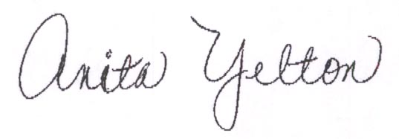

Anita Yelton

