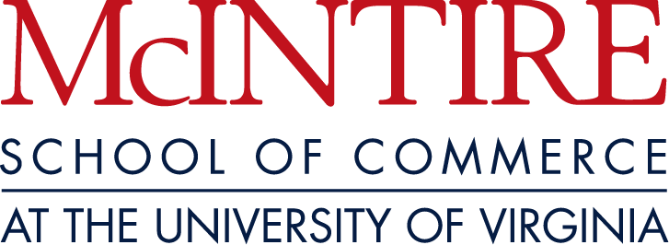

The McIntire Center for Financial Innovation

Symposium
Volatile Energy Prices: Risks and Opportunities
November 8-9, 2001

Symposium Theme

The recent volatility in various energy prices (crude oil, natural gas, and spot electricity in particular) illustrates the practical importance of risk management to consumers, distributors, and producers alike. It has also created opportunities to create value and shareholder wealth. This symposium will examine how some major market participants have responded to this enhanced volatility to manage their energy price risk exposure and exploit some of the profit opportunities volatile energy prices create. More specifically, we will explore how some firms have transformed themselves in the wake of deregulation and increased price volatility. Potential issues to be discussed include: the cause of the recent “electricity energy crisis” in California, whether the problem in California is localized or likely to spread to other parts of the country, the extent to which “deregulation” of the electric utility industry has contributed to price volatility, the relationship between natural gas prices and electricity prices, and how energy firms are changing their focus to take advantage of price volatility. Particular attention will be directed to assessing potential investment opportunities in the energy sector. Finally, a panel of traders will provide a birds-eye view of energy price volatility by discussing trading electricity and natural gas.

The McIntire Center for Financial Innovation

Symposium
Volatile Energy Prices: Risks and Opportunities
November 8-9, 2001

Thursday, Nov. 8, 2001

5:30 p.m. Private Lawn Tour

6:00 p.m. Buffet Reception at Pavilion X, on The Lawn

Friday, Nov. 9, 2001

Program Agenda

Symposium at the McIntire School of Commerce (Monroe Hall Room 130)

8:00 a.m. Continental Breakfast (Monroe Hall Room 110)

8:30 a.m. Welcoming Remarks and Introduction of Participants

Robert Webb, Director, The McIntire Center for Financial Innovation, McIntire School of Commerce

8:45 a.m. Panel Discussion: “Energy Price Risks and Profit Opportunities:
A Managerial Perspective”

Moderator: To be determined

Panelists:
Paul Koonce, Senior Vice President of Market Services, Dominion Resources, Inc.
Dr. Jay Lukens, President, Lukens Consulting Group (tentative)
William P. Utt (Engineering ‘79/’80, Darden ‘84), President and CEO, Tractebel North America

10 a.m. Break

10:15 a.m. Panel Discussion: “Investing in the Energy Sector”

Moderator: To be determined

Panelists:
Kenneth Beer, Partner, Johnson Rice & Company
Philip Deutch, Partner, Perseus
Energy analyst (to be determined)

11:15 a.m. Panel Discussion: “Energy Trading: Natural Gas and Electricity”

Moderator: Robert Webb

Panelists:
Michael Selman (Arts & Sciences ’80, McIntire ‘82), Vice President, The Williams Companies

Beau Taylor, Vice President, Morgan Stanley Dean Witter & Company
Rick Thatcher, Vice President of Market Services, Dominion Resources, Inc.
Enron representative (to be determined)

12:15 p.m. Closing remarks and adjournment

12:30 p.m. Lunch (Monroe Hall Room 110)

Saturday, Nov. 10, 2001

University of Virginia v. Georgia Tech Football Game at the Scott Stadium
Call Maria Salazar on 804-924-3176 to reserve a seat in the McIntire Skybox Suite. Tickets are limited and will be issued on a first come first served basis.

