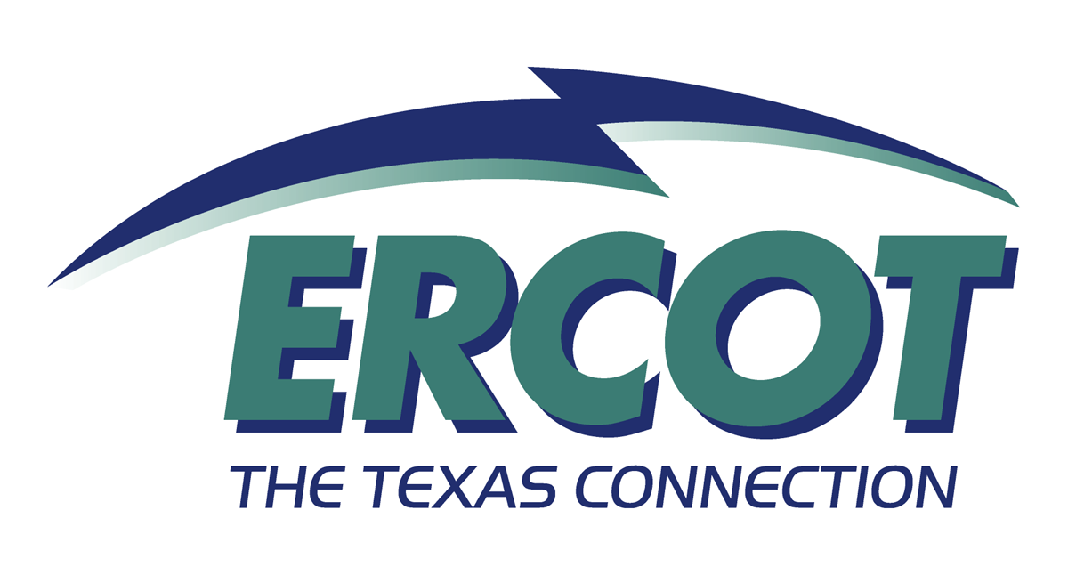

Nineteenth Annual ERCOT Operations Seminar
Market Participant Training

Tuesday
Time | Topic | Key Presenter
13:00 – 13:15 | Introductions and Logistics | James Hinson
13:15 – 13:45 | Current Events | Sam Jones
13:45 – 14:00 | Break
14:00 – 14:45 | Voltage Control Fundamentals  Includes a detailed discussion on the influence of reactive power on the bulk power system. Methods for minimizing the effects of reactive power requirements on system voltages will be discussed. Finally, examples of the impact of system conditions on reactive power flow will be explored. | Gary Miller
14:45 – 15:00 | Break
15:00 – 15:45 | Voltage Control Procedures  Addresses terminology associated with the market, the establishment and application of voltage profiles, general guidelines, and voltage variance control. The presentation will also address the use of reactive devices and reserve requirements, and scope of control on the implementation of such. Communication content and reporting requirements will also be discussed along with the responsibilities of the different parties. | Vann Weldon
15:45 – 16:00 | Break
16:00 – 17:00 | Renewable Energy  A high level presentation on the history and goals of the Renewable Energy Credit Trading Program for Texas. The benefits of the program to the people of Texas and to Market Participants and investors will be discussed. It will include some operational procedures and a presentation on how Market Participants can participate in the program. The presentation will also cover transmission concerns associated with Renewable Energy in west Texas. There is an expected 1,000 MW of new wind turbines that will be on line next year in west Texas. | Roy McCoy

Nineteenth Annual ERCOT Operations Seminar
Market Participant Training

Wednesday
Time | Topic | Key Presenter
08:00 – 08:45 | Market Operations Overview  A wide-ranging review of how the ERCOT Wholesale Market operates. Responsibilities of ERCOT and Market Participants will be defined. The scheduling and bidding process, both Day Ahead and Adjustment Period will be reviewed along with Ancillary Service requirements and procurement. Submission and use of Resource Plans will be discussed. Transmission congestion management and related zonal, unit specific, and Out Of Merit Balancing Energy deployment issues will be presented. The functions of each ERCOT operating desk will be defined and explained. Current challenges to ERCOT operations and upcoming changes will be explored. | Kent Saathoff / Joel Mickey
08:45 – 09:00 | Break
09:00 – 9:45 | Market Operations Overview (Continued) | Kent Saathoff / Joel Mickey
9:45 – 10:00 | Break
10:00 – 12:00 | Market Operations Overview (Continued) | Kent Saathoff / Joel Mickey
12:00 – 13:00 | Lunch
13:00 – 14:45 | Black Start  Explains the dynamics of the interconnected system that could result in a system blackout, measures currently in place to prevent this occurrence, and restoration plan designed for the event if it does occur. Because of the increased complexity of the ERCOT Interconnection environment, discussing the critical roles of the dispatchers and operators in performing the necessary tasks in the system restoration process is needed. The presentation is intended for use in training programs and as a reference for power system dispatchers and plant operators. The focus is to provide an overview of the dynamic phenomena that could bring about a system shutdown, communications that are necessary to first prevent and then if unsuccessful, restore the system and the concepts involved with developing the plan and executing it correctly. | Richard Sikes / Woody Rickerson
14:45 – 15:00 | Break
15:00 – 15:45 | ERCOT Guides  High-level overview of the ERCOT Guides with emphasis on the Change Control Process. This presentation also introduces methods to search and condense the Guides as a quick reference tailored to each entity’s specific needs. | Brad Calhoun
15:45 – 16:00 | Break
16:00 – 17:00 | Compliance  Overview of the guiding principles behind the NERC Reliability Compliance program, focusing on how ERCOT will implement it in 2002. Key measures and expected results will be reviewed, along with sources for more information. | Mark Henry

Nineteenth Annual ERCOT Operations Seminar
Market Participant Training

Thursday
Time | Topic | Key Presenter
08:00 – 08:30 | Status of ERCOT | Tom Noel
08:30 – 09:15 | IT Update  ERCOT has developed and deployed many new systems over the past year. This session will review those systems currently in place at ERCOT. The objective is to give Market Participants an overview and general understanding of ERCOT systems with a focus on the interfaces. The session will also look ahead to future IT developments that may impact Market Participants and their systems. | Steve Grendel
09:15 – 09:30 | Break
09:30 – 10:15 | Control Performance  The presentation will give QSE and PGC dispatchers knowledge of proper turbine performance and what mode of control produces the best performance for reliable system operation. The objective is to explain the interaction of system frequency, turbine droop, and customer load. Will also explain the responses of different types of turbines in different modes of control. This will include steam turbines in variable pressure mode, turbine following mode, boiler following mode, and coordinated mode. Combustion turbine droop in temperature control mode, pre-select mode, and part-load mode will also be covered. The presentation is intended for use in training programs and as a reference for power system dispatchers and plant operators. The focus will be on providing an overview presentation of the dynamic phenomena that provides the operator with the first line of defense during system disturbances. | Sydney Niemeyer
10:15 – 10:30 | Break
10:30 – 11:30 | Summer Assessment 2002  A review of expected conditions for the Summer Season 2002. It will include a review of new generation, available generation, projected demand, and transmission limitations. | Ken Donohoo
11:30 – 12:00 | Mementos, Certificates, Wrap-Up | James Hinson

