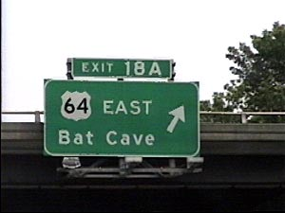
Sushh, it’s a secret…

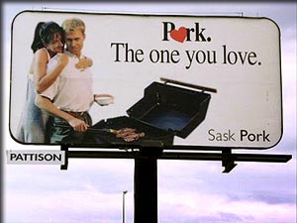
The “other” white meat..

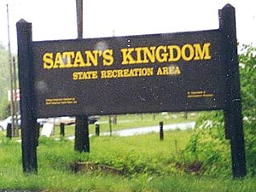
Leave your soul at the front gate please.

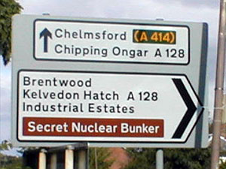
Sushh, it’s a secret… #2

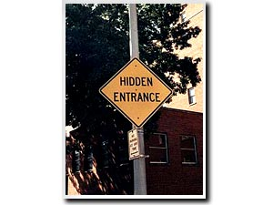
Sushh, it’s a secret… #3

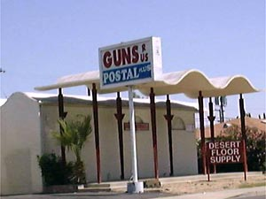
This one is in Phoenix AZ, no lie!

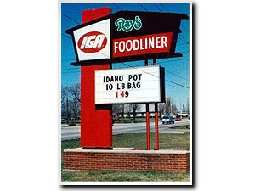
Idaho state legislature puttin the street dealers outta bidness.

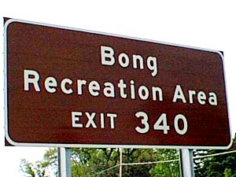
Amazingly, Bob and Dave never made it to their original destination,,, wherever it was.

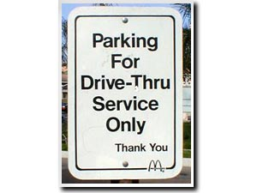
???

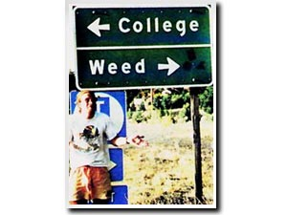
Major dilemma.

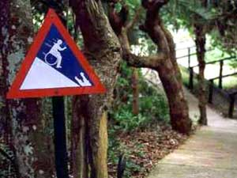
“CAUTION: HANDICAPPED MAN EATING CROCODILE AT BOTTOM OF HILL”

