VOTING FOR DUMMIES

Presidential Election Ballot 2000

Specifically Designed for Residents of West Palm Beach County, Florida
___________________________________________________________________________

Check the box BENEATH (i.e. below, underneath, at the bottom of) the picture of the candidate who you want to be the next President of the United States. Please check the AL GORE box only.

Pat Buchanan
George W. Bush

Al Gore
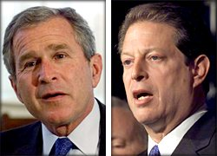
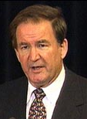

You have chosen George W. Bush. Are you sure you want to vote for George W. Bush?  Yes No (I was confused, change  my vote to Al Gore) |  | You have chosen Al Gore. Great job. Your ability to understand complex voting ballots is a tribute to the national education system. |  | You have chosen Pat Buchanan. This candidate is NOT Al Gore. Are you sure you want to vote for Pat Buchanan?  Yes No (I was confused, change  my vote to Al Gore)
If you circled “Yes” above, do you realize that George W. Bush is NOT Al Gore?  Yes No (I was confused, change  my vote to Al Gore) |  | Do you wish to cast a second vote for Al Gore?  Yes Yes |  | If you circled “Yes” above, do you realize that you are throwing your vote away?  Yes No (I was confused, change  my vote to Al Gore)
You really meant Al Gore, Didn’t you?  Yes Yes of Course |  | How about a third?  Yes Yes definitely |  | If you circled “Yes” above – you can’t be serious, so we will automatically change your vote to Al Gore – we know that’s what you meant.

Referendum Vote: Should all votes cast in this election be recast in favor of Al Gore?

Yes I’m confused

Opinion Survey: Do you think that the residents of West Palm Beach County, Florida have enough common sense to elect a President of the United States?

No Huh?

