NYISO

Reference Price Data Template
Instructions

EXCEL VERSION

April, 2001



5172 Western Avenue
Altamont, New York 12009
(518) 356-6000

Table of Contents

Page

Introduction 2
Getting Started 3
Specifying Inputs 4

Introduction

Market Monitoring and Performance has developed this data template as a Microsoft Excel_{R}-based workbook consisting of several spreadsheets. This template was created to collect cost information from market participants to support the calculation of reference prices where appropriate as specified in the Market Mitigation Plan.

The template allows the user to enter data and review and/or modify assumptions, and print the results. Knowledge of Excel is not required to enter the data, but it will enhance the understanding of the operations being performed.

There are three general types of production cost information that must be entered into the template to meet the data requirements of the NYISO. They are: variable; fixed; and other production costs. The spreadsheets have both data input points (cells are formatted blue) and calculated fields (cells are formatted black). The user enters data in the cells marked for input and the template calculates the required information. This information is summarized on the main page in an easy to view format.

The variable costs are broken down into fuel and variable O&M costs. Fuel costs are entered into the spreadsheet for each output segment of the unit. Fixed costs are broken down into fuel to start the unit by segment and the various fixed costs underlying the plant’s operations, such as property insurance and wages. Other production costs include Risk Premium, Emergency Output Costs, Opportunity Costs, and Environmental Costs.

TEMPLATE STRUCTURE

The Template is made-up of the following spreadsheets:

1. Main
2. Fuel Costs
3. Variable Production (Prod) Costs
4. Fixed Costs
5. Other Costs

Chapter 2 - Getting Started

HARDWARE/SOFTWARE REQUIREMENTS

The Template is a relatively small Excel file which is written using Release 9.0. Due to the size of the Template, NYISO recommends the following hardware and software configurations as minimum requirements for using the Template

Processor: Pentium 200 or faster
RAM: 16 MB
Hard Drive: .5 MB free
Software: Microsoft Excel_{TM} (version 8.0)
Printer: Any laser or inkjet printer

OPERATING THE TEMPLATE

The template is accessed by starting Excel and opening the file NYISOAMP_COST_WORKSHEET.XLS.

After retrieving the NYISOAMP_COST_WORKSHEET.XLS file, Excel’s main menu bar will appear on the top of the screen, however an Excel file remembers where the cursor was when the file was last saved and the file may not open on the main spreadsheet. The main spreadsheet is shown in Figure 1. The Template is set to recalculate very time an input is changed and the user will see the results of their changes instantly

Figure 1

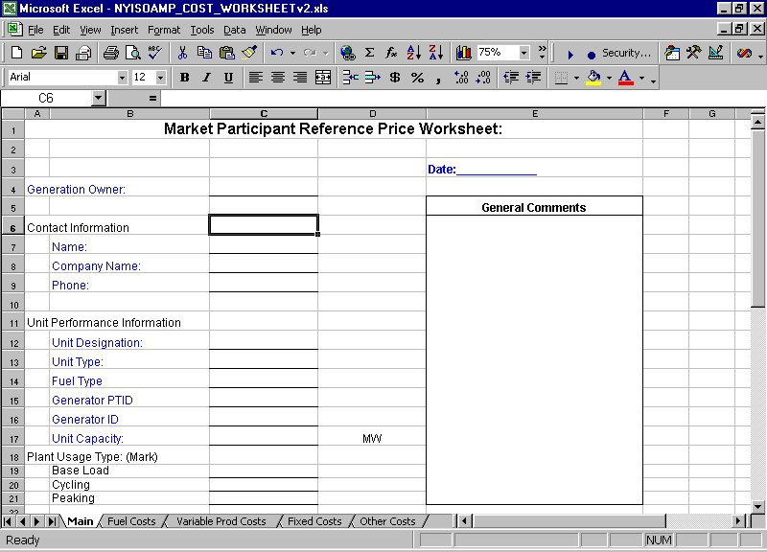
Chapter 3 - Specifying Inputs

In this chapter, we will discuss the modification of key Template inputs. The input data develops a cost based bid price for the unit and will be used to compare to the actual bid price of the unit. The cost based data is broken down into separate components. They are:

- Basic Unit Information
- Fuel Costs
- Variable Fuel and O&M Costs
- Fixed Fuel Costs to start the unit and other fixed costs like wages and taxes.
- Other Costs: Risk Premium, Emergency Output Costs, Opportunity Costs, Environmental Costs

There are three data input conventions designed into the Template.
They are:

- All text entry fields have blue labels and the cells are underlined.
- All number entry fields are blue and have a “– “ which represents a zero value.
- All percent entry fields are blue and have a value of “0%” in the field.

As stated above, the template is made up of five separate spreadsheets; below is a brief description of each spreadsheet.

1) Main Spreadsheet – The user enters basic information about the bidder and the unit. This information should be typed into cells that have been underlined adjacent to blue labels. Segment information should be entered with a brief description and all number values on this page are obtained for the other sheets and should not be modified directly.

2) Fuel Costs Spreadsheet – This sheet is intended show the average costs of each type of fuel used by the generating unit, with multiple sources possible for each type of fuel. The template shows six segments because the fuel types or sources can change for a unit depending on the output level. Therefore, each segment corresponds to the fuel types and sources for the unit’s entire output at the level.

First type the name to the fuels starting on line B5. Then enter the sources of the Primary Fuel starting on line 13. In cell D13 enter the cost of the primary fuel per MMBTU for the first segment. In cell E13 enter the percentage the first source of fuel is of the total for the primary fuel in the first segment. Follow suit for each segment and each fuel source until all fuel types are complete. See figure 2 as example of the first fuel segment.

Figure 2.

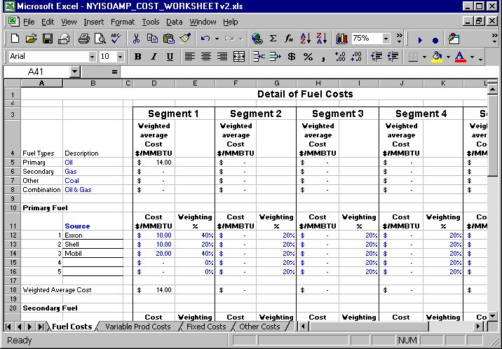

3) Variable Prod Costs Spreadsheet - This sheet is intended to collect the underlying data necessary to calculate the variable production costs of the unit. For most units, the largest component of the units variable production costs is its fuel component, which is based on the unit’s heat rates over its entire output range and the costs of its fuel collected on the prior worksheet. It does not include environmental costs, which are included on the “other costs” sheet.

This sheet requires input in columns C and D. Enter the Output in (MW) by segment and the incremental Heat Rate in (BTU/KWh) by segment. This is combined with the fuel costs from the previous sheet and gives a cost for each MW of output. Also, on this sheet starting on line 57 is an area to add in variable O&M costs and other costs that vary with production. See figure 3.

Figure 3.

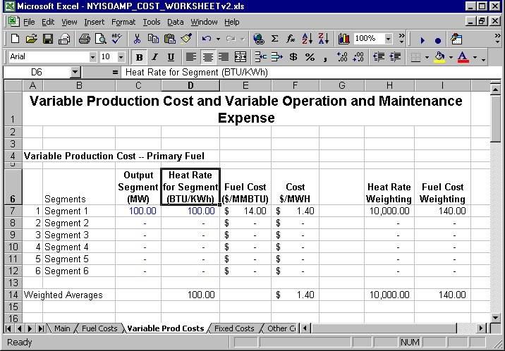

4) Fixed Costs Spreadsheet – This sheet allows suppliers to enter data on fixed costs for the unit that they deem relevant to the calculation of reference prices. This sheet requires inputs in column D, Fuel Required to Startup in (MMBTU). The fuel data is broken into the 6 segments and the four fuel types and the maximum fuel cost by fuel type is carried to the Main sheet in the summary. On this sheet there are also entry points for fix costs related to the plant.

5) Other Costs Spreadsheet - This sheet contains data entry points for Risk Premium, Emergency Output Costs, Opportunity Costs, and Environmental Costs. The Risk Premium allows the generator to represent to the NYISO how certain risks associated with receiving a day-ahead schedule have been incorporated in their bids (if at all).

The Emergency Output costs are the incremental costs that may be associated with running the unit beyond its normal operating range. These costs may only be relevant for certain types of generating units that can take actions to raise the output of their unit above its normal range for limited periods of time.

Risk Premium and Emergency Outputs costs require the user to identify their assumptions first and then outline in a text box their method for calculating the measure. Once the method is explained the user enters the results into lines 23 through 28 for Risk Premium and lines 53 through 58 for Emergency Output Costs. Opportunity Costs require a value and a detail explanation of how that value was created. Environmental Costs require a rate of emission and a cost per unit.

