Scope of Work

Enron Capital and Trade Resources has asked AGENCY.COM to provide an estimate for the design, development and implementation for an Online Commodities Trading System. The purpose of the system will be to facilitate global, online, real-time trading of Enron Capital and Trade Resource products using the internet media to interface with Enron’s internal trading systems.

Definition of Deliverables
This Definition of Deliverables outlines in detail what AGENCY.COM will deliver during the project. AGENCY.COM will make each of the deliverables available in electronic and printed form.
Enron Communication Site
Description: | AGENCY will provide Enron with a communications site via the internet containing all documentation of the project. The site will be available through secure access based on user id and passwords.
Delivery Method: | Available via the internet site (e.g. www.eriver1.com/enron) .
Status Reports
Description: | AGENCY will provide Enron with weekly status report detailing activities related to the project, progress against plan, and any issues that may affect the delivery of the project.
Delivery Method: | Status reports will be emailed to the Enron team on a weekly basis. In addition, AGENCY will post the status report on the Enron communication site – extranet.
Enron Discovery:
Description: | The Discovery Document is comprised of a general project overview, a list of determined technical requirements, the detailed functional requirements, as well as an initial site map and content description. The Discovery Document will also detail the project timeline and costs.
Delivery Method: | The final printed copy will be sent via Express mail and posted on the Enron communication site.
Enron Prototype Site
Description: | AGENCY will provide Enron with a prototype based upon the current requirements provided in the Power Point presentation given on 05/13/1999. Two developers will be dedicated for four weeks to developing the prototype.
Delivery Method: | AGENCY will provide a demonstration of the prototype at the end of the four-week period.
Enron Information Architecture:
Description: | The Information Architecture flowchart defines the navigational structure and content organization of the Web site.
Delivery Method: | The Information Architecture will be available on the development site. The final printed copy will be faxed or sent via Express mail.
Enron Content Schematic:
Description: | The Content Schematic is a detailed outline of the site navigation and content organization planned for each section of the site. This document will provide a road map for site production.
Delivery Method: | The Content Schematics will be available on the development site. The final printed copy will be faxed or sent via Express mail.
Enron Initial Creative Comps
Description: | Three design concepts defining the potential “look and feel” of the site. Enron to select a design direction from the three designs.
Delivery Method: | Comps will be posted to the AGENCY.COM development site.
Final Proof of Concept
Description: | 3 – 4 screens from selected design direction that incorporates client feedback. This may contain one primary screen and additional supporting screens to emphasize navigational/menu use.
Delivery Method: | Proof will be posted to the AGENCY.COM development site.

Assumptions and Dependencies
This project plan assumes
- Information concerning the progress of the project will be made available to senior management via weekly status reports emailed to the Enron and AGENCY teams.
- Any travel or related expenses on Enron's part is not included in this estimate.
- Any software and/or hardware needed for the web site is not included in this estimate. AGENCY will provide a list of hardware and software specifications at the end of the Discovery phase.
- All outside expenses are estimates and will be billed at actual.
- Workload will be billed on a Time & Materials basis. A range for the project is included.
- Any work added to or deleted from the scope, which is not outlined in the Definition of Deliverables, or Milestone Timeline may affect the schedule and budget. Additions to the scope of the project will be documented and approved by Enron prior to starting tasks related to the scope addition.
- The database that will be used for the site will be completely and thoroughly documented by June 8, 1999 on the part of Enron. This includes schematics for each table used by the site, and source code for any stored procedures that might be used.
- This project assumes completing the system as defined in the functional requirements presented to AGENCY on 05/13/1999. Once the Discovery Document is completed in the first portion of the project, the Discovery Document will define scope for the project. Any changes to the Discovery Document, once completed, may effect the timeline and budget for the project.
- Enron will provide sign-off for each individual deliverable as it is completed in an expedient manner. If after 1 day of receiving notification that the deliverable is ready there has been no communication between Enron and AGENCY, the deliverable will be determined as acceptable. Approved documents and milestones will not be altered after final sign-off.
- Staging hardware will be installed and accessible within four weeks of commencement of the project.
- Production hardware will be installed and accessible within eight weeks of commencement of the project.
- Jay Webb and Tilak Mandadi will be accessible and dedicated to AGENCY.COM during the project to keep with the schedule and deadline of the project.
- Enron will provide a lead engineer that will be dedicated to the project, and will be accessible and empowered to answer questions and approve decisions concerning the database and/or hardware/software configuration.
- Enron will provide all branding and creative guidelines necessary for development of the site at the commencement of the project.
- Enron will provide AGENCY with a single point of contact for approving creative and branding elements developed for the site. Enron will have all decision-makers present at the creative review where the creative direction will be determined.
- Enron will provide AGENCY with a twenty-five percent down payment for the project due within two weeks of commencement of the project.
- Phase 1 of the project will encompass the deployment of a full English language system only. The navigation will be text based multilingual for FIGS + English. Enron will provide the translation of the content for the site. The database architecture and design will be completed for a multi-language system in Phase I, however, the presentation elements will not be completed.
- This phase of the project will only involve multiple currency trading; however, no real time currency conversions will be handled in this phase. Transactions will occur in the currency they are presented.
- AGENCY is allocating a dedicated team of 11 people to the project, and a total of 14 dedicated full time equivalents. Additional resources can be allocated from AGENCY’s staff of over 600 people, if necessary.

Tasks and Project Timeline

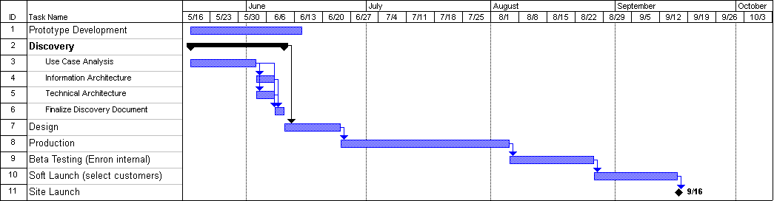

AGENCY will provide a more detailed cost estimate and time frame during the week of May 17th.

Estimated Project Cost $1,200,000 – $1,500,000
Down Payment $ 300,000 (Due upon commencement of project)

This estimate does not include travel and related expenses, hardware and software for the project, or licensing fees.
JESICA components, IF used, are available to Enron for an additional $100,000 per component to include the SOURCE CODE. If the project does not use JESICA these fees for JESICA components do not apply.

APPROVAL
This section is to verify acceptance of the requirements listed above and contained herewith in the attached document. The signatories below are Company authorized personnel, and have assessed or consulted with the appointed company agent to assess the attached documentation that makes up the comprehensive component functionality.

AGREED AND ACCEPTED

AGENCY.COM Enron

_________________________ __________________________
By: By:
Name: Madelon Coover Name:
Title: Business Development Director Title:
Date: May 17, 1999 Date:

Note: Both parties agree that to obtain delivery dates that are considered acceptable to meet client expectations certain modifications of these functional specifications might take place in the future. Additions and/or changes to the requirements will be evaluated to determine the affect on the project schedule and project estimate. The project schedule and estimate may then be adjusted and/or the modifications may be implemented as a later release.

