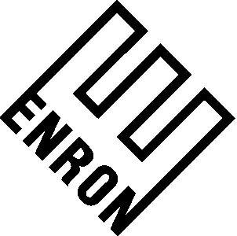

To: | Leslie Lawner
From: | Jeff Hodge | Department: | ENA - Legal
Subject: | Diversion Question | Date: | September 28, 2025

In follow-up to your phone message, I have put together a quick paragraph on diversion relating to the gas contracts of Enron North America Corp. ("ENA"). That paragraph is as follows:

Under the gas contacts of ENA, a diversion of gas as a result of governmental action would likely be an event of force majeure excusing the performance of ENA. As an aside, you should note that the vast majority of ENA's gas business involves deliveries to its customers at various city gates. ENA has very limited exposure to transportation or pipelines owned by local distribution companies.

I trust the foregoing meets your current needs. Should you have any questions or comments, please contact me at your convenience.

cc: Mark Haedicke
Richard Sanders

