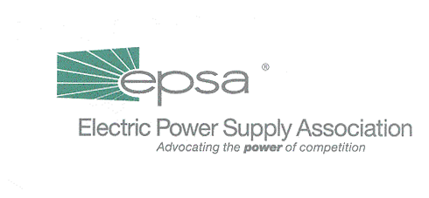
1401 New York Avenue, NW
11th Floor
Washington, DC 20005
202/628-8200
202/628-8260 fax
www.epsa.org
Memorandum
TO: | Legislative Affairs Committee
FROM: | Scott A. Weiner, Legislative Affairs Committee Chair  Andrea L. Spring, Manager of Government Affairs
DATE: | July 6, 2001
RE: | Broad Industry Negotiations with House Leadership Staff on Electricity Legislation

Congressmen Tom DeLay (R-TX) and Steve Largent (R-OK) are crafting electricity restructuring language which DeLay intends to present to House Energy and Air Quality Subcommittee Chairman Joe Barton (R-TX) and House Energy and Commerce Chairman Billy Tauzin (R-LA) as the basis for either stand-alone legislation or an electricity title of a larger energy bill. EPSA has participated in four meetings DeLay’s staff has held on this legislation, and will also attend one scheduled for this afternoon. This memo summarizes these meetings.
DeLay’s staff has asked a number of stakeholders from the electricity community, including EPSA, to participate in a series of meetings to negotiate the basic principles and specific legislative language to be included. The stated goal of these meetings is to produce language which could realistically be passed by the Energy and Commerce Committee anytime within the next three weeks.
The issues discussed include:
- Transmission Jurisdiction: Includes the “FERC-light” provision, which puts the currently non-jurisdictional utilities under some FERC oversight. Other possible transmission provisions include a clarification that FERC has the authority to regulate all transmission or a requirement that all load serving entities be required to take transmission service under the RTO tariff.
- RTOs: Does not include a mandatory RTO provision, but may include language preventing states from prohibiting or unreasonably delaying RTO formation.
- Transmission Siting: Establishes a regional planning process with a FERC backstop; establishes federal eminent domain.

- Electric Reliability: This would create a new self-regulating electric reliability organization (ERO) to develop enforceable reliability standards.
- Interconnection: Sets forward a process for establishing uniform interconnection standards, and provides for the right to interconnect and purchase backup power.
- Incentive Rates for Transmission
- Public Utility Holding Company Act: Repeals PUHCA and establishes access to books and records.
- Public Utility Regulatory Policies Act: Prospectively repeals PURPA. Language proposed by the American Chemistry Council is under discussion which would allow companies with QF facilities to wheel power to their affiliates, in both open and closed states.
- Market Power: Currently a placeholder; APPA is circulating proposed language, but it’s not clear if there is broad support for it.
- Tax Incentives: Private use, capital gains and incentives for investment in transmission infrastructure.
This is also an incredibly short time frame in which to create legislative language, and these are obviously contentious issues on which there is still great disagreement among the stakeholders. The transmission jurisdiction question continues to be a difficult one, with NARUC in particular still determined that the states have jurisdiction. The reliability section will evolve as industry talks on reliability language continue. It is very likely that some of these provisions – including transmission jurisdiction–will not be included in the final legislation.
There is a Subcommittee markup scheduled for 11:00 a.m. on July 10 (for the “Energy Advancement and Conservation Act of 2001”). Since Energy and Commerce Committee staff are still drafting the conservation and other provisions which will be included in that bill, it is difficult to see how this electricity language could be included in that markup, but DeLay’s staff will not rule out that possibility.
If you would like a copy of the latest version of the draft legislative language sent to you, please e-mail Donn Salvosa (dsalvosa@epsa.org) at EPSA.

